

ASIA PACIFIC COLLEGE

School of Computing and Information Technologies

LitPath AI: Smart Pathfinder for Theses and Dissertations

Final Documentation Submitted to the Faculty of the

School of Computing and Information Technologies

In Partial Fulfillment of the Requirements for

Systems Analysis and Detailed Design

MSYADD1

By

Charijoy Cempron

Marielle Kloie Concepcion

Jenine Elaine Dulay

Tracie Tomon

Mr. Jose Eugenio L. Quesada

October 2025

**Table of Contents**

**PM Docs Chapter 2** 5

**I.** **Charter** 5

**II.** **Objectives** 8

**III.** **Scope** 9

**IV.** **Stakeholder analysis** 12

**OpenProject Activities** 13

**Budgets** 13

**Roadmap** 13

**Work Packages** 14

***Work Packages by Tracie Tomon*** 14

***Work Packages by Charijoy Cempron*** 14

***Work Packages by Jenine Elaine Dulay*** 15

***Work Packages by Marielle Kloie Concepcion*** 15

**Backlogs** 16

**AY 2025-2026 T1 Sprint 01 Board** 17

**Gantt Chart** 17

**Design Thinking output (5 Stages)** 18

**Stage 1 – Empathize** 18

**1.1 Client, Employee and Customer Interviews** 19

**1.2 5 WHYs (Simplified)** 41

**1.3 Personas** 44

**1.4 Empathy Map** 48

**1.5 Pain-Gain Analysis Summary** 52

**Stage 2 – Define** 53

**2.1 Clustered Problems** 53

**2.2 Problem Statement** 54

**2.3 How-Might-We** 55

**Stage 3 – Ideate** 58

**3.1 Brainstorming Session** 58

**3.2 Crazy 8s** 59

**3.3 Post-It Voting** 63

**3.4 Desirability, Viability, Feasibility** 64

**Stage 4 – Prototype** 67

**4.1 Storyboards** 67

**4.2 Mock-up Design** 80

**Stage 5 – Test** 103

**Dataflow Diagrams** 106

**Level 0 (Context Diagram)** 106

**Level 1 diagram** 106

**Level 2 diagrams** 107

**1.0 Search Thesis/Dissertation** 107

**2.0 View Thesis Details** 107

**3.0 Provide Feedback** 108

**4.0 View Search History** 108

**5.0 Log In to Account** 108

**6.0 Manage Usage Analytics** 109

**7.0 Manage Feedback** 109

**Use Case Documentation** 110

**Use Case Diagram** 110

**Fully Dressed Use Cases** 110

**Activity diagrams with Swim-lanes** 126

**1.0 Search Thesis/Dissertation** 126

**2.0 View Thesis Details** 127

**3.0 Provide Feedback** 128

**4.0 View Search History** 129

**5.0 Log In to Account** 130

**6.0 Manage Usage Analytics** 131

**7.0 Manage Feedback** 132

**Test Cases** 133

**UC-01 TC01** 133

**UC-02 TC02** 133

**UC-10 TC10** 134

**Entity Relationship Diagram** 135

**Technology Stack** 135

**GitHub APC-SoCIT Project Repository URL Link** 136

**OpenProject Team Site URL Link** 136

**Cloud hosted site URL Link** 136

# **PM Docs Chapter 2**

## **Charter**

**Purpose**

LitPath AI was created to improve the quality, efficiency, and relevance of research experiences in academic libraries, particularly within OPAC (Online Public Access Catalog) systems. Students and researchers often face difficulties such as vague or irrelevant results, limited keyword matching, outdated user interfaces, and the lack of common research website features like in-text citation when searching for theses and dissertations. LitPath AI enhances the current system the DOST-STII has (OPAC) by having advanced filters and AI-powered query analysis to help users quickly find relevant theses and dissertations along with a citation tool. This improves research efficiency and maximizes access to DOST-STII Library's theses and dissertation collection.

**High-level project description**

LitPath AI is an AI-powered search engine designed to improve access to the DOST-STII Library's collection of theses and dissertations. It enhances the current OPAC system by offering:

* AI-powered query analysis for understanding user intent when searching
* Advanced filters for more precise search results
* In-text citation tool for easier reference
* Offers recommendations of related research based on the current research you are viewing

The system also includes an admin dashboard that allows library staff to track search trends and monitor usage for future updates.

The project will go through the following stages: planning, interface design, backend development, system integration, testing with users, and final deployment for presentation.

**High-level milestone schedule**

|  |  |  |
| --- | --- | --- |
| **Milestone** | **Estimated Date** | **Status** |
| Project Scoping | April 2025 | Completed |
| Information Gathering for project requirements | April- May 2025 | Completed |
| Completion of project deliverables, documentation, and final outputs | June 2025 | Completed with little revision for final paper |
| Completion of interactive prototype design (for Figma prototype) | June 2025 | For revision for MSYADD1 due to changes in project |
| Execution of the design thinking process (Stage 1 - Stage 5) | August 2025 | Completed |
| Finalization of process diagrams and project management documentation | August 2025 | Completed |
| **Development Phase:** | | |
| Develop the core UI elements: **System UI**, **Citation Generator**, and **Bookmark** functionality | Sep - Oct 2025 | In progress |
| Develop the **Feedback** mechanism and **Filters**. | Oct- Nov 2025 | Not started |
| Develop more features: **Generate overview** and the **AI Search Engine**. | Dec 2025 - Jan 2026 | Not started |
| Develop features that enhance the user's research process: **Related Searches**, **Research History**, and **Follow-up Questions** |  | Not started |
| Develop the final high-level features: **Admin login and dashboard** and **Integration to OPAC**. |  | Not started |
| **Testing Phase:** | | |
| Internal Unit Testing, Integrated System Testing | Feb-March 2026 | Not started |
| Usability testing |  | Not started |
| Performance optimization, Bug fixes | March - April 2026 | Not started |
|  | | |
| Deployment | May- July 2026 | Not started |

**Rough cost estimate and budget**

LitPath AI, as mentioned by our client form DOST-STII, does not require a formal budget. However, there are some minor operational costs related to development and testing:

Expected Costs:

* Cloud services that will be shouldered by DOST-STII.
* AI-related tools and services that will be used for the development of the system.

**Stakeholders**

* Student researchers (primary users)
* DOST-STII librarians and staff
* Project-Based Learning (PBL) instructor
* Library systems developers (future collaborators)
* LitPath AI development team (our team)

**Project manager**

**Jenine Elaine Dulay**, Group Leader

**Project manager’s responsibilities**

* Ensure progress aligns with the milestone schedule
* Assign tasks and monitor team contributions
* Communicate with instructor and client when needed
* Oversee system integration, testing, and documentation
* Organize final outputs for defense and presentation

**Project manager’s authority**

* Prioritize tasks and development features
* Reassign tasks when necessary
* Manage team budget and resource allocation
* Facilitate conflict resolution
* Make final decisions with group consensus

**Formal declaration of sponsor’s support**

**Sponsor Name:** Khasian Eunice Romulo

**Position:** Client / Science Research Specialist II/ Unit Head of Digital Information and Processing Delivery Unit

**Support Statement:**  
As the client, I support the LitPath AI project. This system addresses real problems experienced by students and researchers. It is a step forward toward modernizing our academic researching tools by using artificial intelligence. I encourage the team to stay committed to quality, collaboration, and creative problem-solving.

## **Objectives**

**LitPath AI Case Study Objectives**

In the pursuit of academic and professional research, theses and dissertations are crucial sources of original, comprehensive, and often localized studies. The Department of Science and Technology - Science and Technology Information Institute (DOST-STII) Library houses a valuable and growing collection of academic materials from DOST Scholars, which are classified and cataloged through its Online Public Access Catalog (OPAC).

Although the DOST-STII Library houses a valuable and growing collection of graduate theses and dissertations, the system presents difficulties in locating relevant theses and dissertations due to exact keyword matching, limited filtering options, slow search process, and lack of Artificial Intelligence. These difficulties created a major barrier for students, researchers, and other professionals. Users who are exploring a new research area or are unsure of precise terminology find it difficult to discover relevant materials, leading to research inefficiencies and the underutilization of the library's key academic resources.

The objective of the proposed project, LitPath AI: Smart Pathfinder for Theses and Dissertations, aims to address the limitations of the current DOST-STII OPAC system through the implementation of an AI-powered search engine designed to improve accessibility and help users discover relevant academic works.

**Categorized Objectives**

|  |  |  |
| --- | --- | --- |
| **Objective** | **Category** | **Measure** |
| Improve search efficiency and precision | Performance | Achieve a user satisfaction score of at least 3.5 out of 5 from testers on the relevance and ease of use of the new search features. |
| Help users discover more relevant studies | Performance | Top 10 search results reach a minimum of 70% accuracy based on user and expert validation |
| Create a better and faster user experience by reducing system response time | Performance | Reducing system response time to under one second for processing and displaying search results |
| Provide a built-in citation generator that supports APA, MLA, IEEE, and Chicago styles | Quality | Accuracy will be verified through expert review and user testing to ensure correct citation formatting |

## **Scope**

**Scope Statement**

|  |
| --- |
| **Project goal and objectives**  *(What the project is supposed to achieve.)*  The primary goal of this project is to develop and implement an AI-powered search engine to increase the discovery and use of the DOST-STII Library's collection of theses and dissertations.  The project will achieve this through the following specific objectives:   1. To improve search efficiency and precision, the system will be equipped with advanced filters allowing users to narrow down results by discipline, recency, and date range which directly solves the problem of the limited search mechanism. Success will be measured by achieving a user satisfaction score of at least 3.5 out of 5 from testers on the relevance and ease of use of the new search features. 2. To help users discover more relevant studies, the system will leverage AI-powered algorithms to provide semantically relevant search results. These algorithms will analyze user queries and content to ensure that the top 10 search results have a minimum relevance accuracy of 70%, based on user feedback and expert validation. 3. To create a better and faster user experience, the interface will be redesigned to be more intuitive and responsive, with a goal of reducing system response time to under one second for processing and displaying search results. 4. To make citing sources easier for researchers, a built-in automated citation generator that supports multiple citation styles, including APA 7th Edition, MLA 9th Edition, Chicago Manual of Style, and IEEE. Accuracy will be verified through expert review and user testing to ensure correct citation formatting. |
| **Project Boundaries**  Within scope: *What is included in the project.*   1. Data Source: The project will use the existing collection/database of graduate theses and dissertations from the DOST-STII Library. 2. System Integration: The system will integrate with the current OPAC of the DOST-STII Library without requiring a full redesign of the OPAC. 3. Primary Functionality: A search engine that delivers and ranks relevant literature based on user queries or research interests, improving search accuracy and relevance. 4. User Interface: A user-friendly interface designed for easy navigation, enabling users to search for and review academic materials with minimal effort. 5. Citation Feature: The system will offer an automatic citation generation feature, supporting multiple formats such as APA, MLA, Chicago, and IEEE. 6. Feedback Feature: A feedback mechanism will be incorporated, allowing users to provide comments and ratings after using the system to help improve the service.   Out of scope: *What is excluded from the project.*   1. Full-Text Access: The project will not provide full-text access to or scanning of physical theses/dissertations that have not yet been digitized. The system will focus on abstracts and metadata for these materials. 2. Creating or Managing Materials: The project will not involve the addition, deletion, or overall management of materials in the library’s collection. It will focus on improving access to the existing resources, rather than altering the collection itself. |
| **Project Deliverables**  *(The tangible items produced by the project.)*   1. AI-powered search engine - A fully functional backend system that provides AI-powered semantic search and content-based recommendations. This engine will be delivered with an API for seamless integration into the existing DOST-STII Library OPAC. 2. User Interface - A responsive and intuitive web interface for searching the library's collection. This includes the main search page with advanced filtering options (by discipline, recency or date range) and a built-in automated citation generator supporting APA, MLA, Chicago, and IEEE styles. 3. User Feedback Tool - This feature captures user feedback through star ratings and comments. This tool will capture user ratings and comments to measure satisfaction and provide data for validating the relevance of search results. 4. Manual and Final Report - A complete package containing all necessary documentation for future use and maintenance. This includes a technical manual, a user guide for researchers and staff, and a final report verifying that all project objectives have been successfully met. |
| **Success Criteria**  *(How you determine that the project and deliverables have been completed successfully.)*   1. System achieves at least 70% relevance accuracy for its top 10 results. This will be measured through a combination of expert review and the user feedback system. 2. System achieves an average user satisfaction score of at least 3.5 out of 5 from the test group of students and DOST employees. Feedback must also confirm the system makes their research process feel faster and easier. 3. The new search system is fully integrated with the existing library OPAC and consistently processes search queries and displays results in under 1 second. 4. All key deliverables - the AI engine, the user interface including the citation tool, user feedback system, and all documentation, have been formally signed off on and accepted by the project stakeholders. |
| **Project Assumptions**  *(Information that is not known at the time.)*   1. The current library servers or the planned hosting environment has the capacity to support the new AI engine and meet the performance requirement of delivering search results in under one second. 2. The project team will have continuous and stable access to the DOST-STII database and any necessary technical systems throughout the project timeline. 3. The project scope will remain stable throughout the development phase. 4. The necessary people at DOST-STII will be available to help with the project when needed. |
| **Project Constraints**  *(Limitations such as time, budget, etc.)*   1. The project must be fully completed, tested, and deployed by the fixed deadline. All work and objectives stated in the paper must be accomplished as part of MCSPROJ. 2. The project is constrained to building a system that only reads information from the existing database; it will not have any capability to add or manage the library's collection. 3. Due to budget limitations, the project will exclusively rely on open-source software and technologies. |

## **Stakeholder analysis**

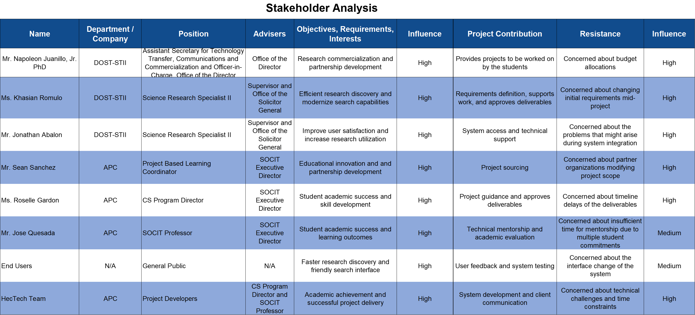

# **OpenProject Activities**

**Budgets**  
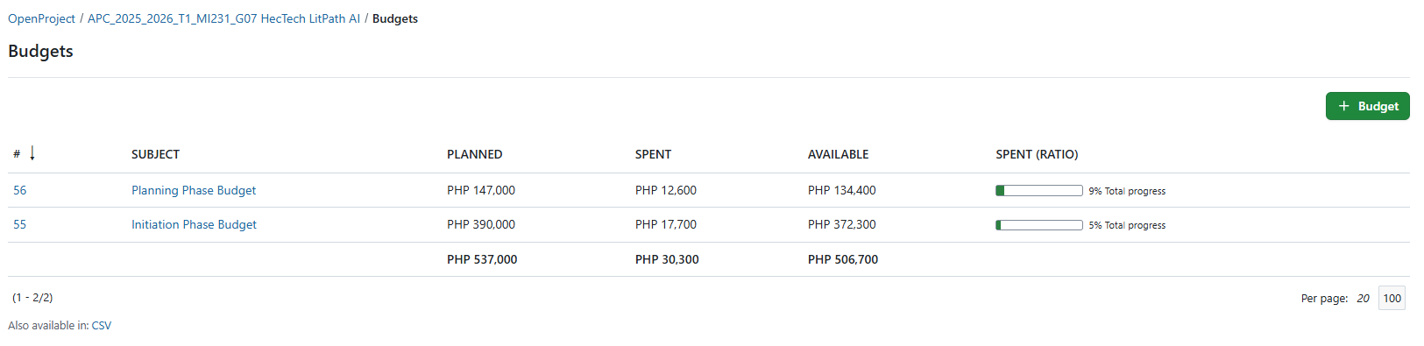

**Roadmap**  
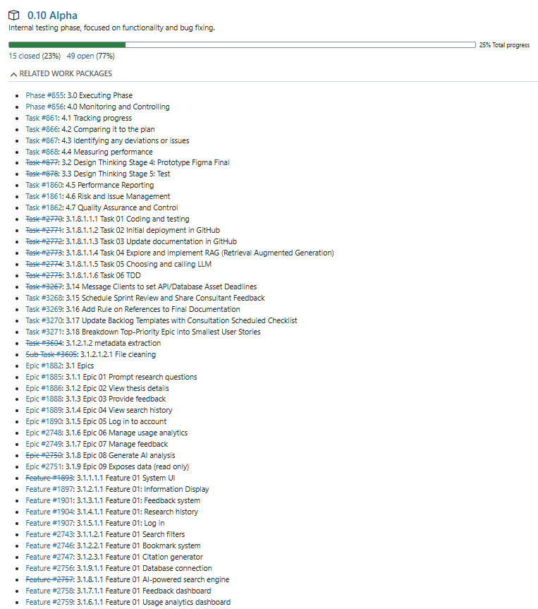

**Work Packages**

***Work Packages by Tracie Tomon***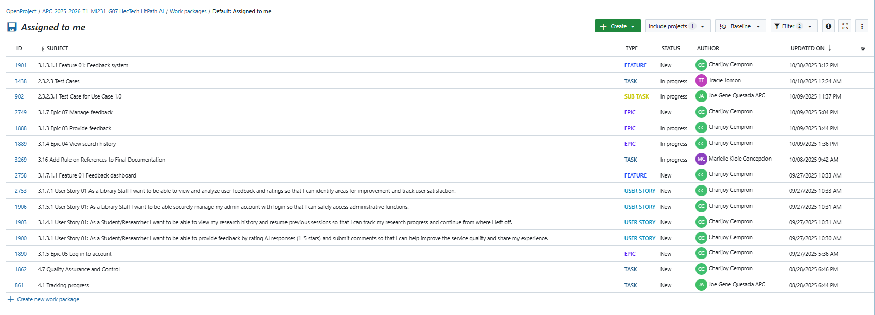

### ***Work Packages by Charijoy Cempron***

### ***Work Packages by Jenine Elaine Dulay***

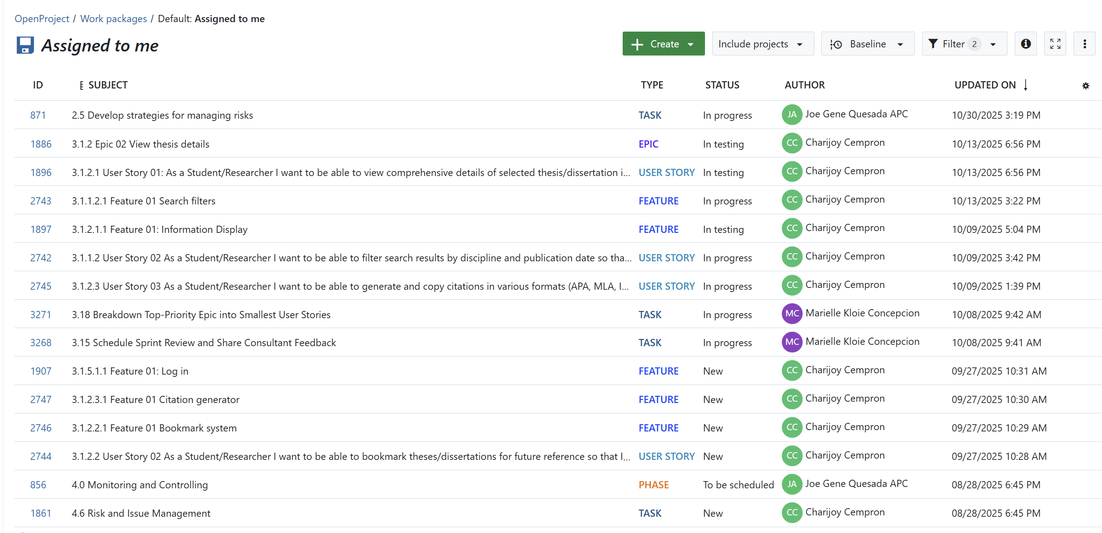

### ***Work Packages by Marielle Kloie Concepcion***

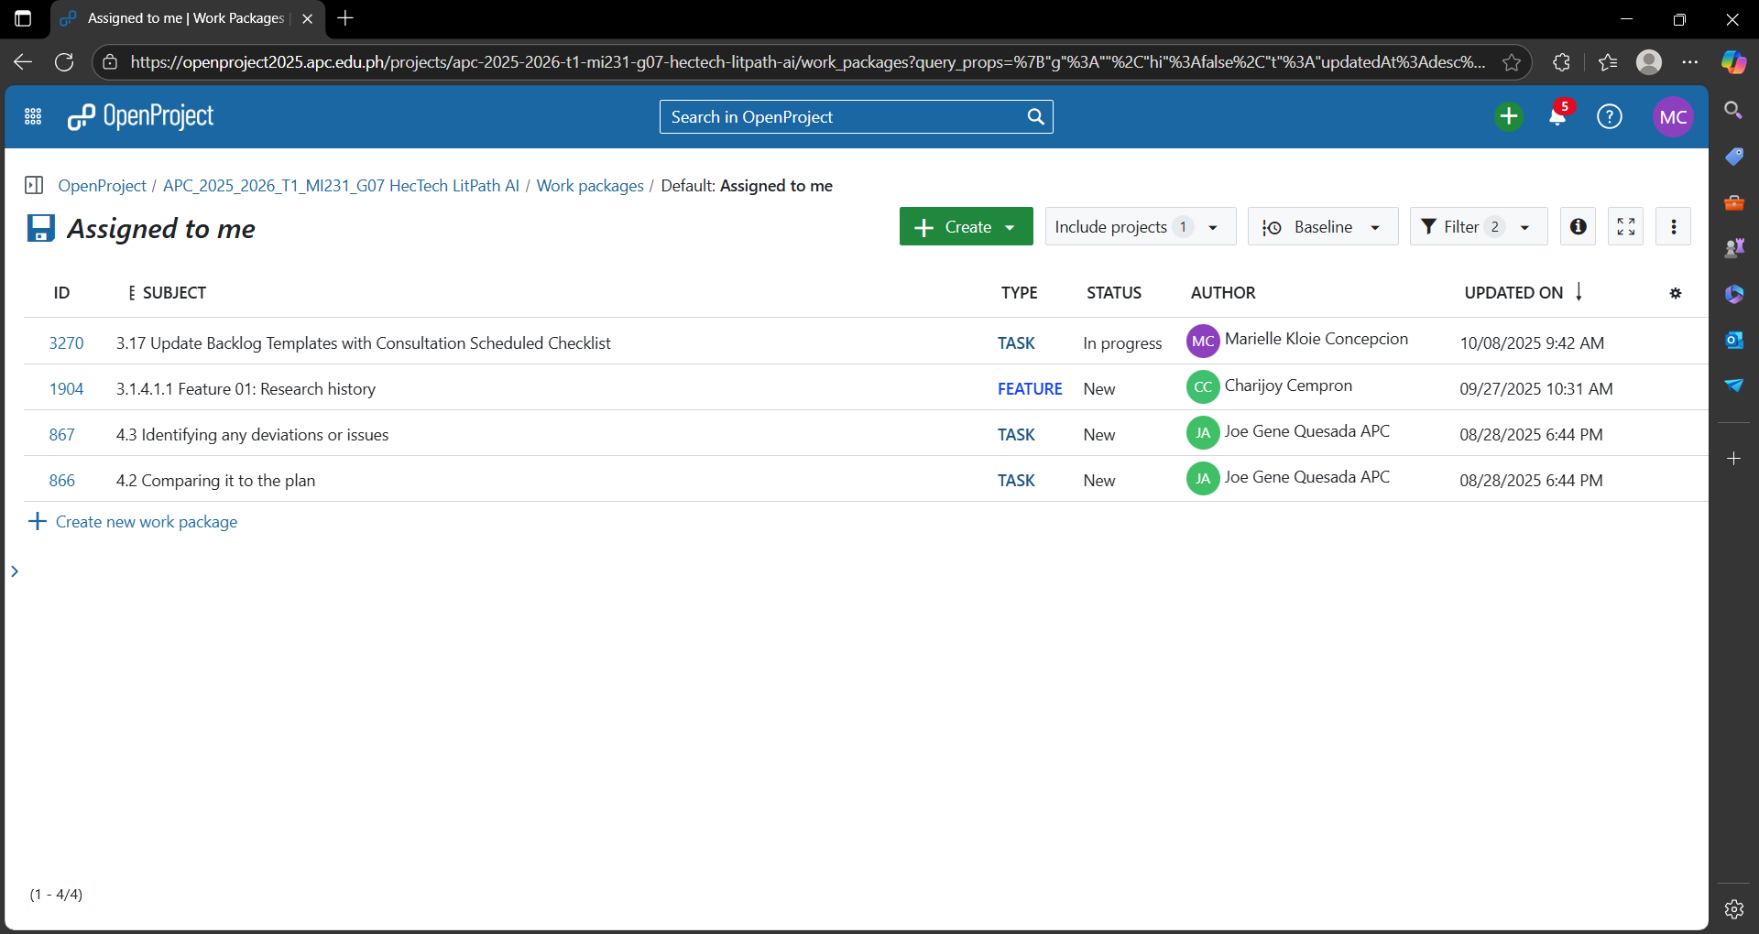

**Backlogs**  
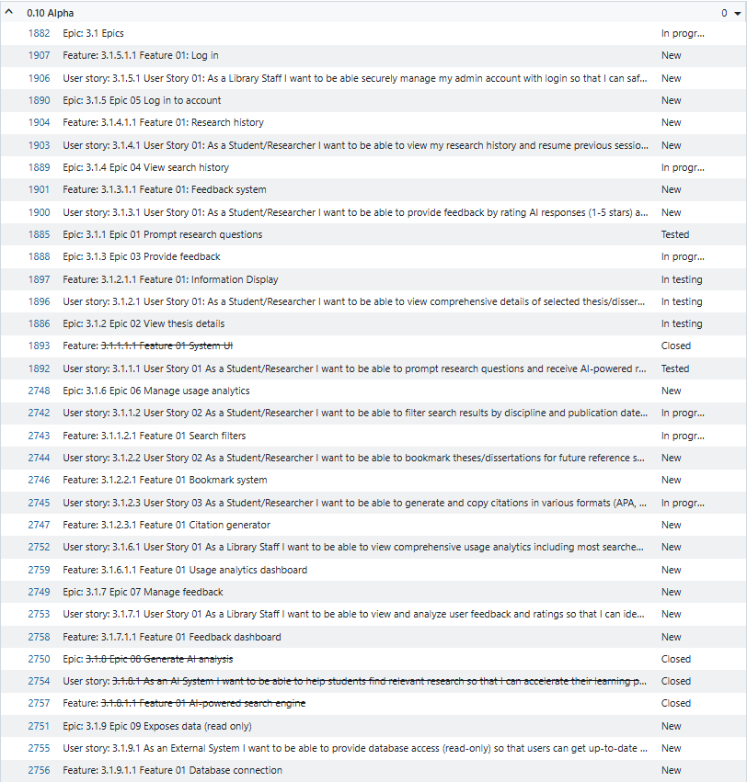

**AY 2025-2026 T1 Sprint 01 Board**  
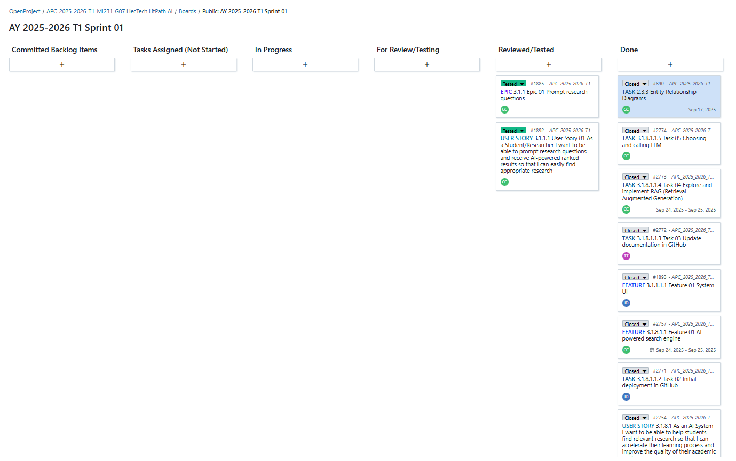

**Gantt Chart**  
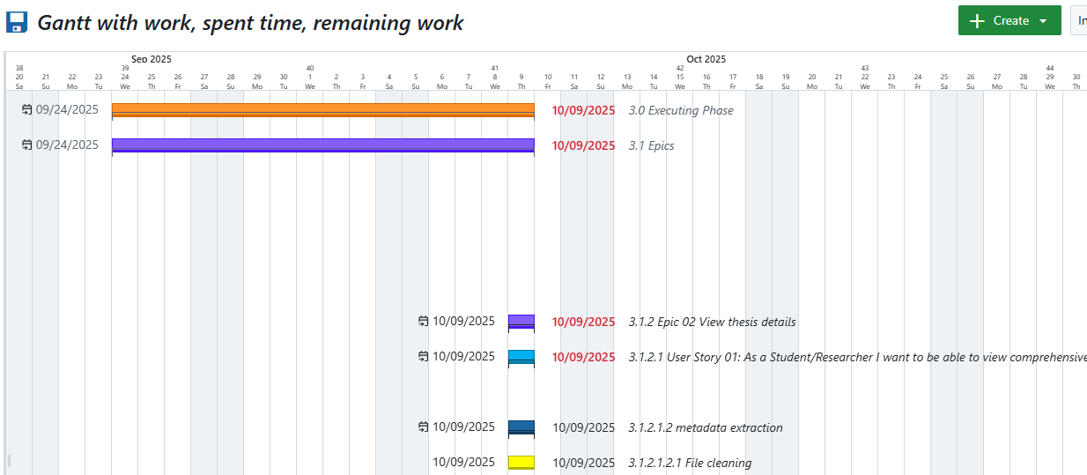

# **Design Thinking output (5 Stages)**

## **Stage 1 – Empathize**

**Introduction**

To build a solution that truly works, we had to start by understanding the people who will use it. The goal of this first stage was to learn about the main challenges and motivations of our client, their employees, and their customers. We made sure to set aside our own opinions to focus only on what we learned from them.

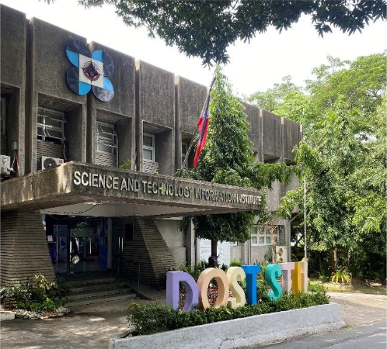

*Figure 1. DOST-STII Library*

Our main approach was talking to people directly. We started by visiting the DOST-STII office to interview our client and one employee in person. This helped us understand their work environment.

Next, we interviewed two customers online using Microsoft Teams to understand their point of view. Using both in-person and online interviews helped us get a complete picture from everyone involved.

After the interviews, we organized all the information we gathered. Our team worked together to create personas, which are simple profiles that represent our client, the employee, and the typical customer.

We also filled out empathy maps to show what users think & feel, hear, see, and say & do. This helped us clearly see what matters most to them, what their biggest frustrations are, and what they need from the service. Everything we learned here will guide the rest of our project.

### **1.1 Client, Employee and Customer Interviews**

#### 1.1.1 Interview with the Client

We interviewed both clients at the same time. One met us in person at the DOST-STII Library, while Mr. Jonathan Abalon joined on Zoom.

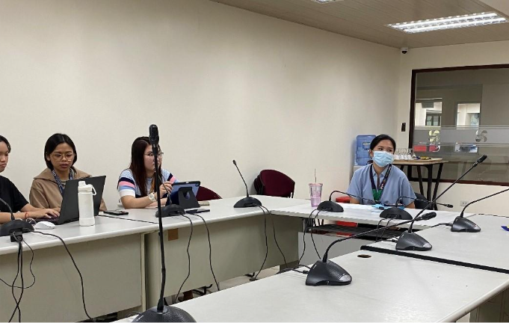

*Figure 2. Interview with Clients*

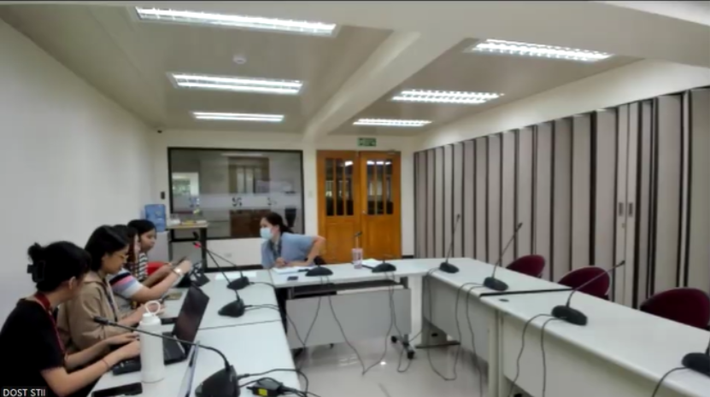

*Figure 3. Interview with Clients (1)*

**Flow of the interview with Ms. Khasian Romulo (08/13/2025)**

|  |  |
| --- | --- |
| **Question** | **Answer** |
| Tell me about your current role and what a typical day looks like | *“Unit head of digital processing and information where we interview outstanding scientists and publish featured articles to encourage the youth in science and propose and develop projects like LithPath AI and sometimes we train people in committee works ganyan kumbaga we wear too many hats.”* |
| How long have you been in this position and industry? | *“9 years”* |
| What are you your goals in the next 6 months? | *“Finish LithPath AI project and deliverables and the list of thesis/dissertations to be used for the project.”* |
| What's your biggest challenge or frustration at work? | *“Ang bagal ng government minsan mag di-digital kami pero at the end of the process may manual pa din so parang naduduplicate siya and the employees who are hesitant to change.”* |
| Why do you think this problem is occurring right now in your situation? | *“Hindi kasi aligned ang government agencies and the generation gap of the employee but mostly talaga jan misalignment”* |
| Why do you believe these factors contribute to the problem? | *“Ang laki ng trust issues sa technology din minsan like what if mawala sya parang usually mas gusto nila evidence yung traditional even the budget is very limited.”* |
| Why is research discovery important to you? | *“Kailangan may changes na sila parang pag stuck ka kasi sa ngayon lang, wala ka ng progress so you need research to advance in medicine, adapt to emerging technologies, and solve problems or to have opportunities.”* |
| Why do you think knowledge accessibility aren't being addressed in the current system? | *“Nakakasearch naman siya pero kulang lang siguro, kunwari nag eexpect ako ng maraming results, I think may kulang lang sa update ng system na yun and napabayaan din kasi talaga yun, ang tagal bago sya naupdate, super luma pa ng codes na ginamit.”* |
| Why would solving this problem transform your work and the students' experience? | *“Ang goal kasi namin is easier talaga para mabawasan yung burden ng clients looking for answers kapag even samin meron kaming mga points na stuck kami na parang nahihirapan tayo so i-aasses namin kung san may pwedeng bawasan na process tapos i-propose namin so laging ganun continous improvement, enhance experience and lesser time pero you can still get quality service for the students and even our stakeholders.”* |
| When you need to solve a problem, where do you go for information? | *“Depende sa affected problem, pag ka stakeholders, we hold a focused discussion, identify their problems, and assess if may resources kami to solve their problem and if none then we will request funding for project proposals.”* |
| What tools do you use daily for work? | *“Google sheet, google docs, scinet, facebook, canva, grammarly, viber and we have many tools pa.”* |
| How would you know if a solution was working? | *“Bumabalik yung tao actually we receive good feedback and they ask for more yun yung mahirap eh pag gusto nila they ask for more and parang na-unload kami ng isang malaking task yun yung feeling tas dadagdagan ulit kami ng task. Continous problem solving.”* |

#### **1.1.2 Interview with Employee**

We also conducted a face-to-face interview with one of the library's employees who uses the OPAC to help users with their library searches.

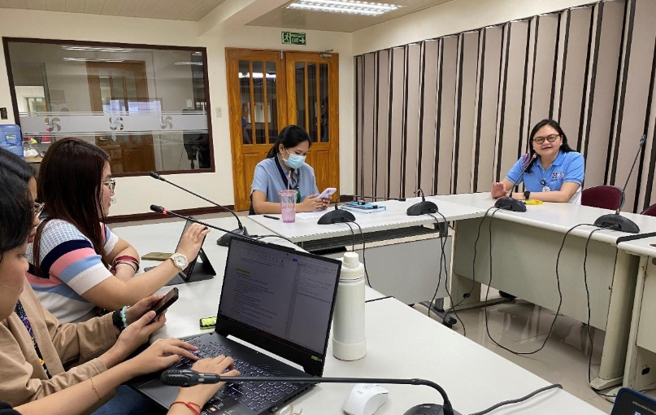

*Figure 4. Face-to-Face Interview with Employee*

**Flow of the interview with Ms. Ronna Mae T. Pamilacan (08/13/2025)**

|  |  |
| --- | --- |
| **Question** | **Answer** |
| What’s your name, age, and role? | *"My name is Ronna Mae T. Pamilakan. I'm 36 years old. Yung role ko sa library, mainly aside from front line, ako yung naghahandle ng social media page ng library."* |
| How long have you been working here? | *"Sa STII? Four years. Four pa lang. 2021. Four years. February."* |
| How did you start working here, and why did you choose this field? | *"So, nag-start ako dito. COS, contract of service. Nagsimula ako as user repair, science research assistant. Yung repair ng mga books for archives, yun. Mainly DOST publications na for archives, COS. And then later, yung opening sa SRS-1, Science Research Specialist 1, nung 2023, June, July 23."* |
| What are your main tasks and responsibilities on a daily and long-term basis? | *"So, yung day-to-day operations ng library, nag-assist ako kapag may events like hybrid seminar, library orientation, and tour. So yun, yung sa front line, nag-ca-cater kami or pinaprovide namin yung may request na resources ng clients online and on-site and inventory. Ayan, yung mga pub mats na pinapost sa FB page ng library."* |
| What do you enjoy most about your work? | *"I enjoy po na hindi lang limited siya, or parang hindi naman siya naka-chain lang sa desk. Maraming variety, maraming klase ng mga ginagawa. So, na-enjoy ko mostly yung pub mats, yung paggawa ng pub mats sa Canva kasi malapit din sa undergrad ko course which is graphics technology."* |
| What parts of your work do you find easiest and most challenging? | *"Easiest, yung pub mats, patuloy ng pub mats sa Canva. And challenging, kasi kapag ano na, yung sabay-sabay na yung mga deadlines, kapag magsama na yung mga core functions and support functions."* |
| Can you describe how you currently assist researchers, students, or other users in finding academic resources? | *"So, pag may mga nag-request na clients online and on-site, nakikita namin yung request nila. Kapag on-site, matatanong kasi namin, mas madali, kasi nandun na rin yung clients. Kung halimbawa, may ganito lang yung available na resources, makapag-search pa kami ng ibang related articles or other online resources. Kapag lima yung nakita nila or napili nila yung book, makakapag-provide pa kami ng mas maraming alternative options.*  *Sa online, may 8 working hours for us to provide yung materials. Kasi nga, hindi lang naman yun din sa material request yung kiniki-ter namin. So may parang manto-allowance sa time. Kung kailangan, kailangan i-provide yung resources. Well, sa on-site kasi, kailangan 5 minutes."* |
| How do you track or respond to inquiries from library users? | *"Yung pag-provide ng material requests. So, may monitoring sheet kami. Google Sheet pa lang yun eh. Pero, since may monitoring sheet kami, nilalagay namin yung logs—kung kailan ni-request ni client, and kailan namin i-provide, tapos ano yung topic.*  *Actually, before pa ng monitoring sheet sa G-Drive Google Sheet, may form pa yung material request slip na pinapafill-up namin kay client, then pinapabalik sa naming para dun may hardcopy request nila sa kailangan yun, iniipon naming yun and then code naming yun sa monitoring sheet."* |
| How often do you interact directly with other library users online and offline? | *"Madalas, kapag open yung library. Kasi ngayon, ano yung inventory lang, comprehensive inventory. So ilang months lang ako sa library ngayon. Ah, nitong inventory period, online naman okay pa rin yung service namin.*  *Kaya lang, nitong ito yung first, sem. Since ako yung nagha-handle ng pub mats, parang ako lang yung alternate. Kapag hindi kaya ng dalawang kong kasama, or wala sila, ako yung sumasagot sa online. On-site naman, bukas halimbawa yung library, dati last year, araw-araw yan.*  *May times na wala masyadong clients. Pero may time din na halos puno talaga yung library, wala na silang maupuan. So, madalas."* |
| What common questions or problems do users usually bring to you? | *"Yung material requests lagi. “May material po or resources po ba?”*  *May nagtanong na rin kung nagpa-provide kami na parang makapag-advise sa thesis nila, which hindi kami mandated sa ganun. Kasi syempre, kapag may thesis advisor sila or sa research nila. Kung mapaprovide namin resources or yung referral pag wala talaga yung hinahanap nila dito sa library namin."* |
| How do you assist users who are unfamiliar or are searching for the first time for academic materials? | *"The first-time client, tapos may nirequest siya. Ayun, nilalapitan ko. Minsan naman, sila rin yung nag-approach talaga. Minsan naa-lata ko na matagal sila dun sa may registration, halimbawa, tagal nilang nakatayo. Minsan doon nahihiya silang approach.*  *So, kapag nagtanong naman sila, ina-explain ko kung paano gamitin yung OPAC, tapos kung ano yung mga klase ng materials na makikita dito sa STII Library, na focus siya sa Science and Technology and Innovation. May nagtanong dati tungkol sa wika sa Pilipino, so nire-refer ko siya sa ibang libraries na makakapag-provide resources."* |
| What is the most challenging part of your work when helping users find the information they need? | *"Siguro sabay-sabay din sila, tapos yung paggamit sa online public access catalog, hindi sila familiar kung paano i-search or i-key in yung research nila or yung topic na gusto nilang mahanap. Minsan nilalagay nila buo, kumpletong title, which is wala ka talagang masyadong makikitang results.*  *Unlike kapag iniba mo yung keywords mo, makakapag-search ka na mas maraming results yung lalabas. Tsaka pag sabay-sabay talaga sila. And then, may material requested din kasi. So, pag hindi sila nakakasunod dun sa tamang format, maraming erasures."* |
| How do you handle requests for resources that are not available in your current database or library? | *"So, kapag wala dun sa library namin, nagha-hanap ako ng related online resources. And then pag wala talaga, or mas may mahanap silang resource sa ibang library, ni-rerefer ko sila. And then, sinasabi ko yung contact details. Sine-search ko na rin yung website ng library. Tapos sinasabi ko sa client."* |
| Are there situations where you feel the current system slows down your work or the user’s research process? | *"Ayun, yung nakaka-disload sa akin, doon sa process ng paghanap, kapag may nakita si client sa OPAC na material na nandito sa library namin. However, yung physical material na yun, minsan naka-line up siya for digitization. So, nandito siya sa kabilang room, tapos yung pagkakalagay pa patong-patong na. Hindi siya katulad dun sa library na nakatayo. Minsan nakakatumba yung mga books or references.*  *And also, kapag may mga hindi makitang resources, yung physical hindi makita. Pero yung sa system, nandun. Ito yung mahirap."* |
| What challenges do you face in organizing and updating the library’s digital and physical collections? | *"Dati kase nakaopen shelves kami may ano kami araw-araw may nasheshelved kami na material sa designated area so symepre hindi lang yung ginawa naming kaya, ano, minsan, na hindi siya, tsaka pala si student or si clients, kapag humihiram, hindi niya magbabalik sa tama yung spot kung saan siya dapat. And also, kapag may nagtutour, library tour, hindi maiwasan kasi na siyempre magsi-stop over dun sa General Reference or sa Filipiniana. So, nakakahugot sila ng material ng libro. Tapos, syempre, sa gulat ng basa, hindi nila naalala kung saan talaga yung lalagay. Pinapamisan, pinapatalagay na lang din namin sa itaas ng shelves tapos kami na lang magbabalik. So, may time talaga na kukuha siya ng 3 hours. One day, 3 hours lang para i-determine yung material sa tamang lugar."* |
| How about sa digital database? | *"Digital database, kapag may hinahanap nila, one naka lang siya. Hindi siya downloadable. Sa may nakita nga kanina, ano, yung alternative na resources online kaya hindi siya downloadable. May kailangang subscription."* |
| What are your thoughts on using AI tools to help users search and interact with academic resources? | *"It will be a lot helpful talaga. Lalo na sa yung pagse-search ni client. Mas makapadali talaga kung may AI. Saka, dapat mag-adapt na rin tayo."* |
| How do you think an AI-powered platform could make your work easier? | *"Makapag-search. Tsaka ano din, halimbawa, yung may binigay na title si client dun sa business status niya. Tapos, doon and there, medyo limitado lang kasi din. Minsan, nababox na rin talaga yung isip ni client—kahit ako rin eh—dun sa title. May limitado lang ako na pwedeng i-… Or yung pag na-reword mo yung topic niya. Kasi ayun, mas makapag-proof siya ng most likely na tamang keyword, tapos mas malapit or related na resources yung lalabas."* |
| What specific features would you like to see in an AI-assisted research platform? | *"Mabilis ma-search tsaka yung lalabas na results mas malapit dun sa ano talaga, topic na desire nito.*  *Yung parang, siyempre, kailangan mo ma-provide agad yung materials ni client. So, parang hindi ka na rin gumugol ng marami pang oras mag-search, tapos pag binasa mo, ay hindi pa pala ‘to."* |
| If you could change one thing about the way the library system works right now, what would it be and why? | *"I don't know if you will not watch this. Mas madali yung ma-search. Tapos, in ano rin, siguro dun sa part naman din ng design na mas ma-appreciate ni client. Parang halimbawa, how Spotify or Netflix works—ma-visual dun kasi, lalo na kapag sa mga students. Mas ma-appreciate nila. Tsaka siguro mas madali nilang mag-grasp or maintindihan kagad na, “Ah, ito yung resource mo.” Hindi pa na pwede. Mas maganda pang ganyan—sounds, movies, movies.*  *Siguro yung mapagsama-sama niya yung relative. Alam mo, kapag sa DOST, marami kasing agencies eh. Parang ganun, malalaman ng students kung ano kagad yung dapat nilang puntahan na office or i-contact na office. Nakakapag-example pala, yung sa mga testing, IPDI pala, DOSN pala. Although may nagtatanong naman sa amin, may nag-i-inquire. Ay, ano, compatible din yun kasi i-route namin. Ganito ang mga best things that were used."* |
| Do you think the new methodologies through technology can improve your current system and attract more researchers/library users? Can you share your thoughts? | *"Yung pag may new system na may na-indicate sa’yo with AI, hindi naman. Kasi mas mabilis. Tapos, in a way na mas ma-appreciate ni client. Painting din lang niya. Mas makaka-attract talaga din ang clients kasi ease of doing things din."* |
| How do you see the role of libraries and research assistance evolving in the next 5 years or at least the next few years? Like, what are your plans? | *"Dapat ano lang siya, hindi siya limited sa physical or sa books. Hindi, dapat sa digital na rin. Tsaka, dapat mas ano pa rin eh, mas si library dapat natutulungan niya pa rin yung mga clients na organize yung mga info. Actually, hindi natin problema yung information eh, kasi guarded na nga tayo ng info. The question is, ano yung dapat—yung right information at the right time. Providing right information at the right time when the client needs it.*  *So, dapat, ayun. Kaya doon sa physical labor, kapag mag-aalisan na yung students, yung ma-sense sa lighting or sa aircon—kapag konti na lang yung tao, hindi na yung aircon. Dapat maging hub si library talaga na, aside from learning, dapat may collaboration. Mag-poster siya sa PALSA community."* |
| What is your hope for how AI could impact research accessibility in the Philippines? | *"Saan na yung union? Kailangan tayo na mga Pilipinas, tigay ito natin sa library para mas makapagbigay pa tayo ng mga assistance at resources na much faster and better."* |

#### **1.1.3 Interview with Customer #1**

Since the DOST-STII Library was closed for its inventory, we were unable to interview users in person. Instead, we opted to interview students from nearby universities online via MS Teams, one of whom had even completed an immersion program there.

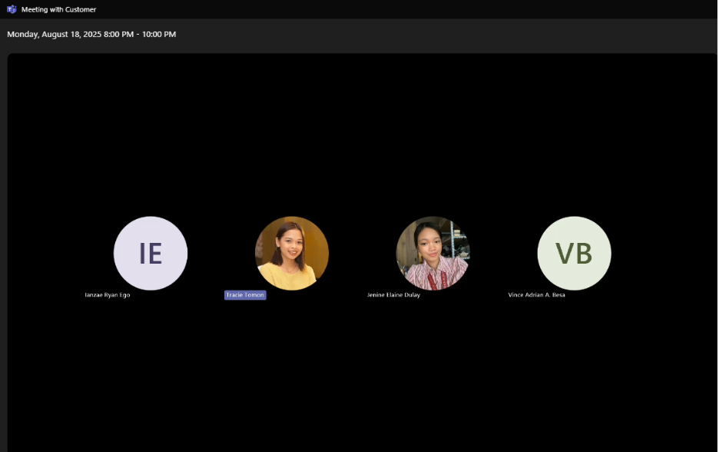

*Figure 5. Interview with Customers*

**Flow of the interview with Mr. Ianzae Ryan Ego (08/18/2025)**

|  |  |
| --- | --- |
| **Question** | **Answer** |
| To start, could you tell me a bit about your professional or academic background? (Name, age, education). | *“Hi, good evening. My name is Ianzae Ryan Ego, 20, currently studying at the Technological University of the Philippines – Taguig Campus, taking up BSIT.”* |
| Roughly how often do you find yourself using the DOST-STII OPAC? And what's your main goal when you do? | *“As much as I used the Google Scholar, I think pwedeng mabenefit rin sa paggamit nito. Usually sa amin rin kasi, sa department ng IT, meron rin kasing ginagawa na ganitong website which is taga archive ng mga different kinds of research and theses na ginawa ng ano natin. So as for me, ito yung pwede kong makuhanan ng mga research material and sources especially mga results na pwede makapag-verify ng mga kailangang makuhang results sa amin, like maverify kung tamang results ba ung nakuha namin or ito ba yung tamang solution na gagawin namin.”* |
| What types of materials from the OPAC are most essential for your work? | *“Yung mga typical na pwede kong makitang materials na pwedeng magbenefit sa student, yung mga research material lalo na yung mga sources, for me, na nakalagay dito sa mga types dito sa website na pwedeng magbenefit sakin lalo na sa paggawa ng capstone, research and mga thesis na need naming gawin as a student.”* |
| What are some of the exact words or phrases you've typed into the search bar recently? | *“Nakabase ako kung ano yung mga given na searches, yung mga available like nong una sa material types, sa may theses and dissertations, ito yong mga una kong sinearch and other fields of research and location. Mostly, naoverwhelm ako sa mga other choices na mga availability ng mga choices sa OPAC. Usually kasi sa mga ganito may mga categories sila na naka-arrange. Nakaka-overwhelm sya, lalo na sa locations.”* |
| How do you keep track of the materials you want to find in the library? Do you use a specific tool or method? | *“Ginagawa ko yong pagdownload kung available. Dinodownload ko sya then sinesave sa specific folder. Pero pag back up, minsan nilalagay ko sya sa hard drive para mas masecure yong gagamitin na materials. And binobooknark ko rin para mas madali kong makita.”* |
| When you're looking at a page of search results, what information stands out to you visually? What do you notice first? | *“Nakadeck lang sya, hindi kita yong text pero okay naman sakin yong nakikita na source, quick view and full catalog. Ang problema ko lang sa search results, yong color theme nya, mahirap makita yong mga text. Pwedeng idagdag yong light and dark mode.”* |
| What other websites, apps, or documents do you typically have open on your screen while you are using the OPAC? | *“Nakaopen yung sites ng Google scholar, other libraries for research, AIs like ChatGPT para mas maverify ko yong legitimacy, Grammarly for re-wording sa mga sentences and grammars, YouTube for music para di mapagod habang nagbabasa ng research.”* |
| Where are you physically located when you usually access the OPAC? (ex. at a library computer, on your laptop at home, on your phone while commuting?) | *“Laptop at home”* |
| What do you see when you look at other universities or institutional library websites? What do their search pages look like? | *“Mostly pag nilagay mo na yong keyword or key topic ng research, makikita mo na yong mga related topic, researches na previously nang nagawa sa topic. Pwedeng i-categorize and i-archive yong mga topics.”* |
| Have you seen any posters, announcements, or online posts from the library about its digital resources? | *“Wala naman masyadong nakikita na mga post. Pero sa university library namin, meron silang announcements regarding sa mga available or mga new na nakaarchive na research and previous theses.”* |
| Let’s try to visualize it. If your classmates knew about it, what would they usually say about the OPAC of DOST? | *“Magugulat sila na may ganito rin pala na inooffer ang DOST na website na research library.”* |
| Have you overheard anyone talking about a different tool or website they prefer for research? | *“Kumukuha ng mga ideas sa AI, other websites like Google Scholar at university library, GitHub for coding.”* |
| What do you hear in the news or online about the future of libraries and digital research? | *“As an IT student, mostly connected sya sa mga AI. Mostly connected sya sa pag use ng AI, lalo na sa pagguide at pagkuha ng mga available research materials na pwede mong makuha don sa mga libraries. Gumamit sila ng AI para matulungan nila yong user na hindi masyadong mahirapan lalo na sa pagsearch. Pwede ring gumawa yong AI ng specific prompt para mas maayos yong makuha mong results.”* |
|  |  |
| What's going through your mind when a search returns many more results than you expected? What about when it returns zero results? | *“Tinatry kong kunin yong mas updated na date sa research if maraming results. If ever zero results, tinatry kong i-change yong topic or other topic na pwedeng connected sa topic ko para meron pa ring results. Last resort is gumamit ng AI para makahanap ng research materials.”* |
| How confident do you feel that the search results are showing you the most relevant materials available? | *“Kung maraming search results na related sa makukuha kong topic kasi marami akong makukuhanan na materials at references.”* |
| What are your expectations before you begin a search session on the OPAC? | *“Mabibigay nya yong recently updated research catalog, free yong material para maview and madaling ma-reference yong material. Madaling mabasa yong binibigay na output like letters, titles, and year of publication na connected sa research ko.”* |
| What's the best part of the research process for you? When do you feel most successful? | *“Availability of categorized material type and don’t have to go through manually searching like in Google Scholar.* |
| What are the most difficult parts of your current search workflow? | *“Searching for related topic for research, giving the undesired results and outdated materials, di makita yong pinakarecent na research, wala masyadong nagreresearch kaya outdated yong binibigay na output.”* |
| Are there any tasks in your search process that you feel are boring or hard to navigate? | *“Slow loading time of materials or to provide search results”* |
| Can you describe a time when you felt like you were wasting time trying to find a piece of information? What was happening? | *“Nag-eerror yong code at di namin makita sa kahit anong research kung paano isosolve”* |
| What prevents you from finding what you need quickly and efficiently? | *“Slow network connection at compliance sa kagrupo, ikaw lang gumagawa sa documentation or sa research. Magkakaiba at magkakalayo yong ideas sa need ng research.”* |
| What would an ideal search experience look like for you? | *“When searching for the topic or title, it will provide the most updated research, articles na pwedeng makuha for free, no need to pay for further access.”* |
| What kind of tools or features would make your search process "easier and faster"? | *“Integration of AI with reliable answers for faster results, feature of proof reading and legitimacy of the resources, and availability.”* |
| What would make you feel happy and satisfied with a research tool website? | *“When searching for the topic or title, it will provide the most updated research, articles na pwedeng ma-access for free.”* |

#### **1.1.4 Interview with Customer #2**

Mr. Besa, whom we interviewed online at the same time as Mr. Ego, had completed his immersion at the DOST-STII Library, making his experience with the OPAC particularly helpful.



*Figure 6. Interview with Customers (1)*

**Flow of the interview with Mr. Vince Adrian A. Besa (08/18/2025)**

|  |  |
| --- | --- |
| **Question** | **Answer** |
| To start, could you tell me a bit about your professional or academic background? (Name, age, education). | *“Good evening, everyone. I am Vince Adrian A. Besa, 20 years old. I am an incoming 3rd-year student at the Polytechnic University of the Philippines, Taguig, currently taking BSIT.”* |
| Roughly how often do you find yourself using the DOST-STII OPAC? And what's your main goal when you do? | *“I think etong website has a lot of potential talaga sya na makatulong sa akin, especially sa atin mga students. Masasabi ko lang sa website, parang marami pa siyang kulang na pwede pang dapat gawin o i-improve. Kanina nung tinry kong mag-search dito ng mga researches or articles, nasa loading animation pa lang ako. I think medyo kailangan pa ng improvement. Nagtry ulit ako ngayon mag-search ng mga archive researches, books, or articles, at nagtry ako sa desktop — may lumabas naman na results.”* |
| What types of materials from the OPAC are most essential for your work/course? | *“I think yung mga essential talaga rito sa OPAC is yung mga materials na academic-related, which is a great help for us, especially sa mga students, to help us in our researches or whether we are pursuing something academically related.”* |
| Walk me through the last time you used the DOST-STII OPAC, starting from how you opened the website. What were the first few things you did? | *“Dito marami na akong nakikitang mga problem o kailangan pang gawan ng improvement. So tulad lang din ni Mr. Ego na ginawa niya kanina, inexpolore ko lang tong website: yung FAQs, yung About tab, and then yung OPAC. Sa OPAC, tulad nga rin ng na-experience ni Mr. Ego kanina, na-stuck lang ako sa loading animation ng website. Nanotice ko rin na yung website is not secure. So, I think di pa siya fully nadedeploy o developed. Dito sa kulay ng tab sa OPAC, ganon, siguro medyo dapat i-darken pa ng konti. Then dito sa search button sa OPAC, parang di siya uniform sa theme ng DOST.”* |
| What are some of the exact words or phrases you've typed into the search bar recently? | *“Napansin ko lang dito kanina sa OPAC, pag dinefault mo lang yung mga subjects, etc., nagsstuck siya sa loading animation niya kanina. Then pag nagspecify ako, let's say, cinlick ko dito "theses and dissertations," and yung field, "all fields," then sa location, "all locations," may lumalabas naman na results. I think yung website, tulad kay Mr. Ego, na-o-overwhelm ako since andaming researches o articles na hindi ako familiar masyado. Kung first time ko gagamitin, parang mahihirapan akong i-navigate tong website na ito. Since hindi ba siya ganon ka-user-friendly, dito sa OPAC, pag lumabas yung search results, wala siyang back button para sa OPAC page o section ng website.”* |
| When you find a promising resource in the search results, what is your immediate next step? | *“Usually, when making a research and I find a promising resource, let's say Google Scholar, inoopen ko yung site na yon o research na yun, then cinocopy ko yung link niya, then issave ko sa notes ko. So, whenever gusto ko tignan o basahin yung article na yun, pwede ko siya makita agad.”* |
| How do you keep track of the materials you want to find in the library? Do you use a specific tool or method? | *“Usually yung mga nahahanap kong research sa internet, kung available, dinodownload ko sila, then sinasave ko sa isang folder na madaling makita. Let's say, pangalanan natin yung folder ng "researches" or "studies," then dun ko sila ilalagay lahat.”* |
| When you're looking at a page of search results, what information stands out to you visually? What do you notice first? | *“Yung mga una kong nanotice is yung types of material nila, then yung title ng study, then yung quick view, and then full catalog.”* |
| What other websites, apps, or documents do you typically have open on your screen while using the OPAC? | *“For me naman, yung mga naka-open na tab sa akin when making research or writing a research: syempre una-una is Facebook para makacommunicate sa mga classmates o groupmates. Naka-open din yung Google Scholar ko to find resources and more for references. Yung mga naka-open din na iba kong tab is yung AI, such as ChatGPT, Claude, and many more. Naka-open rin yung tab kong Google Docs para dun ko ilalagay yung mga words o phrases, or kung ano nakuha sa information sa study na ito. Gumagamit rin ako ng mga paraphrasing tools like QuillBot — malaking help talaga siya sa pag-fix ng grammar ko at paraphrase.”* |
| Where are you physically located when you usually access the OPAC? | *“Laptop at home”* |
| What do you see when you look at other university or institutional library websites? What do their search pages look like? | *“Yung mga napansin ko sa ibang university sites tulad ng OPAC, yung search bar nila, pwede mong ilagay yung title ng research mo, then lalabas yung mga related studies sa ginagawa mong research.”* |
| What do you see when you look at other university or institutional library websites? What do their search pages look like? | *“Yung mga napansin ko sa ibang university sites tulad ng OPAC, yung search bar nila, pwede mong ilagay yung title ng research mo, then lalabas yung mga related studies sa ginagawa mong research.”* |
| Have you seen any posters, announcements, or online posts from the library about its digital resources? | *“Sa university namin, may makikita ka ring mga news o announcements na nakalagay kung ano yung mga latest studies na nakapost din sa website na pwede naming i-view. Pwede mo ring makita yung mga physical materials and studies na ginawa ng past seniors namin sa laboratory namin, which is mga nakahard bind na researches. Pwede mong tignan at basahin, at makakakuha ka ng ideas at references para sa gagawing capstone doon.”* |
| What have you heard from your classmates or friends about their experience with the library's catalog? | *“Sa DOST-STII, familiar ako na may library sila. Dito kami nag-work immersion back when we were Grade 12, then dun ko lang nalaman tong DOST OPAC. Kung tatanungin ko yung mga classmates ko o mga kakilala ko kung familiar sila sa site, I think isasagot nila "no."”* |
| Let’s try to visualize it. If your classmates knew about it, what would they usually say about the OPAC of DOST? | *“They’d be surprised that this kind of site exists, kung saan makakahanap kami ng resources or references para sa mga researches namin.”* |
| Have you overheard anyone talking about a different tool or website they prefer for research? | *“May mga nasabi rin yung classmates ko o past classmates ko tungkol sa mga sites na pwede kaming maghanap ng materials. Sa internet o social media, may mga napapanuod rin ako na may ganitong sites, like science-related or other things. Pero nakalimutan ko na yung sites na yon. Sa part ko naman, usually pag programming-related yung mga tanong o problems ko, gumagamit ako ng AI at Stack Overflow para maghanap ng ideas o solusyon sa problem na na-encounter ko.”* |
| What do you hear in the news or online about the future of libraries and digital research? | *“As an IT student, siguro yung libraries, iba, siguro mas magiging less relevant na sila in the future since mostly, yung mga tao gumagamit na ng AI like ChatGPT, where makukuha natin yung mga sagot o information na gusto nating itanong sa kanila. Since na-train pa nga yung AI, nag-iimprove pa siya at naiimprove, siguro mas magiging accurate yung makukuha nating information in the near future. Magagamit na lang siguro yung ibang researches or studies for citations or references.”* |
| What's going through your mind when a search returns many more results than you expected? What about when it returns zero results? | *“Pag naghahanap ako ng research, studies, or articles, let's say walang results na makita, nilalagay ko na sa search bar yung mga related topics sa topic namin. Kung wala pa rin makitang results, magaask na lang ako kay ChatGPT kung meron man na related sa research or study na ginagawa namin.* |
| How confident do you feel that the search results are showing you the most relevant materials available? | *“Hindi ako ganun ka-confident when finding a material in sites like Google Scholar. Pag naglalagay ako ng topic namin or pag sinesearch namin para makahanap ng related topics, usually yung mga lumalabas is irrelevant and mostly outdated yung mga swak talaga sa research na ginagawa ko.”* |
| What are your expectations before you begin a search session on the OPAC? | *“Hindi ako gaano nage-expect dito sa OPAC, since nasabi nyo na ring kanina na etong website was created back in 2012 or 2010. Hindi naman ako gaanong nage-expect na makukuha yung relevant na information or studies dito since medyo outdated siya.”* |
| What's the best part of the searching process for you? When do you feel most successful? | *“Pinaka fulfilling o pinaka natutuwa ako sa searching process is pag yung sinearch kong topic, yung lumalabas na search results is related sa topic ko, at yung date na ginawa sila is relevant pa, let's say 5 years ago lang sila ginawa o latest. Again, yung search results nya is relevant and related sa research na ginagawa ko.”* |
| What are the most difficult parts of your current research workflow? | *“Pinaka difficult is paggawa ng title na papasa sa adviser o instruction namin, paghahanap ng RRL sa study namin, at pinaka mahirap talaga sa akin is yung pag-analyze at interpret ng data o information na na-gather namin sa respondents o participants para sa study namin.”* |
| Can you describe a time when you felt like you were wasting time trying to find a piece of information? What was happening? | *“Nasasayang ako sa oras pag sa group setting puro plano lang. I think the best solution is mag-take ng action at iplan nang maigi yung mga dapat gawin at i-comply sa week na to at sa susunod na weeks. In that way, may guide kami at may process kami na sinusundan para maging organized.”* |
| Are there any tasks in your research process that you feel are boring or hard to navigate? | *“Yung pinaka boring na tasks is maghanap ng research studies or articles. Let's say sa RRLs, yun talaga yung pinaka boring kasi mahirap talaga maghanap ng mga related studies na tutugma o related sa research na ginagawa namin.”* |
| What prevents you from finding what you need quickly and efficiently? | *“Yung nag-prevent sakin is kapag nag-oopen ako ng nagustuhan kong research, study, or article, yung nakikita ko lang o pwede ko lang basahin sa study na yun is yung abstract, o di ko siya ma-fully open o makita. So ayun talaga yung nag-prevent na makahanap pa ng further information na pwede i-cite o gawing reference sa ginagawa naming research.”* |
| What would an ideal research experience look like for you? | *“Pag nagssearch ako, lalabas na sa pinakatop yung most related na topic sa ginagawa naming research. Another thing is, hindi na natin matatanggi na kailangan nating gumamit ng AI para mas mapabilis yung research. Yun nga lang, pag gumagamit tayo ng AI, dapat nag-proofread tayo at vine-verify kung tama ba o accurate ba yung nakuha nating information at galing talaga siya sa isang research study o article.”* |
| What kind of tools or features would make your research process "easier and faster"? | *“For me, yun nga, para mas mapadali at mas mapabilis, gumagamit talaga ako ng AI para mas mapabilis at mapadali yung ginagawa kong tasks. May mga ginagamit rin akong features and extensions wherein, pag may nakikita akong link o website, may nakalagay dun na icon na nagsasabi na legit and verified tong website na to, at hindi siya threat o nagcocontain ng malware files na mag-a-affect sa device natin.”* |
| What would make you feel happy and satisfied with a research tool website? | *“Siguro yung makakapagsaya sakin o satisfy is yung dapat yung mga studies o information na nakalagay doon is open-source and easy to access para madaling ma-access at madaling makakalat ng information sa ibang students para sa mga ginagawa nating research. Siguro yung magpapasaya rin sakin is yung user-friendly at, again, easy navigation.”* |

### **1.2 5 WHYs (Simplified)**

**Problem 1**: Users feel the current OPAC is not meeting their needs, as they are disappointed by its slow performance, security warnings, and confusing layout.

* Why is the OPAC not meeting their needs?
* Because users today expect technology to be fast, safe, and easy to use, but the OPAC falls short of providing this modern experience.
* Why does it fall short of providing a modern experience?
* Because its underlying technology is outdated. This causes it to be slow, freeze often, and lack up-to-date security, which is why browsers show a "not secure" warning.
* Why is the technology outdated?
* Because the system has not been given any meaningful updates or new features for a very long time.
* Why hasn't it been updated?
* Because there has been no plan or budget set aside to keep the system modern and working properly.
* Why was there no plan or budget for it?
* Because improving the OPAC was not treated as a priority, so no one was put in charge of making sure it was taken care of.

**Root Cause:** The main problem is that the OPAC was not considered an important priority. This lack of focus meant it never received the planning, funding, or attention needed to keep it up to date. As a result, it can no longer meet the basic needs and expectations of today's users.

**Problem 2**: The library staff knows the OPAC is old and needs to be fixed, but slow government rules and complicated procedures stop them from making real progress.

* Why do the rules stop them?
* Because different government offices don't work together well. Their rules don't match, which turns a simple technology upgrade into a paperwork burden.
* Why don't the offices work together?
* Because even if the library goes digital, they still have to print everything out for other offices. This doubles the work and makes employees feel like new technology is pointless.
* Why do employees feel new technology is pointless?
* Because they already don't trust computers that much. They worry that digital files might get deleted and feel safer with real paper copies. When a "digital" process still requires paper, it just proves their fears are right.
* Why does this fear of computers persist?
* Because there's not enough money to do a full, proper upgrade. They can only afford to fix small parts at a time, which never solves the whole problem and doesn't build anyone's confidence in new technology.
* Why isn't there enough money?
* Because in the big government system, the library's search tool is easily forgotten or ignored. Bigger projects almost always get the money first, leaving the OPAC with very little.

**Root Cause**: The primary issue is that the library is currently hindered by complex governmental procedures and administrative requirements. Due to limited inter-agency coordination and ongoing budget constraints, it has been unable to carry out the major upgrades needed for modernization. As a result, staff are forced to rely on outdated systems, which limits users' ability to conduct effective research.

This project addresses the issue by taking an alternative approach to existing government procedures. Instead of pursuing a full-scale replacement of the legacy system, a separate search tool has been developed for key research needs. This targeted solution is smaller in scope, more manageable, and allows us to deliver fast, meaningful results directly to users. By demonstrating success in this key area, we not only provide immediate value but also build trust in modern technology. This success story will help reduce resistance to change and create momentum for broader improvements in the future. We are delivering practical benefits today while laying the foundation for transformative upgrades tomorrow.

### **1.3 Personas**

#### **1.3.1 Client Persona**

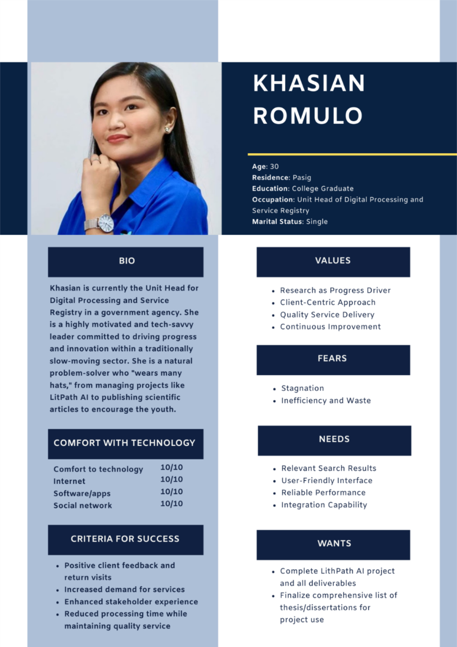

*Figure 7. Client Persona*

#### **1.3.2 Employee Persona**

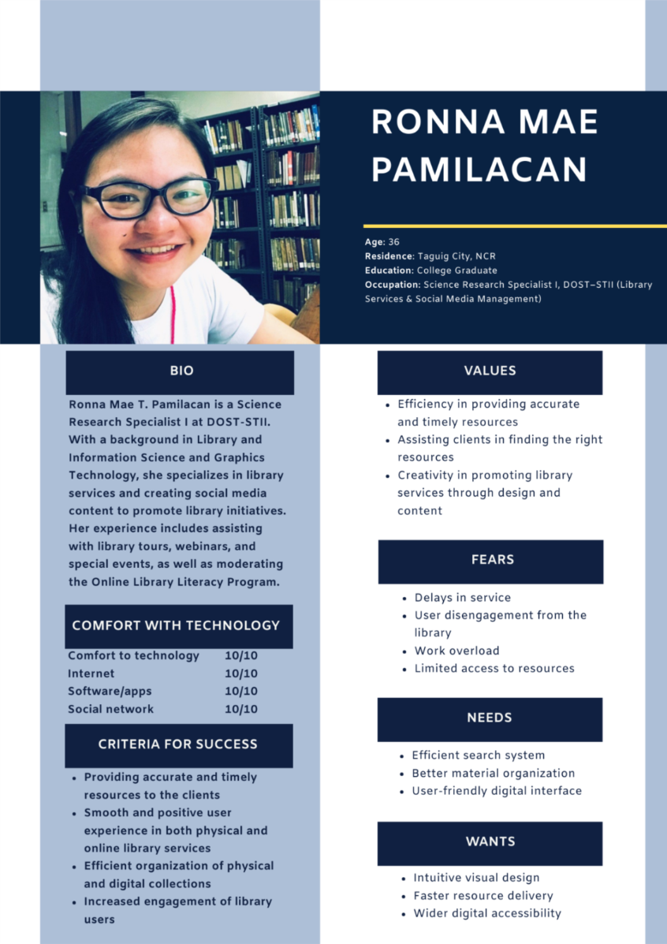

*Figure 8. Employee Persona*

#### **1.3.3 Customer #1 Persona**

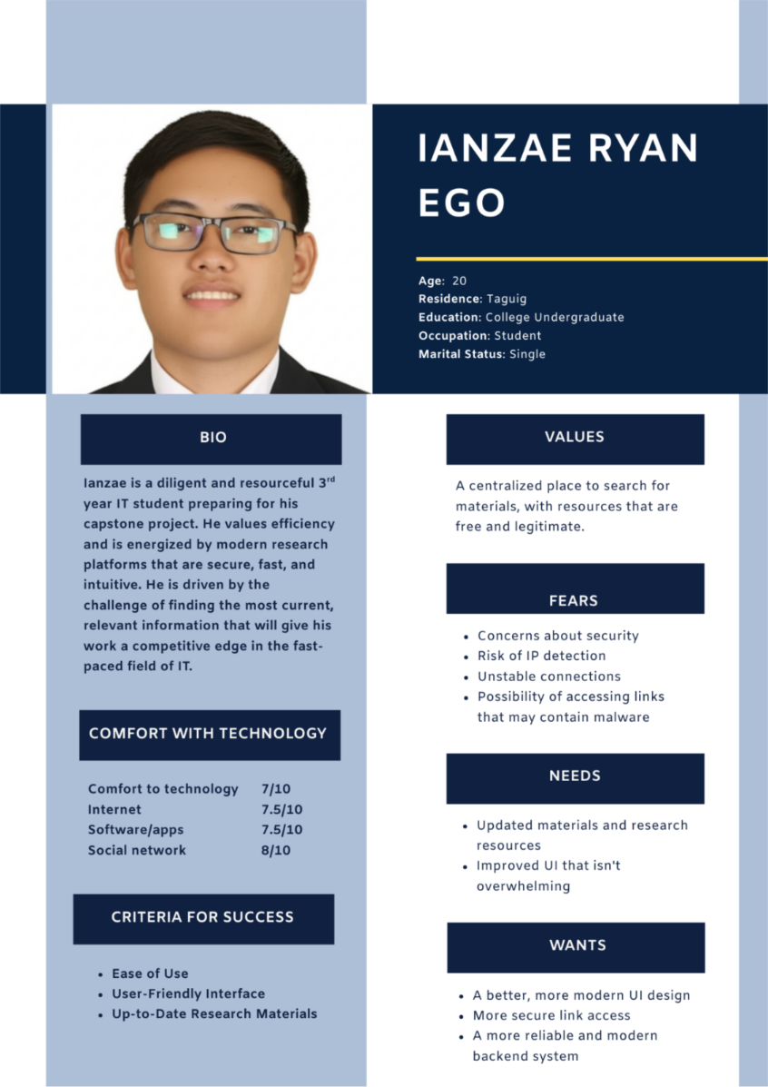

*Figure 9. Customer #1 Persona*

#### **1.3.4 Customer #2 Persona**

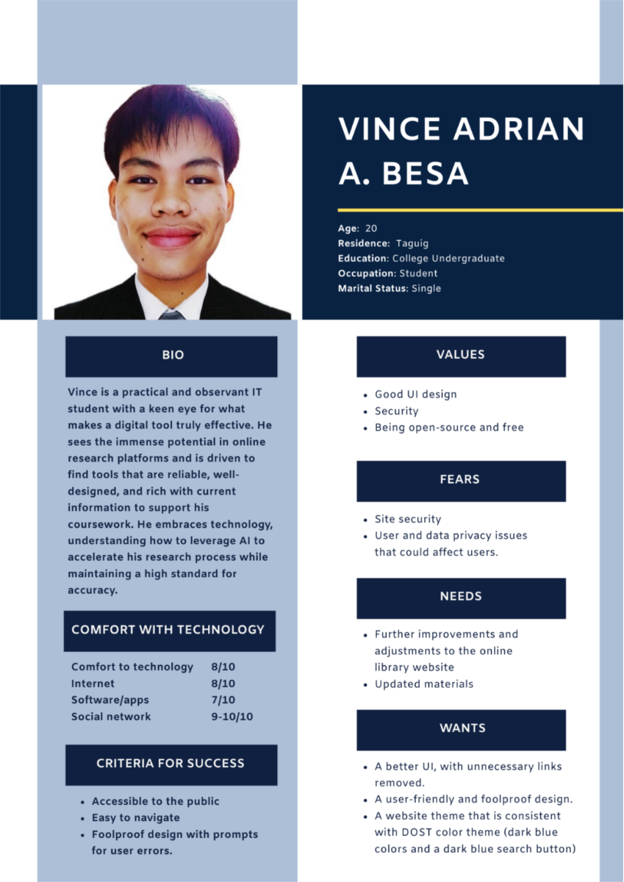

*Figure 10. Customer #2 Persona*

### **1.4 Empathy Map**

**1.4.1 Client Empathy Map**

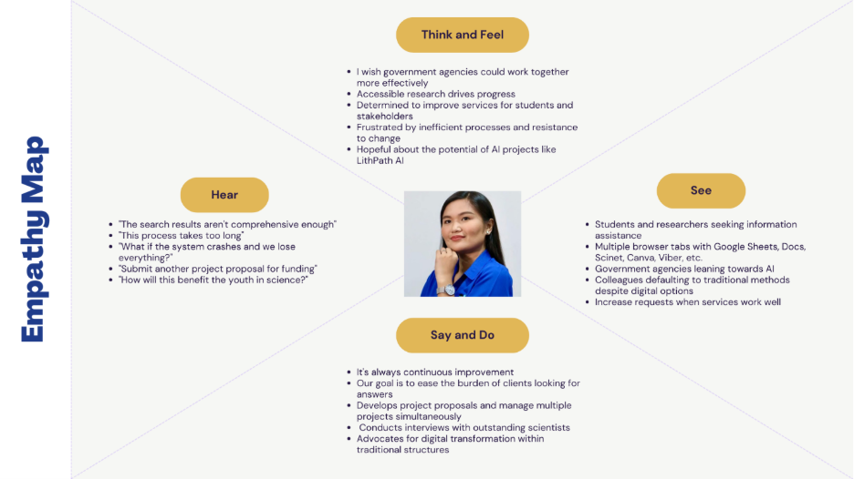

*Figure 11. Client Empathy Map*

|  |  |
| --- | --- |
| **PAIN** | **GAIN** |
| Budget constraints  Limited search results  Coordination and workforce alignment challenges  Outdated system | Efficient Processes  Quality Service Delivery  Successful Projects  Comprehensive search results |

#### **1.4.2 Employee Empathy Map**

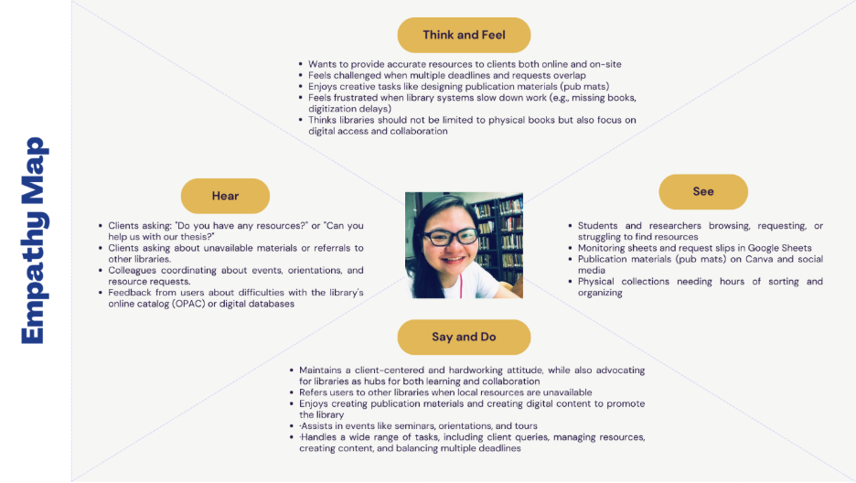

*Figure 12. Employee Empathy Map*

|  |  |
| --- | --- |
| **PAIN** | **GAIN** |
| Overlapping deadlines and workload  Time-consuming search and re-shelving process in inventory  Limited access to digital databases  OPAC search difficulties | Efficient client service  Opportunities for digital transformation and system improvements  Ability to provide alternative resources  Libraries as digital hubs |

#### **1.4.3 Customer #1 Empathy Map**

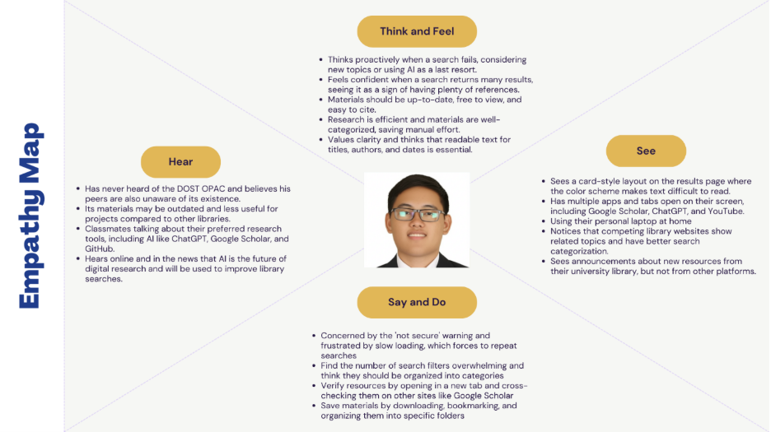

*Figure 13. Customer #1 Empathy Map*

|  |  |
| --- | --- |
| **PAIN** | **GAIN** |
| Irrelevant/outdated results  Slow loading times  Unsolvable problems  Poor connectivity  Difficulty collaborating on group searches | Updated and relevant content  High resource availability  Efficient processes  AI-powered search  Free and easy to access |

#### **1.4.4 Customer #2 Empathy Map**

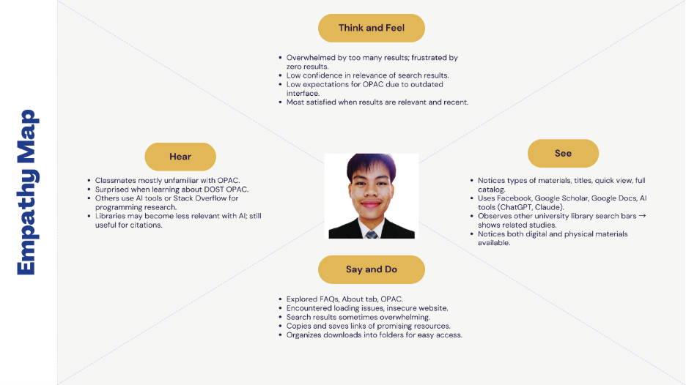

*Figure 14. Customer #2 Empathy Map*

|  |  |
| --- | --- |
| **PAIN** | **GAIN** |
| Website is not secure  Hard to find and access RRLs (only abstracts available)  Hard to navigate  Slow, outdated, and sometimes unreliable system | Open-access studies and reliable references  AI-assisted search for faster results  Tools for better organization  Extensions/features to verify credibility  User-friendly and simple interface |

### **1.5 Pain-Gain Analysis Summary**

|  |  |  |
| --- | --- | --- |
| **PAIN** | **GAIN** | **ANALYSIS** |
| * Hard to find the relevant results because of limited search options * Slow, outdated system with security warnings that reduces trust * System sometimes down and searching take too long * Confusing design and filters make the site difficult to use * Library resources are not fully used because of system issues | * Wants reliable, up-to-date research materials * Hopes for a faster and easier search experience * Looks for modern features clean design * Needs free, accessible, and easy-to-cite resources | * Build a fast, secure, and reliable platform that users and staff can trust * Create a smarter search that delivers accurate, recent, and relevant results * Enhance efficiency with features that save time and reduce manual work for everyone * Design a modern, easy-to-use interface that is credible and familiar |

## **Stage 2 – Define**

In the Define stage, the second step in our design thinking process, our focus was to analyze and narrow down our research findings to frame a central problem statement. Building on the interviews from the Empathize stage, we first listed all the challenges and pain points mentioned by our clients, employees, and customers.

Our team used Trello to manage this information, creating lists of all identified issues. By grouping these points into specific categories, we were able to better organize and understand the data. This process of synthesizing our observations was essential for pinpointing the exact problem our team would aim to solve.

### **2.1 Clustered Problems**

After identifying the initial problems, our team analyzed them to find common concept. This process led us to establish three distinct categories to group the issues: Usability and Performance, Search Results, and Competition from Modern Tools. Using our Trello board, we then organized each problem into its corresponding category to create a structured overview of the core challenges.

**Usability and Performance**

* The user interface is outdated and difficult to use
* The platform's search filters don't offer enough useful options
* Slow loading times lead to user frustration
* Security warnings on the website cause users to lose trust
* System slowdowns make it hard for staff to help users
* Frequent downtime makes the system unstable

**Search Results**

* Search results don’t always match what users need
* Too many results make it hard to find what’s relevant
* Users doubt the timeliness of the information
* Users must check the search results one-by-one to pick out the few that are useful for their research
* Students struggle to find recent and easy-to-cite sources

**DOST OPAC vs. Modern Research Tools**

* The current system does not meet modern user expectations
* Users prefer AI-powered tools over the current platform
* Other library websites have better design and are easier to use
* Limited filters make it hard to narrow down search results
* Missing built-in tools, such as an automatic citation generator

**Clustered Problem in Trello Board**

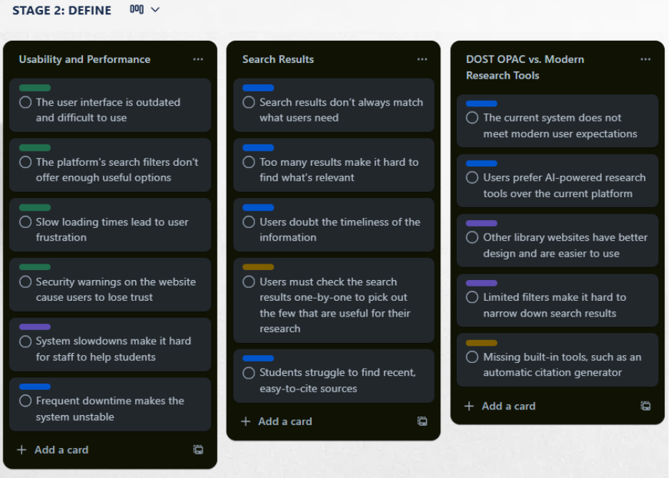

*Figure 15. Clustered Problems in Trello board*

### **2.2 Problem Statement**

After reviewing each cluster of problems, our team combined the main issues into the following clear problem statements:

1. The system is slow, with searches taking over a minute, which frustrates users and wastes time.
2. Technical issues, such as downtime or security warnings, reduce trust and make it harder for staff to assist users.
3. The search function often gives too many or less relevant results, making it hard for users to find accurate and updated sources.
4. The platform’s design is confusing and hard to use, unlike modern user-friendly websites.
5. The system is missing important features like advanced filters, AI-powered suggestions, and automatic citation tools.

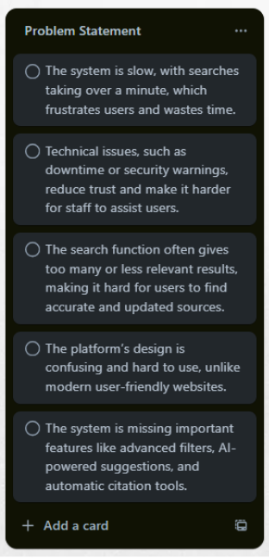

*Figure 16. Problem Statements in Trello board*

### **2.3 How-Might-We**

After finalizing our problem statements, we created “How Might We” (HMW) questions to turn those challenges into opportunities. These open-ended questions are designed to spark a wide range of ideas during our brainstorming sessions. This method keeps our focus on the user needs while encouraging creative and practical solutions.

Here are the How Might We questions our team developed:

1. How might we redesign the platform to be simpler, modern, and better fit users’ needs?
2. How might we rethink the search process so users can easily find relevant and reliable information?
3. How might we reimagine the system’s foundation to make it faster, more stable, and secure?
4. How might we redesign the platform to work well with AI tools for smarter research?
5. How might we rethink ways to reduce employees’ workload?
6. How might we rethink the user experience to improve usability and satisfaction?

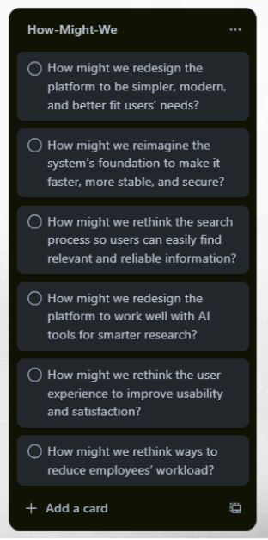

*Figure 17. How-Might-We in Trello board*

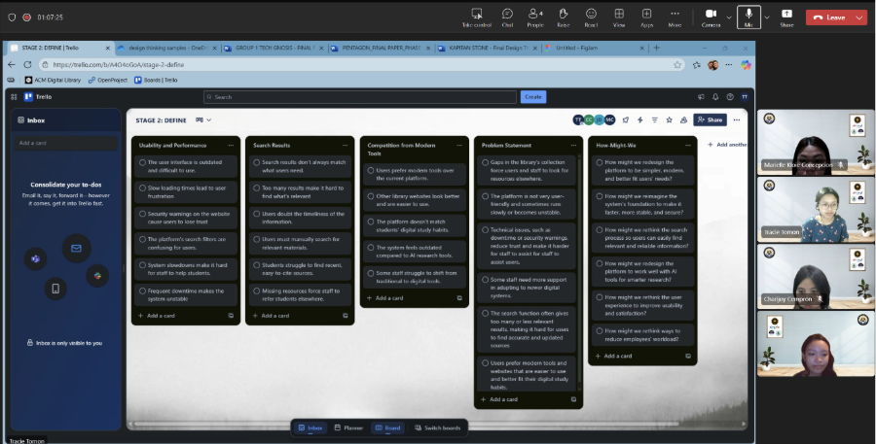

*Figure 18. Collaborative "Define" Stage of Design Thinking using a Trello Board*

**Conclusion**

The Define stage was a key step that helped us turn our research into a clear goal. We analyzed all the feedback from our interviews and grouped the issues into three main categories: Usability and Performance, Search Results, and Competition from Modern Tools. This process allowed us to write focused problem statements, which we then converted into “How Might We” questions. With a clear problem defined, our team is now prepared to begin brainstorming solutions in the Ideation stage.

## **Stage 3 – Ideate**

The third phase of our process is Ideate, where our team shifted from defining problems to exploring potential solutions. Using the "How Might We" questions from the Define stage as our guide, the primary goal was to come up with as many ideas as possible, rather than finding the perfect one right away. We focused on creating an open, non-judgmental environment where every idea was encouraged. In our brainstorming sessions, we aimed to think creatively to find innovative solutions that would improve the thesis and dissertation search experience for researchers and students.

### **3.1 Brainstorming Session**

Our team held a brainstorming session with one main goal: to come up with as many different ideas as possible. To make sure everyone felt comfortable sharing, we created an open and relaxed environment and even looked at how a past team did their brainstorming for inspiration. We utilized Teams as our tool for this session.

Using our problem statements as a guide, each person added their own ideas to our Trello board. The main rule was to focus on quantity over quality and to encourage creative, "out-of-the-box" thinking. After generating a long list of potential solutions, we discussed all the ideas as a group to identify the most promising ones to develop further.

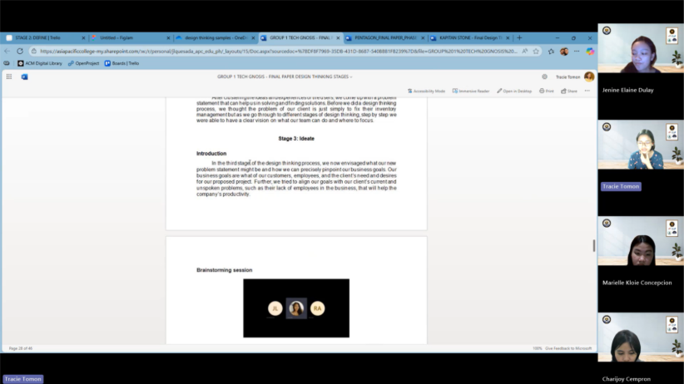

*Figure 19. Stage 3: Ideate brainstorming*

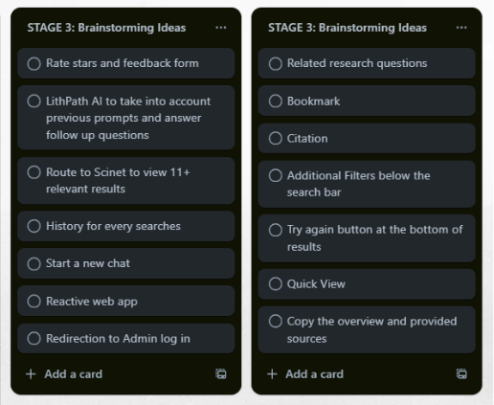

*Figure 20. Trello brainstorming*

### **3.2 Crazy 8s**

To quickly come up with many visual ideas, our team did a Crazy 8’s exercise. While on a live Microsoft Teams call, each of us used pen and paper to sketch eight different ideas in eight minutes. We used the timer in Figma to keep track of the time, as we planned to use it again for our voting session right after.

The one-minute limit for each sketch pushed us to think fast and not overthink our drawings. After the eight minutes, we shared photos of our sketches in the Teams chat. We then took turns explaining our ideas, which allowed everyone to understand the concepts and share creative feedback. This quick exercise helped us move beyond the obvious solutions and gave us many new visual ideas to consider.

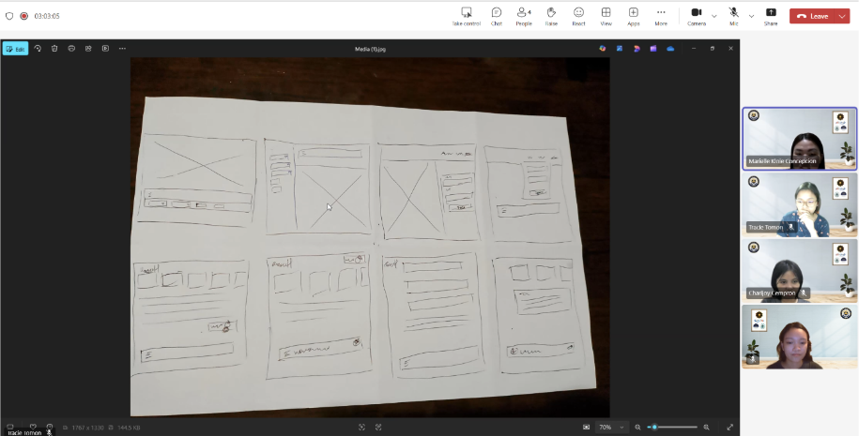

*Figure 21. Explaining "Crazy 8s" Wireframes*

**Charijoy Cempron**

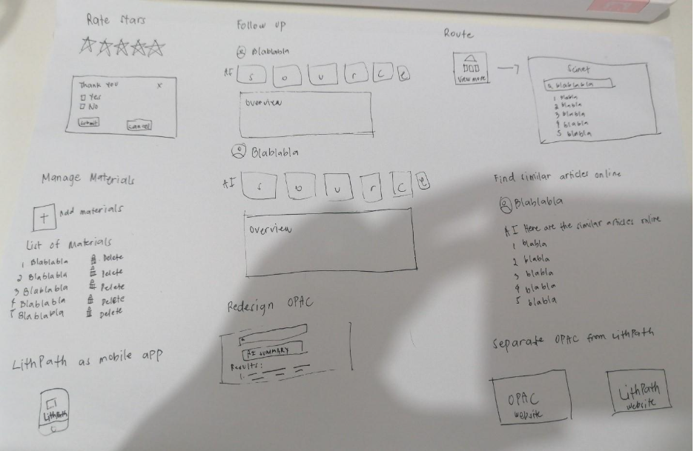

*Figure 22. Charijoy’s Crazy 8s Illustrations*

**Marielle Kloie Concepcion**

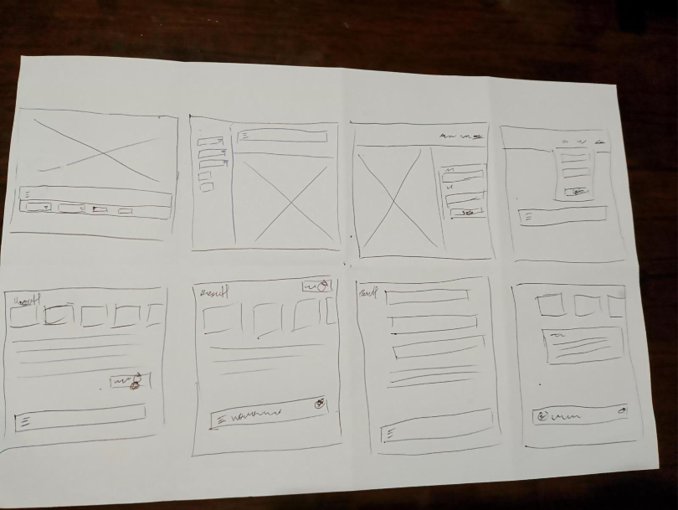

*Figure 23. Kloie’s Crazy 8s Illustrations*

**Jenine Elaine Dulay**

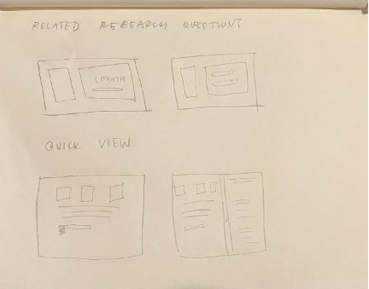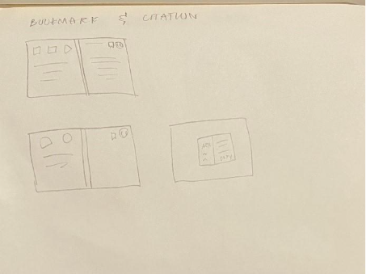

*Figure 24. Jenine’s Crazy 8s Illustrations*

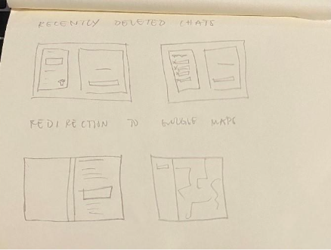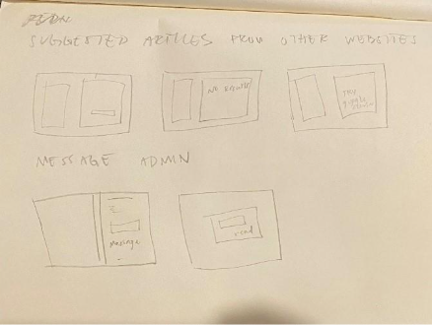

*Figure 25. Jenine’s Crazy 8s Illustrations (1)*

**Tracie Tomon**

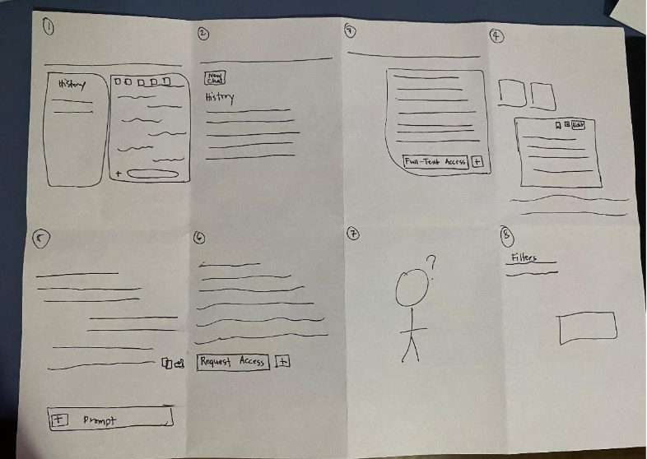

*Figure 26. Tracie’s Crazy 8s Illustrations*

### **3.3 Post-It Voting**

After generating a wide range of ideas, our team's next step was to prioritize them using a Post-it Voting session. We compiled our concepts from the previous activities onto a FigJam board.

Each of our four team members then cast their votes by placing stamps on the ideas they believed had the most potential. This was a fast and visual way to see where we all agreed. The top ideas received four votes, meaning everyone on the team supported them. These chosen features will now be the focus of our work in the Prototyping stage.

Here are the ideas that got the most votes:

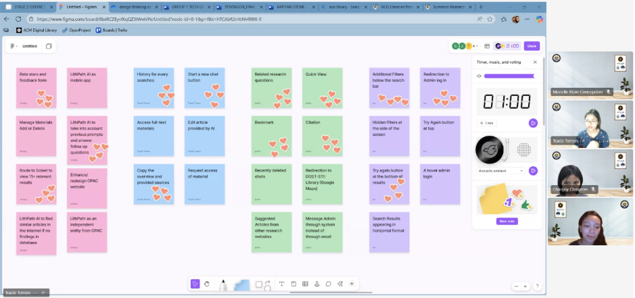

*Figure 27. Post-It Voting*

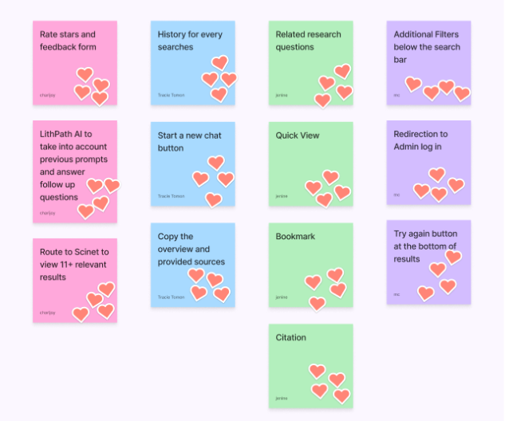

*Figure 28. Final Post-It Votes*

### **3.4 Desirability, Viability, Feasibility**

After choosing our top ideas from the vote, our final step in the Ideate stage was to check if they were strong in three key areas. To do this, we used the Desirability, Viability, and Feasibility framework.

This method helped us ask three simple questions for each idea:

* Desirability: Do users actually want or need this feature?
* Viability: Does this idea help us meet our project's main goals? Does it contribute to long-term growth?
* Feasibility: Can we realistically build this with our current skills and resources?

By checking our top-voted ideas against these three points, we were guided on which ideas to focus on and how to use our time wisely, increasing our chances of building a solution that truly helps our client.

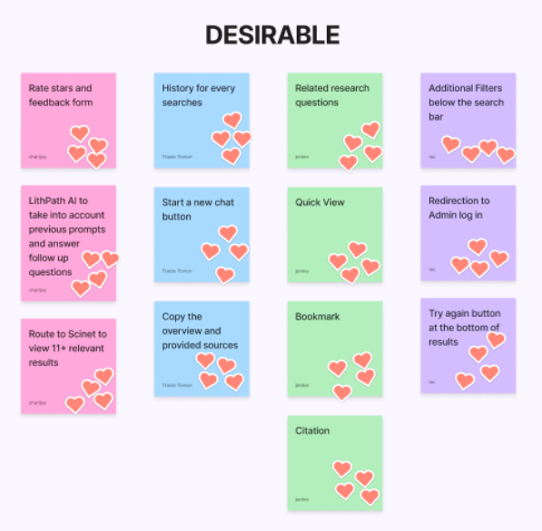

*Figure 29. Desirable features*

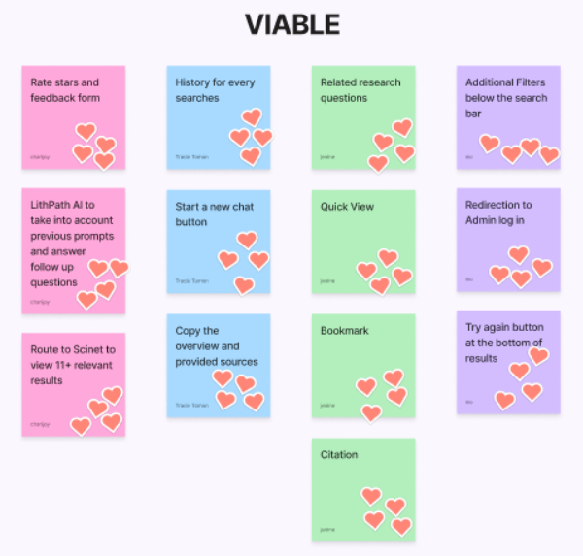

*Figure 30. Viable features*

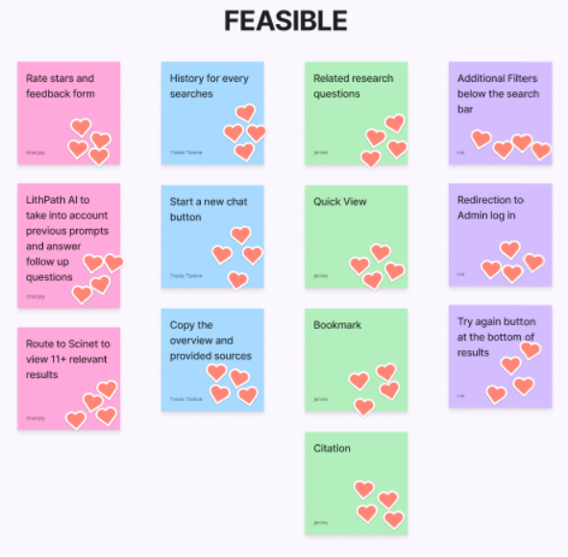

*Figure 31. Feasible features*

## **Stage 4 – Prototype**

The fourth phase of our process is Prototype, where our team started turning ideas into visuals. We used storyboards to document the flow of each feature and created mock-up designs for the complete system workflow. We developed these prototypes using Canva for storyboards and Figma for interface designs. We then prepared this prototype for user testing to gather valuable feedback.

### **4.1 Storyboards**

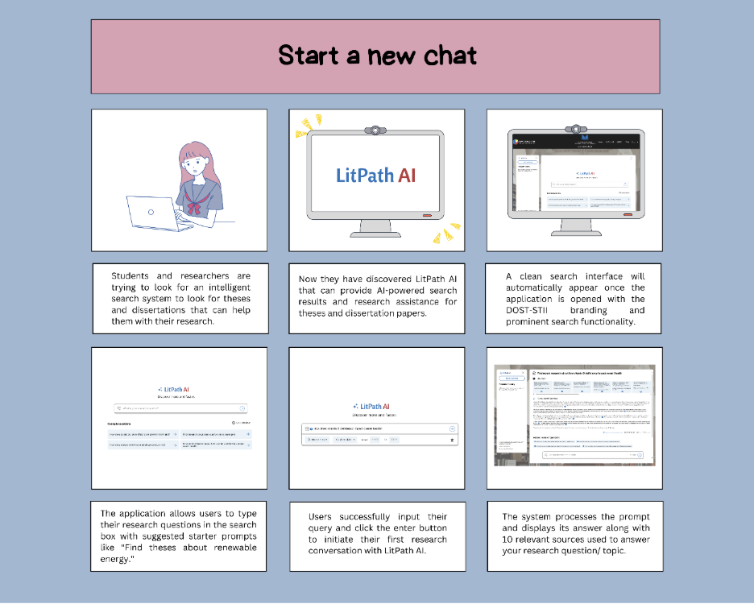

*Figure 32. User Storyboard: Start a New Chat*

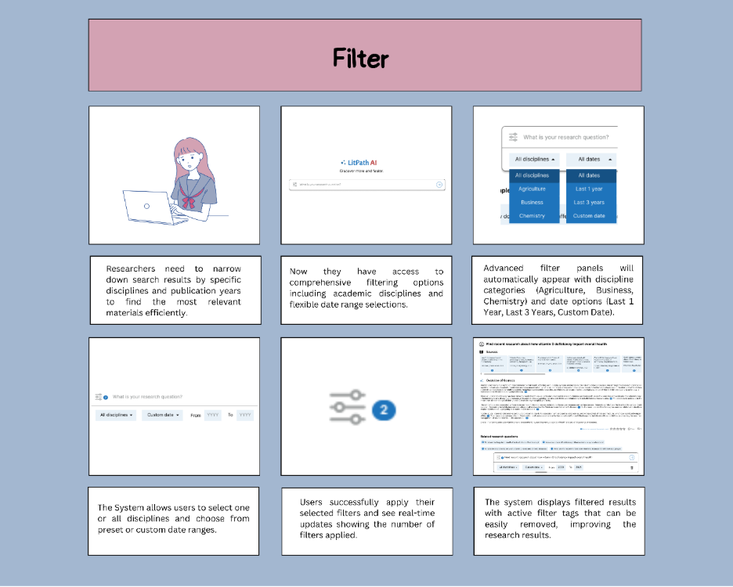

*Figure 33. User Storyboard: Filter*

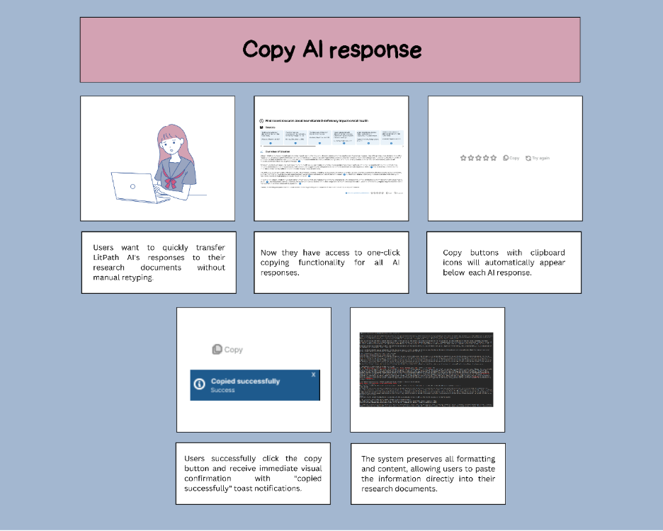

*Figure 34. User Storyboard: Copy AI response*

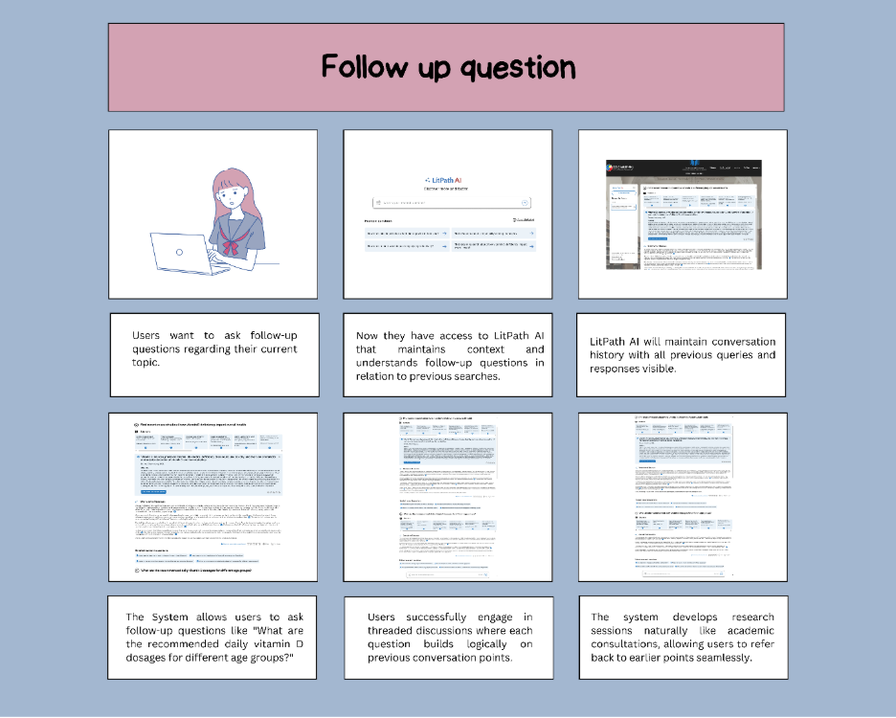

*Figure 35. User Storyboard: Follow-up question*

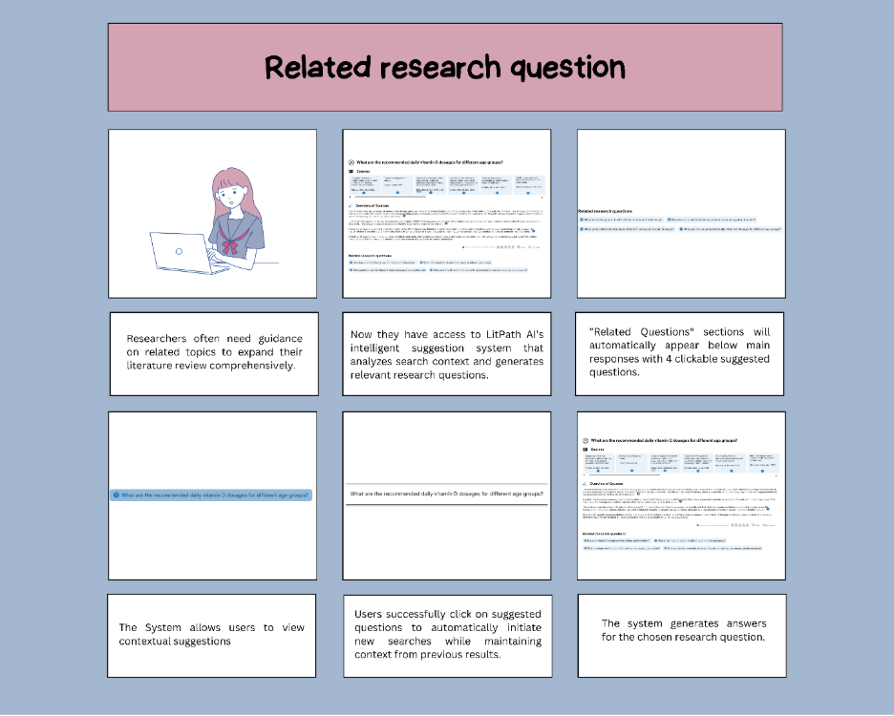

*Figure 36. User Storyboard: Related research question*

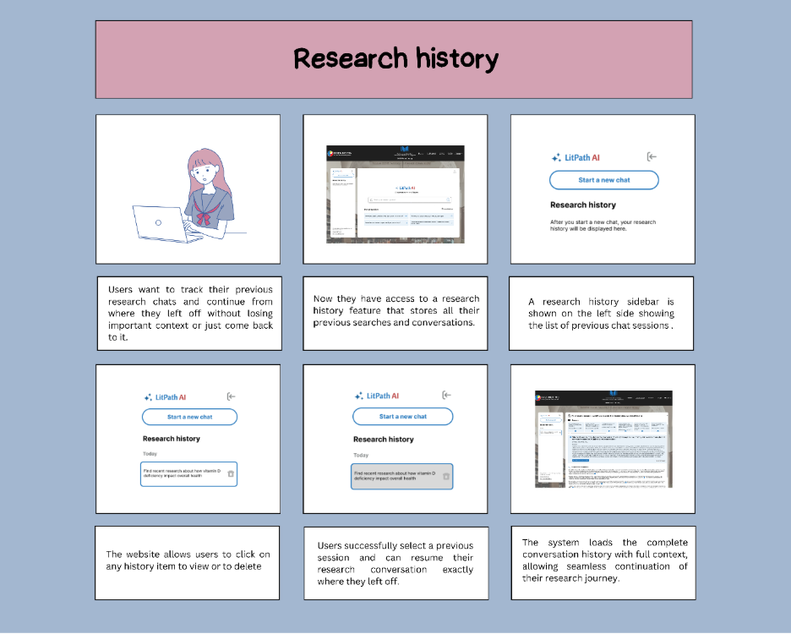

*Figure 37. User Storyboard: Research history*

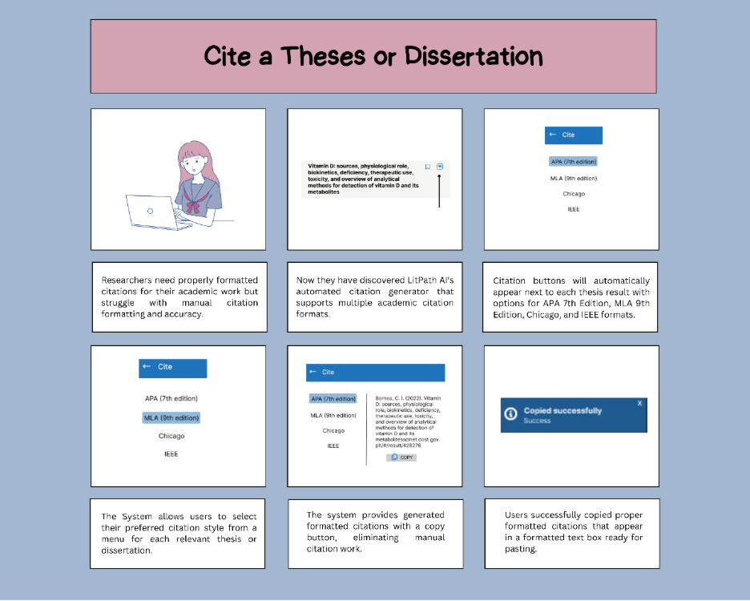

*Figure 38. User Storyboard: Cite a theses or dissertation*

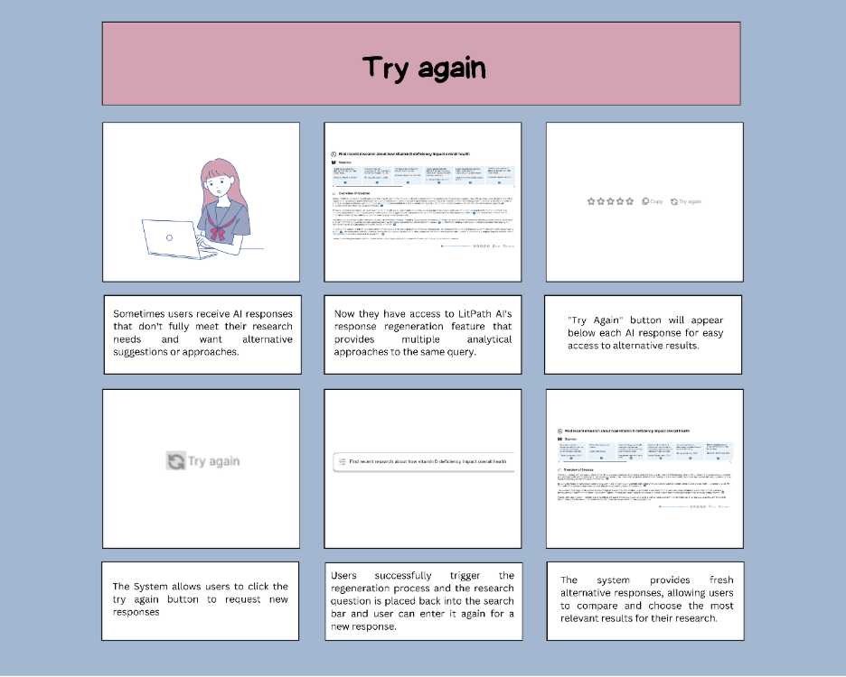

*Figure 39. User Storyboard: Try again*

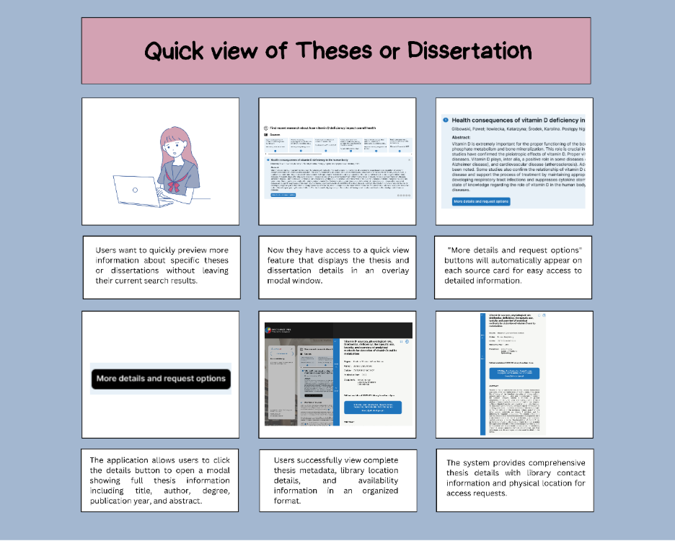

*Figure 40. User Storyboard: Quick view of Theses or Dissertation*

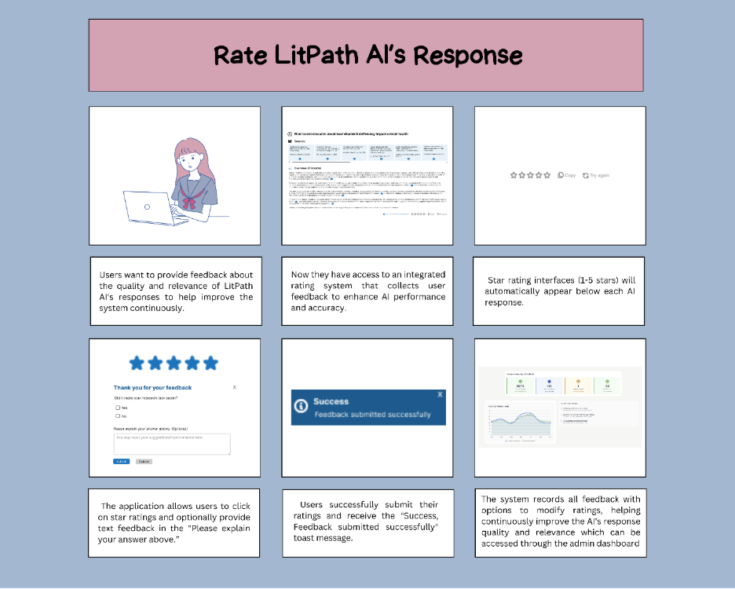

*Figure 41. User Storyboard: Rate LitPath AI’s response*

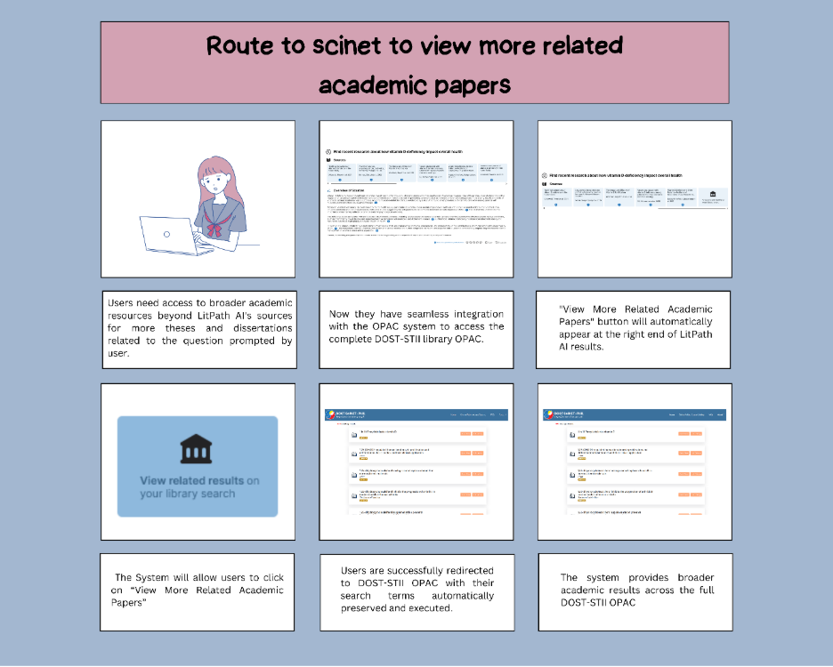

*Figure 42. User Storyboard: Route to SCINET to view more related academic papers*

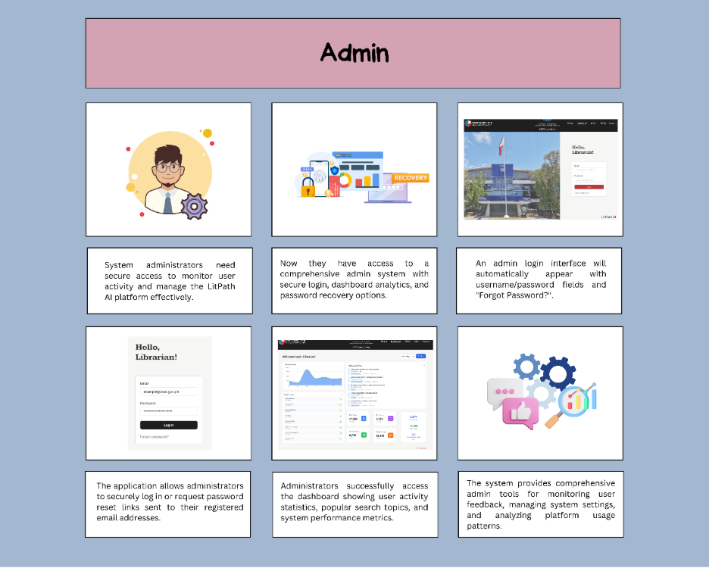

*Figure 43. User Storyboard: Admin Access*

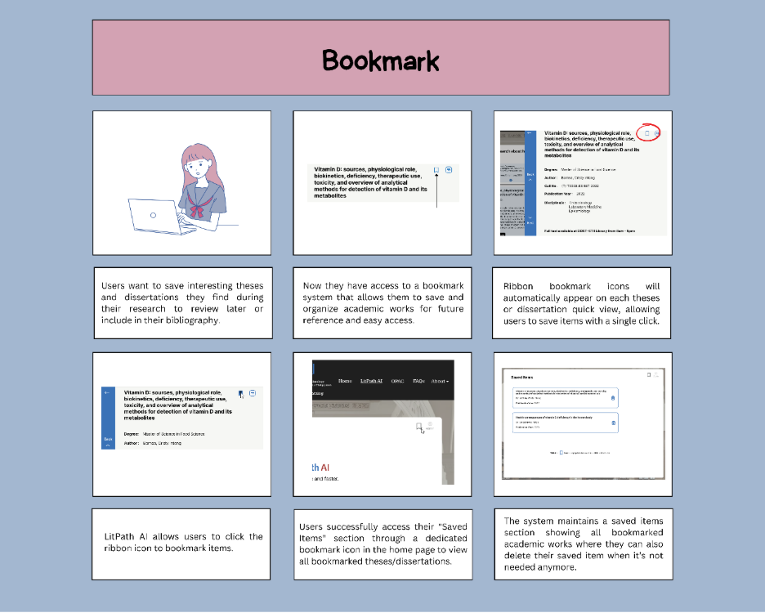

*Figure 44. User Storyboard: Bookmarking*

### **4.2 Mock-up Design**

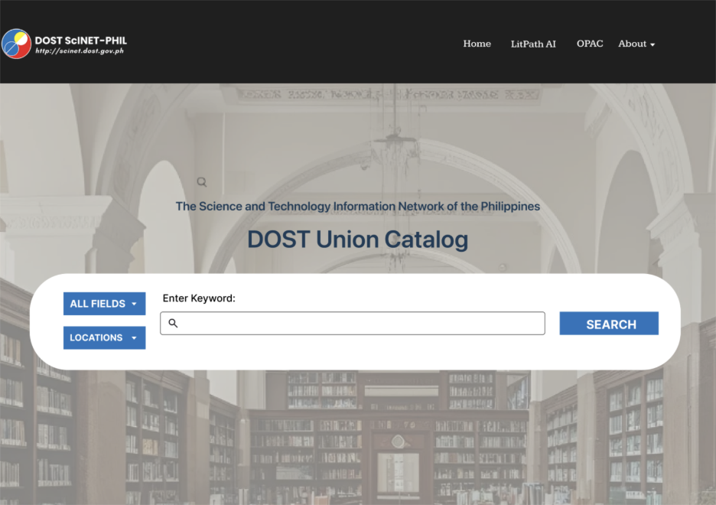

*Figure 45. OPAC Homepage*

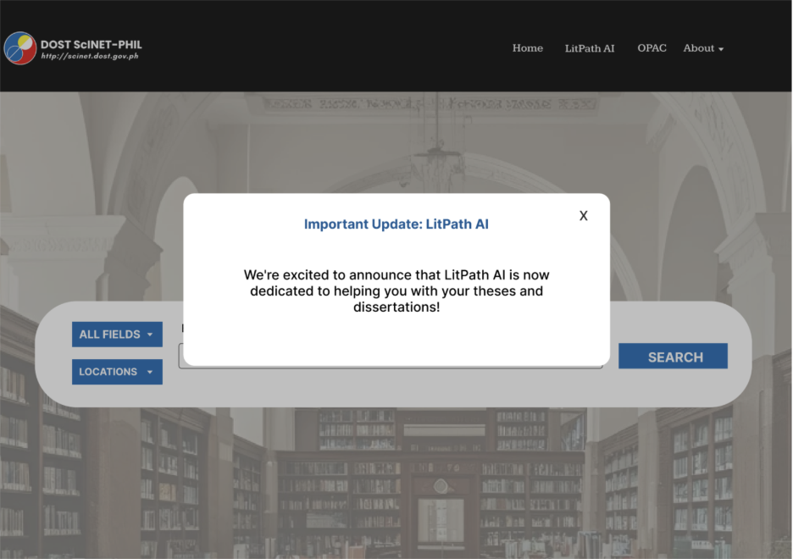

*Figure 46. LitPath AI memo*

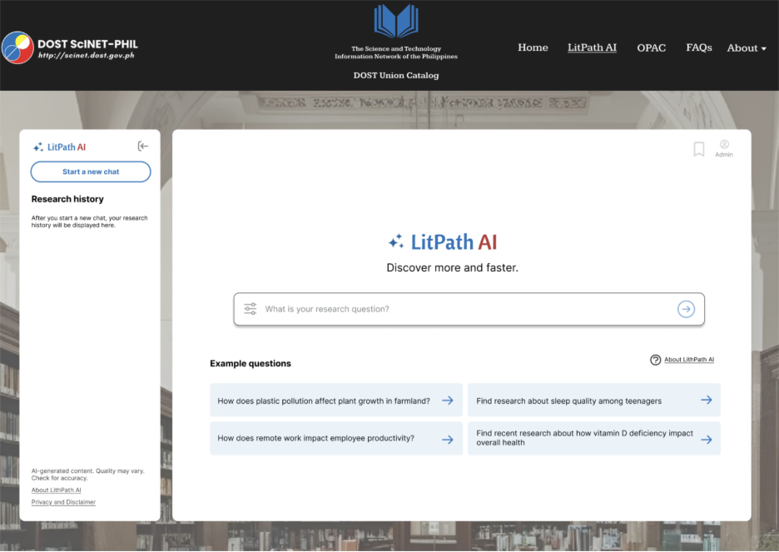

*Figure 47. LitPath AI Homepage*

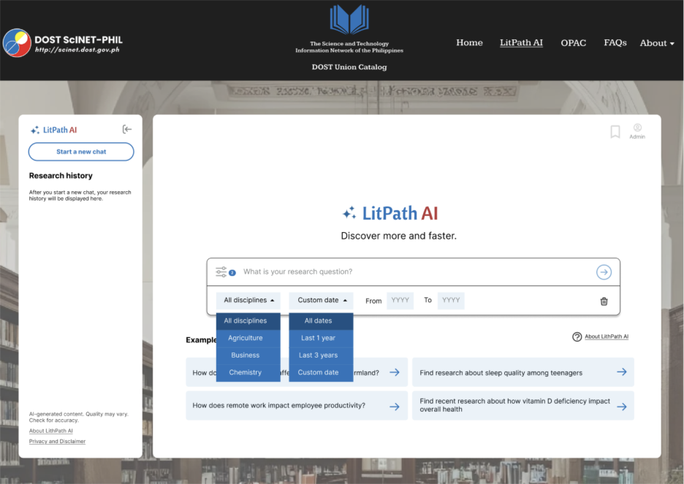

*Figure 48. LitPath AI: Filters*

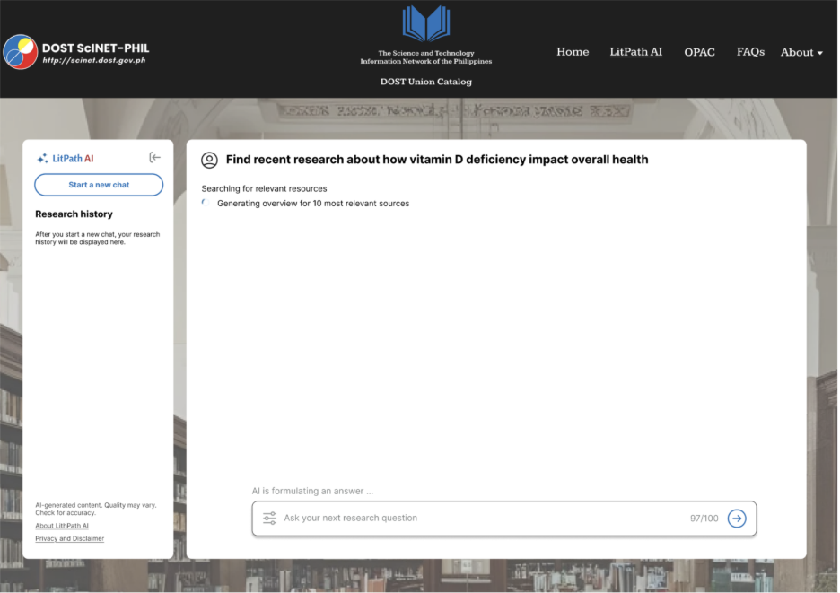

*Figure 49. LitPath AI: Loading screen*

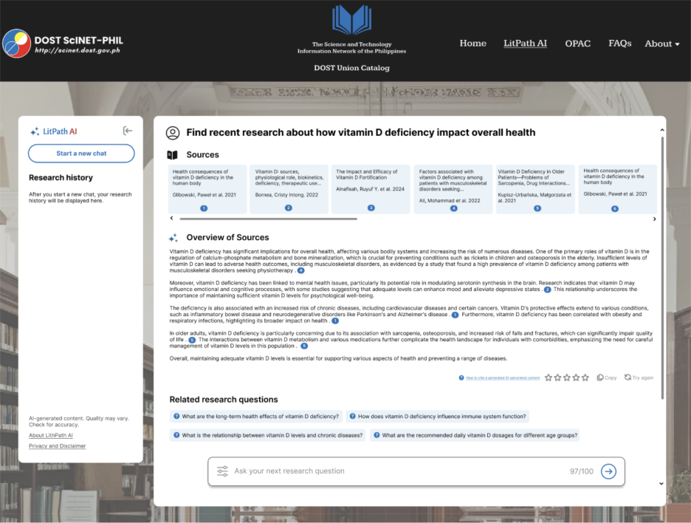

*Figure 50. LitPath AI: Response*

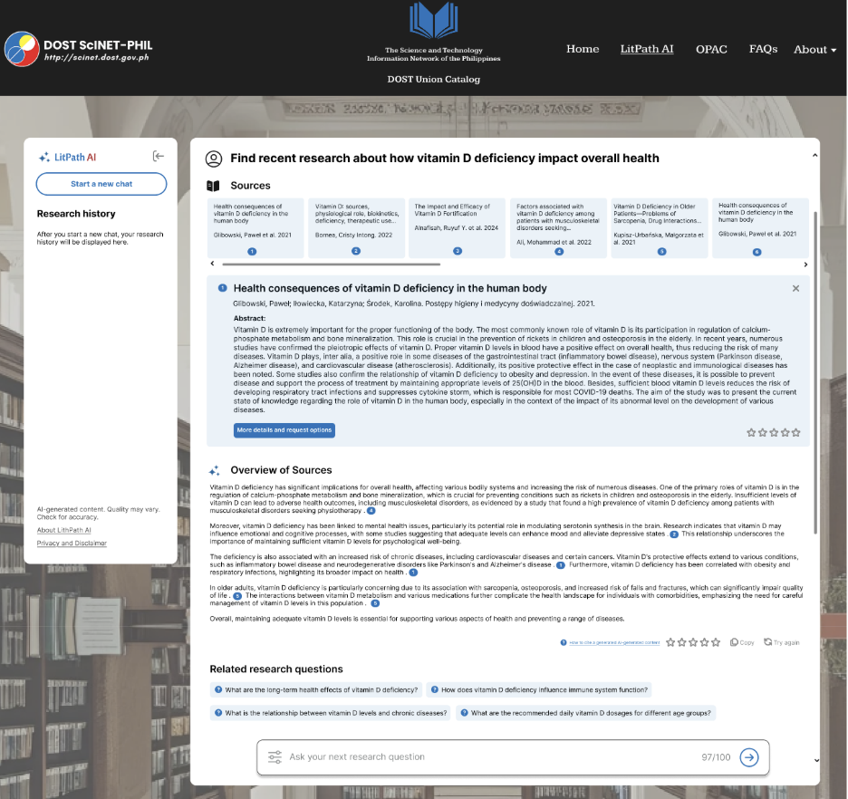

*Figure 51. LitPath AI: Quick view of sources*

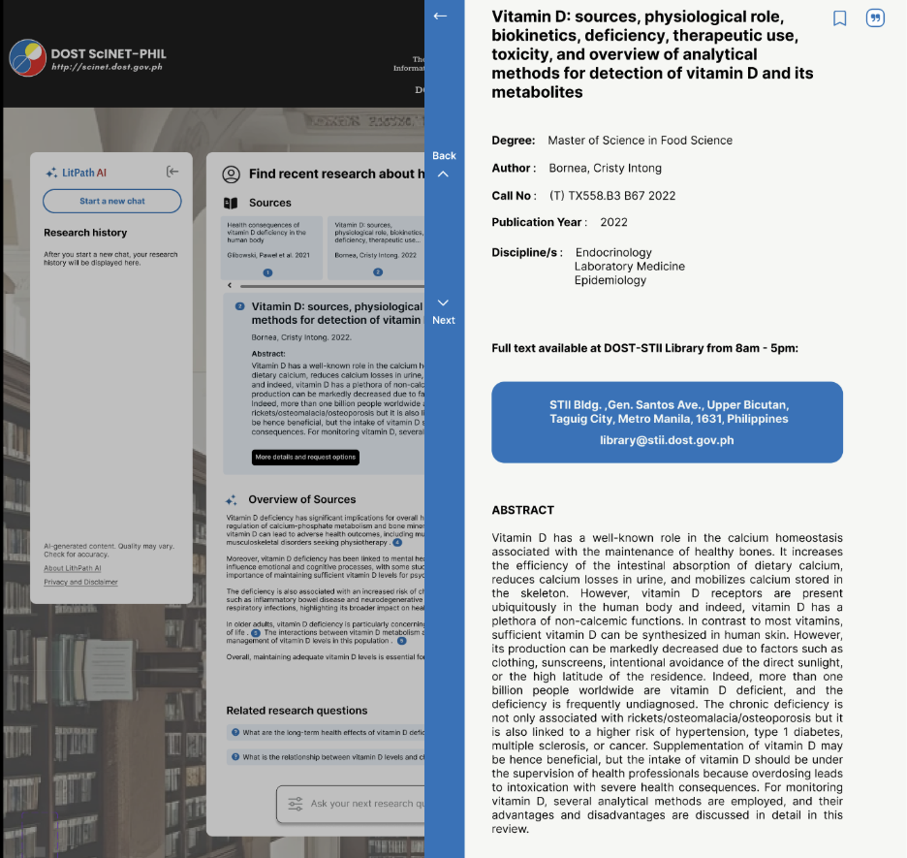

*Figure 52. LitPath AI: Source details overlay*

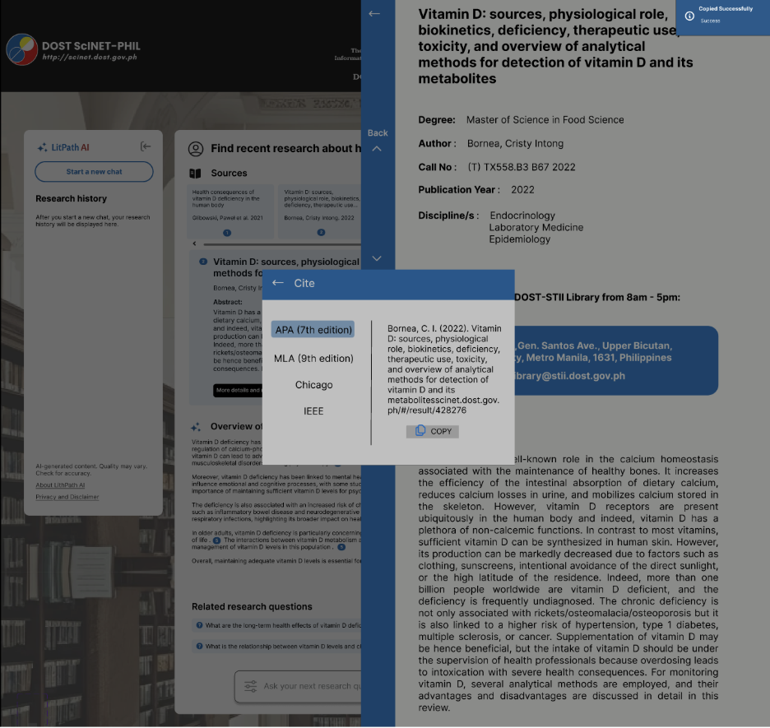

*Figure 53. LitPath AI: Citation*

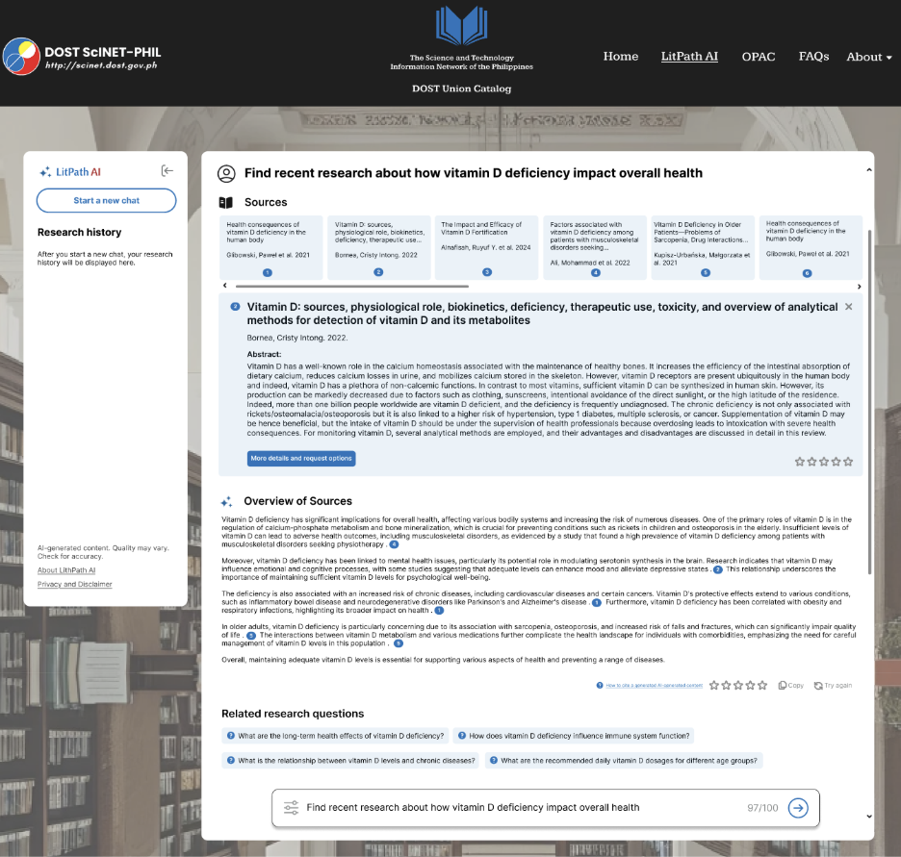

*Figure 54. LitPath AI: Try Again*

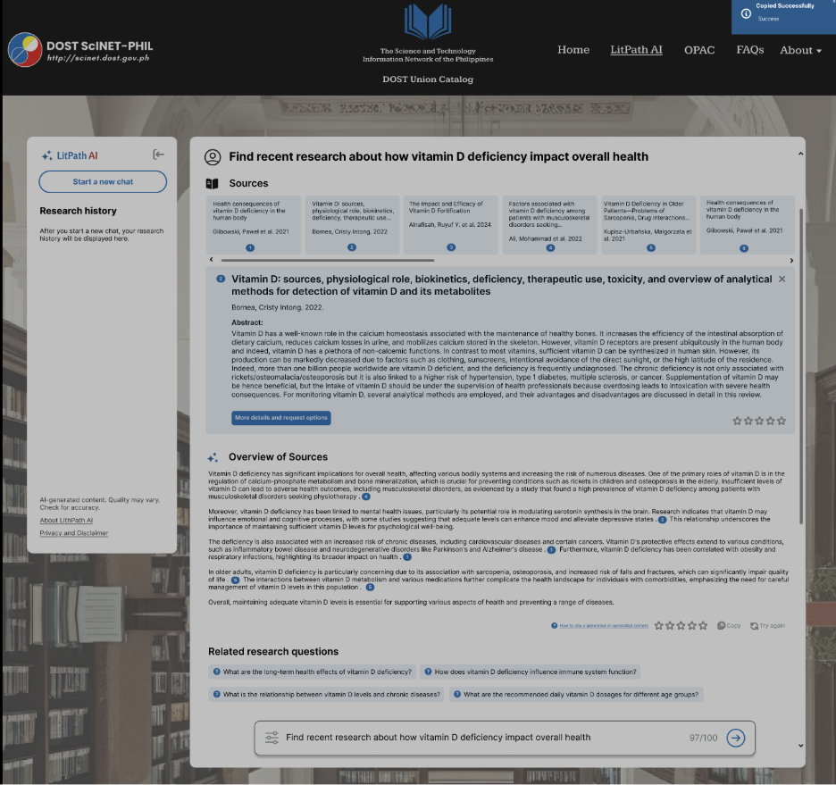

*Figure 55. LitPath AI: Successfully copied AI response*

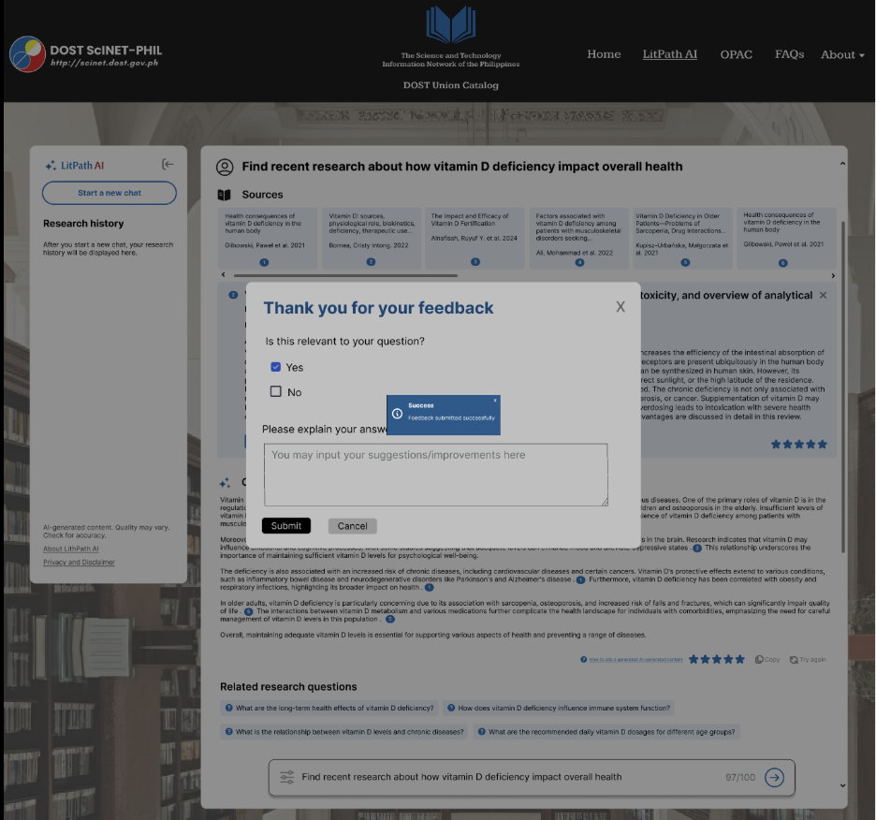

*Figure 56. LitPath AI: User Feedback*

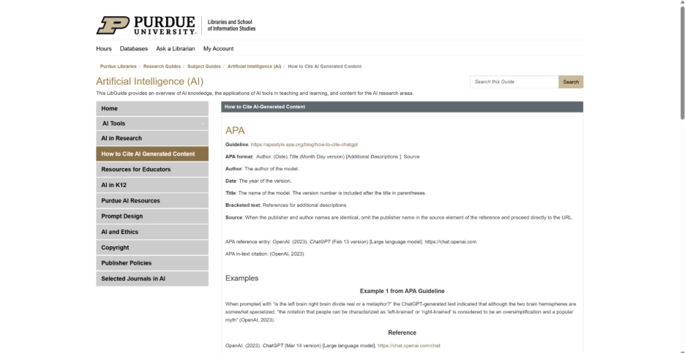

*Figure 57. LitPath AI: How to cite AI content redirection site*

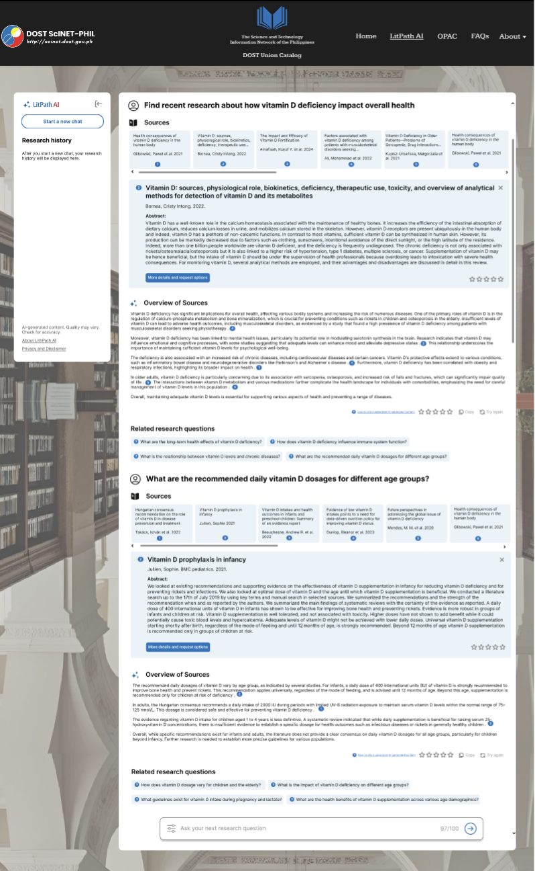

*Figure 58. LitPath AI: Follow-up question*

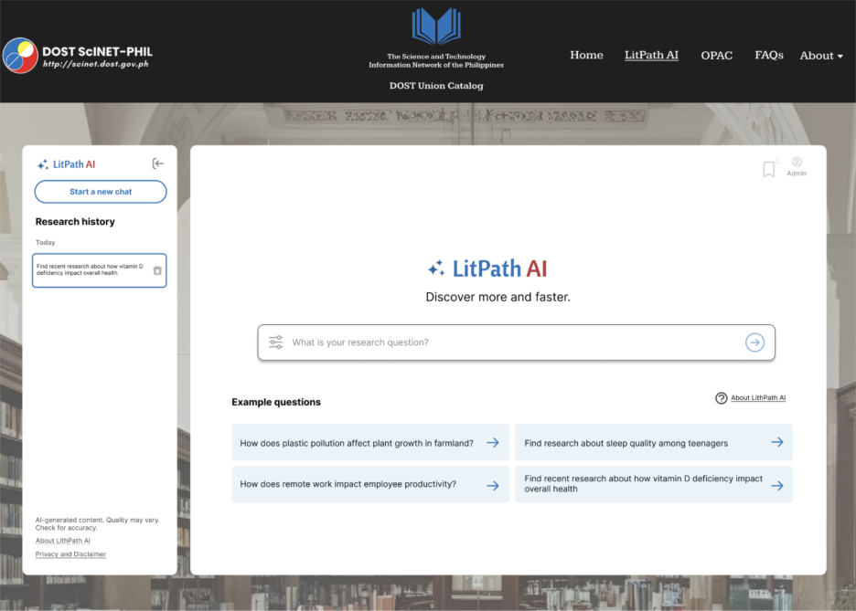

*Figure 59. LitPath AI: Search History*

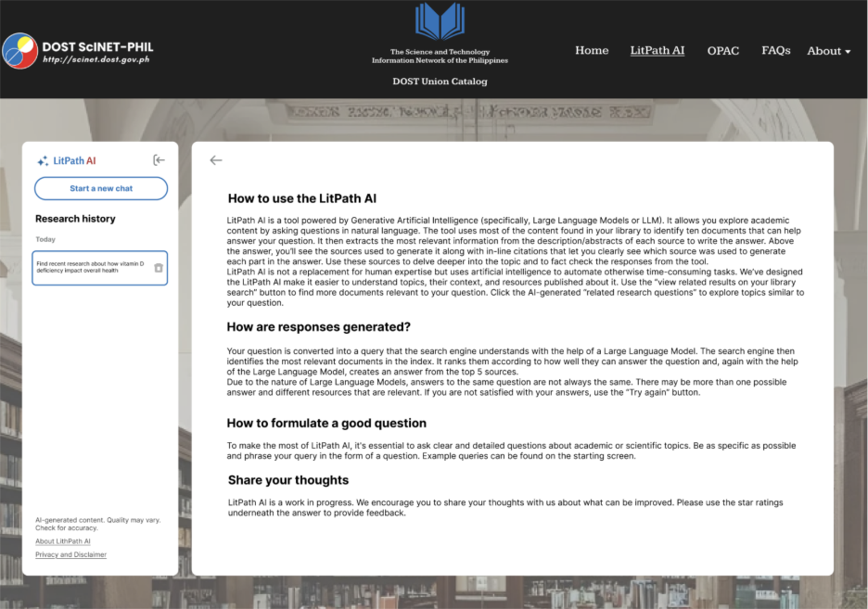

*Figure 60. About LitPath AI*

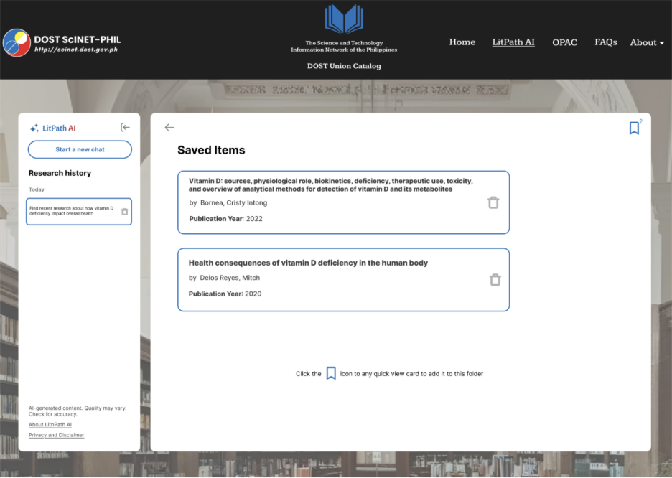

*Figure 61. LitPath AI: Saved Items*

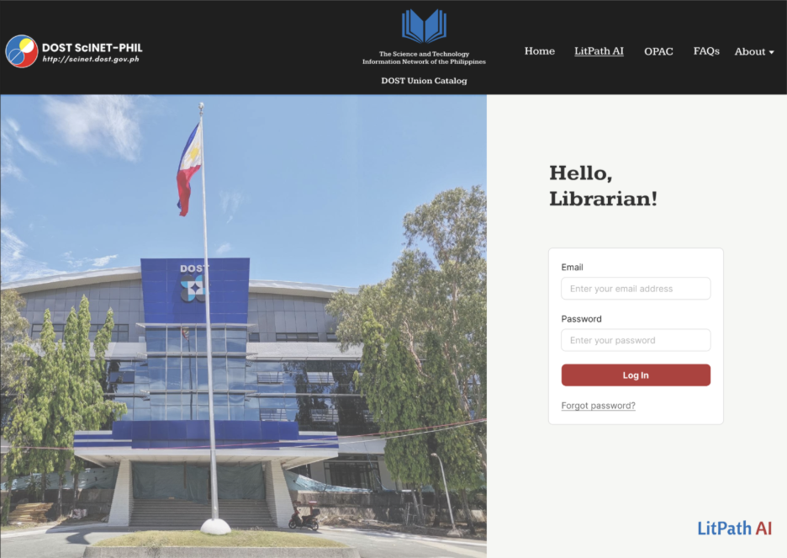

*Figure 62. LitPath AI: Admin Log In*

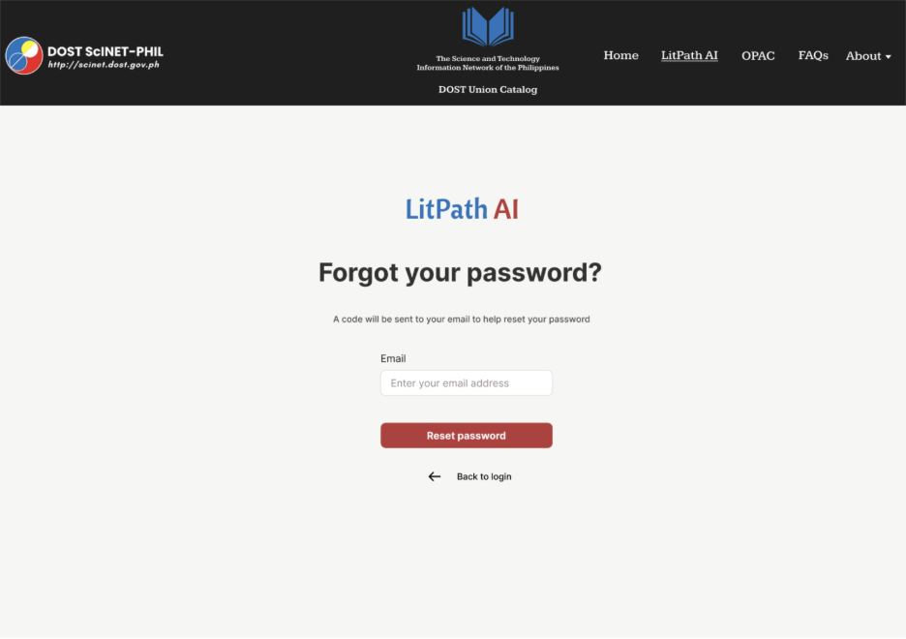

*Figure 63. Forgot password: Enter email*

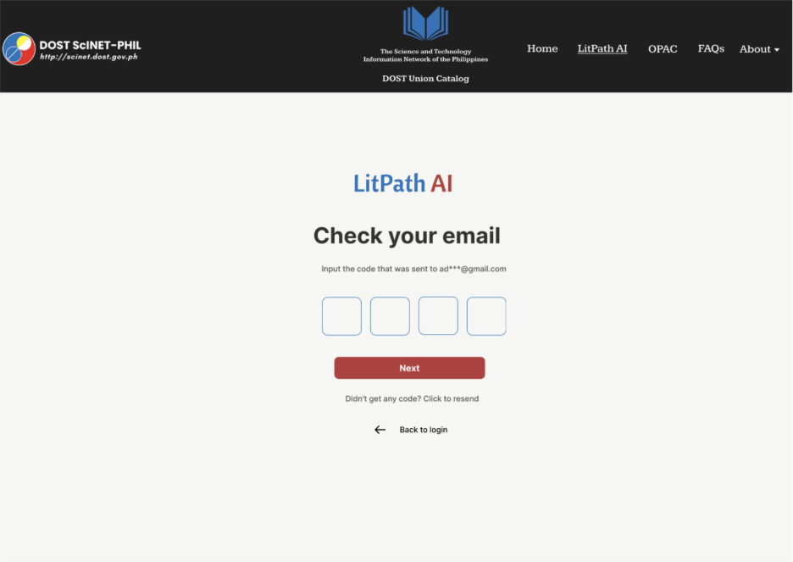

*Figure 64. Forgot password: Email code entry*

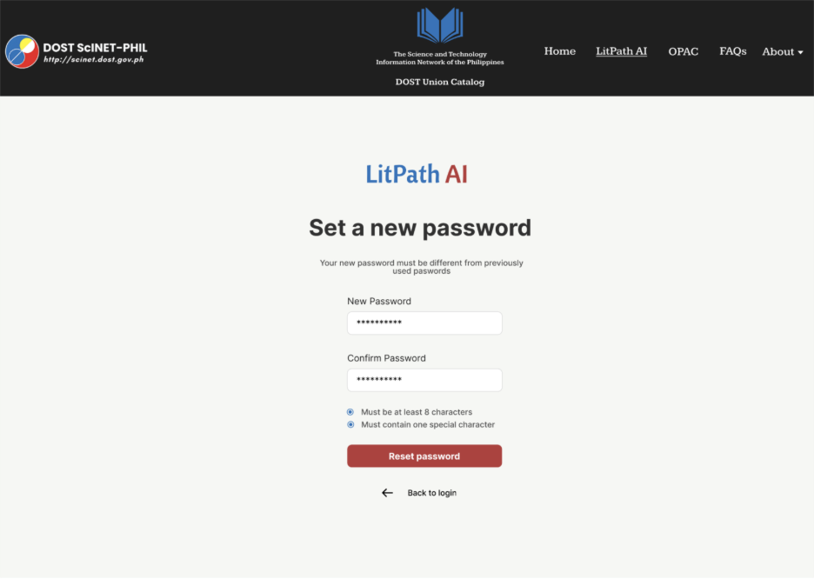

*Figure 65. Setting a new password*

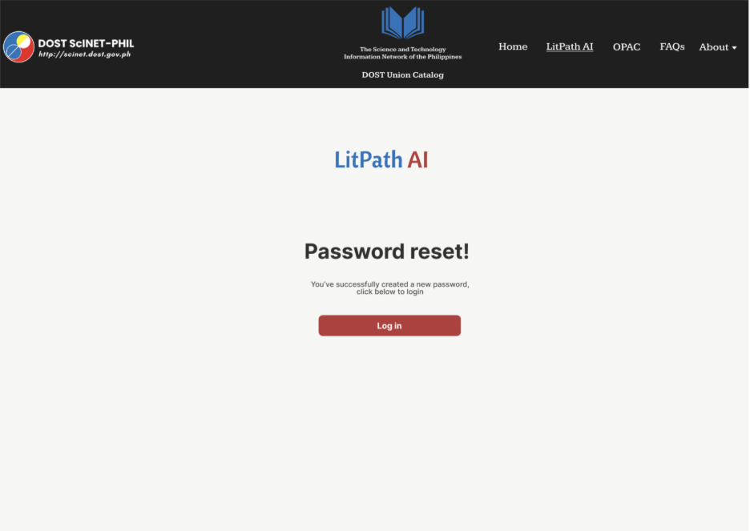

*Figure 66. Successfully resetting of password*

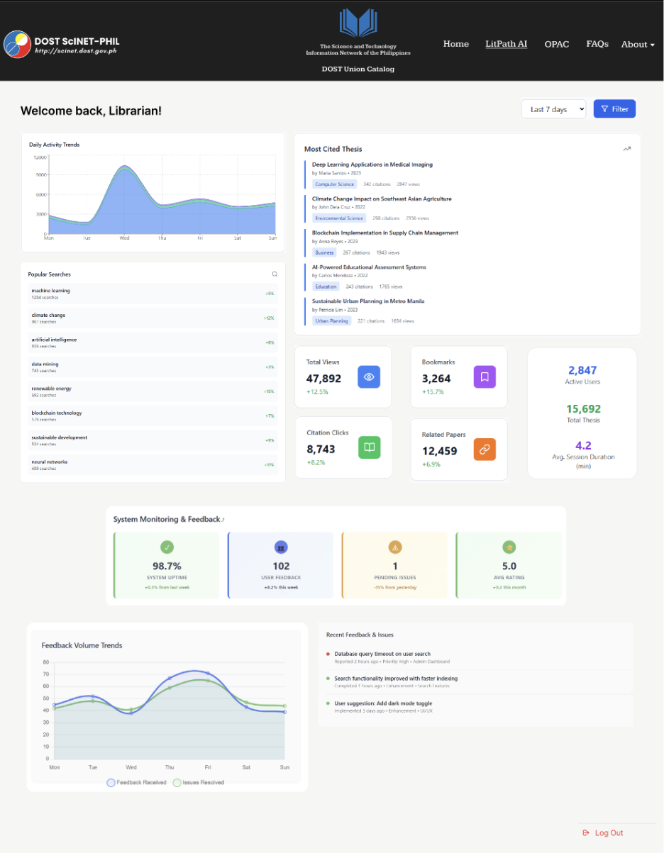

*Figure 67. Admin Dashboard*

## **Stage 5 – Test**

Lastly, the fifth phase of our process is Test, where our team handed over this prototype to real users. We observed how clients and customers interacted with our designs, and we collected their feedback to understand their experience with the prototype. These insights and identified areas for improvement will be used for future development processes.

**CUSTOMER FEEDBACK**

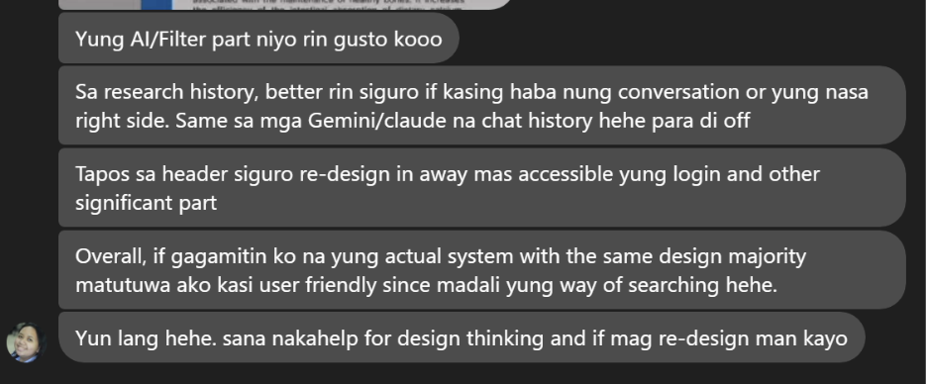

*Figure 68. Customer Feedback*  
*NOTE: Customer 1 is contacted through Facebook Messenger due to busy schedules.*

***General Feedback:***

* Design and color palette is okay, and I suggest making the detail page of the thesis in full screen.
* I’m happy that there is a citation generator and it would be even great to also have in-text citations.
* I also like the search interface features.
* The research history conversation should have been longer.
* Include in the header the login and bookmark so it can be easily accessible.
* Overall, it’s user friendly and the searching process is easy to navigate.

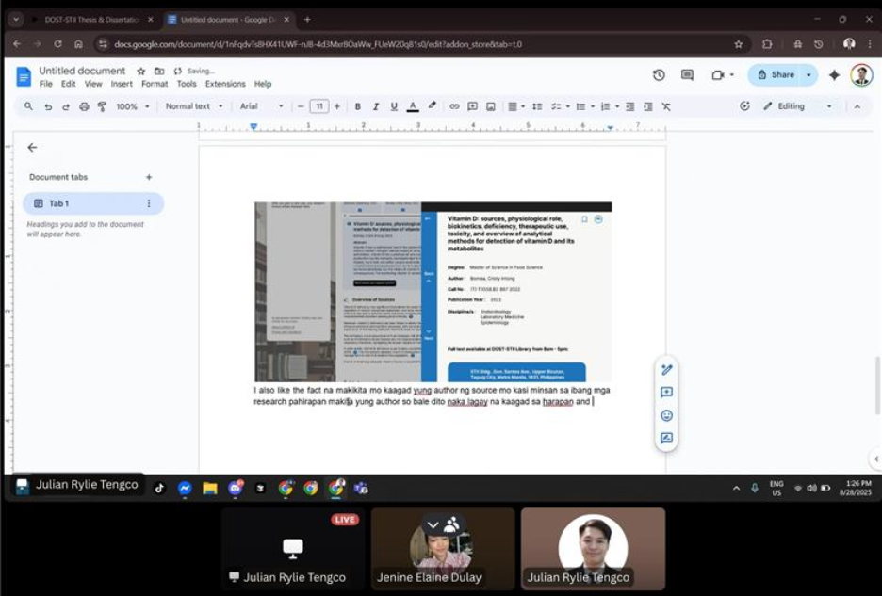

*Figure 69. A screenshot of a customer feedback session conducted via video call*  
**NOTE**: Customer 2 is contacted through Discord due to busy schedules.

***General Feedback:***

* The design and color scheme is okay and simple.
* The features are easy to navigate because all that you need is shown there like the example questions.
* I like that the sources are shown on top because it’s the first thing you see and that you can also view the details where you can view the author and year instantly.
* It’s also nice that the chat history can be saved.
* Overall, it’s easy to use.

**CLIENT FEEDBACK**

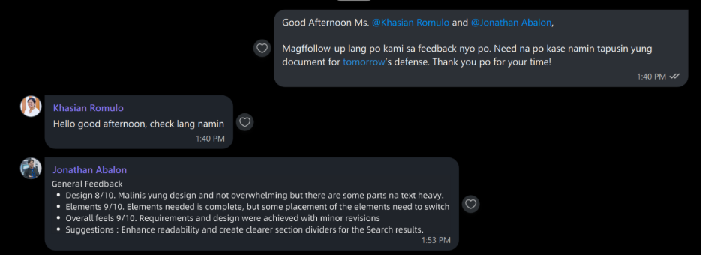

*Figure 70. Client Feedback*  
***NOTE****: Client is contacted through Viber due to busy schedules.*

***General Feedback:***

* **Design**: 8/10. The design is clean and not overwhelming but there are some parts which are text heavy.
* **Elements**: 9/10. Elements needed is complete, but some placement of the elements need to switch
* **Overall feels**: 9/10. Requirements and design were achieved with minor revisions
* **Suggestions**: Enhance readability and create clearer section dividers for the Search results.

# **Dataflow Diagrams**

**Level 0 (Context Diagram)**  
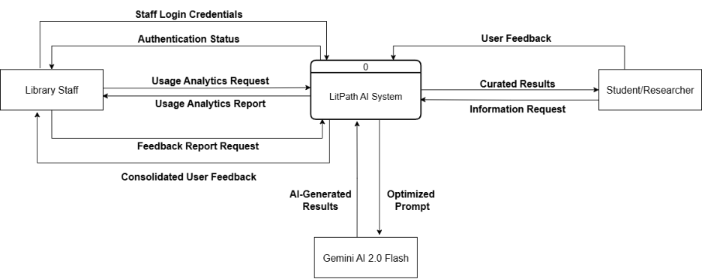

**Level 1 diagram**  
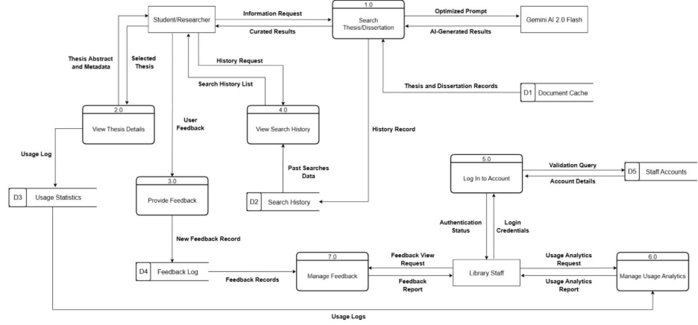

**Level 2 diagrams**

**1.0 Search Thesis/Dissertation**  
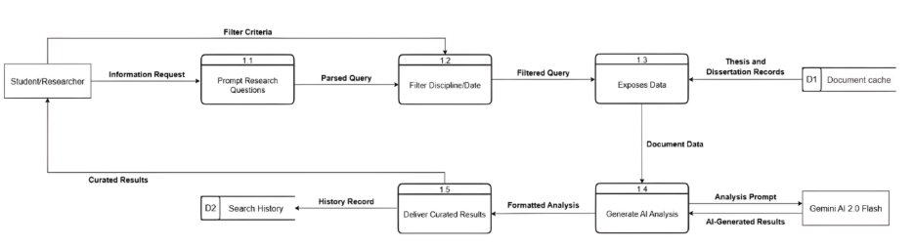

**2.0 View Thesis Details**  
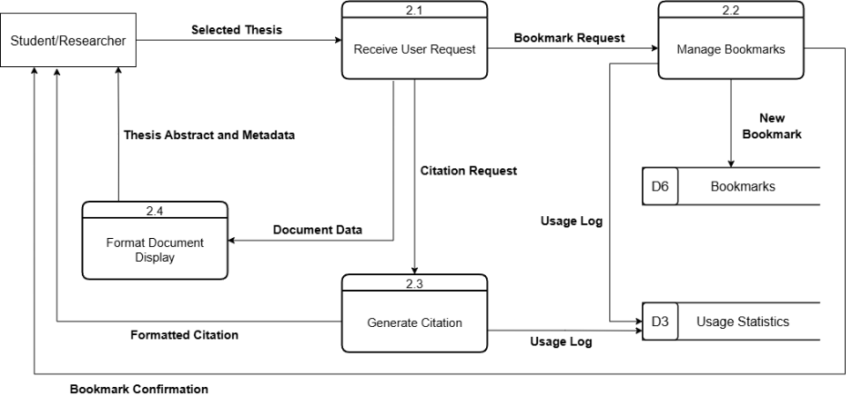

**3.0 Provide Feedback**  
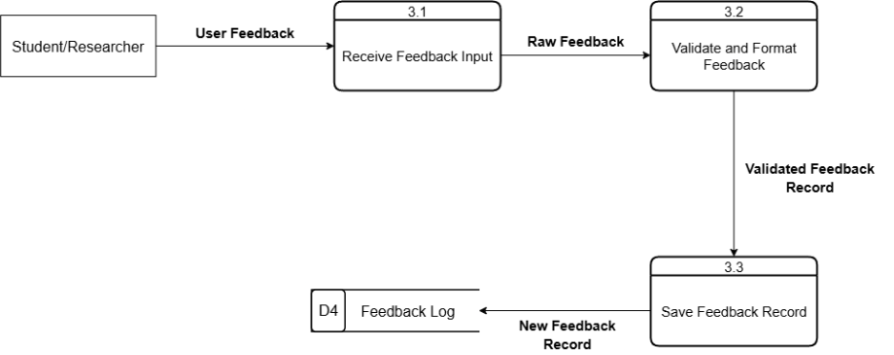

**4.0 View Search History**  
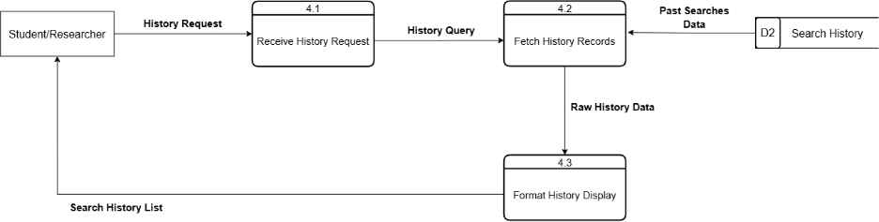

**5.0 Log In to Account**  
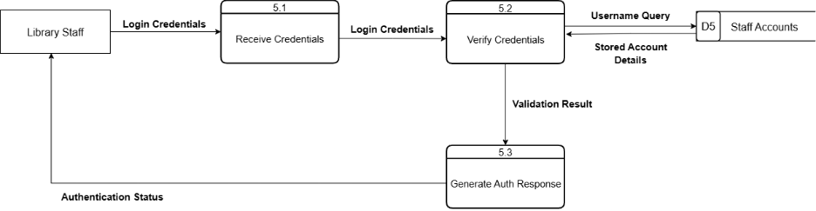  
**6.0 Manage Usage Analytics**  
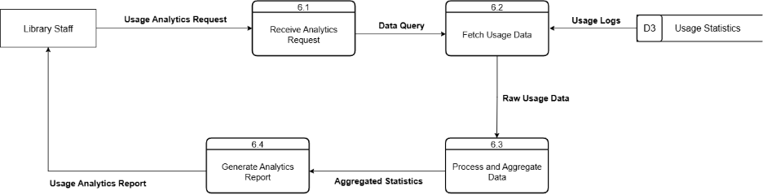

**7.0 Manage Feedback**  
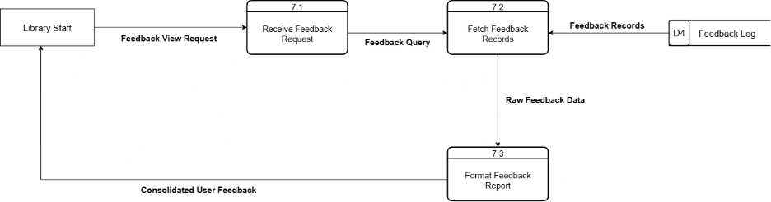

# **Use Case Documentation**

**Use Case Diagram**  
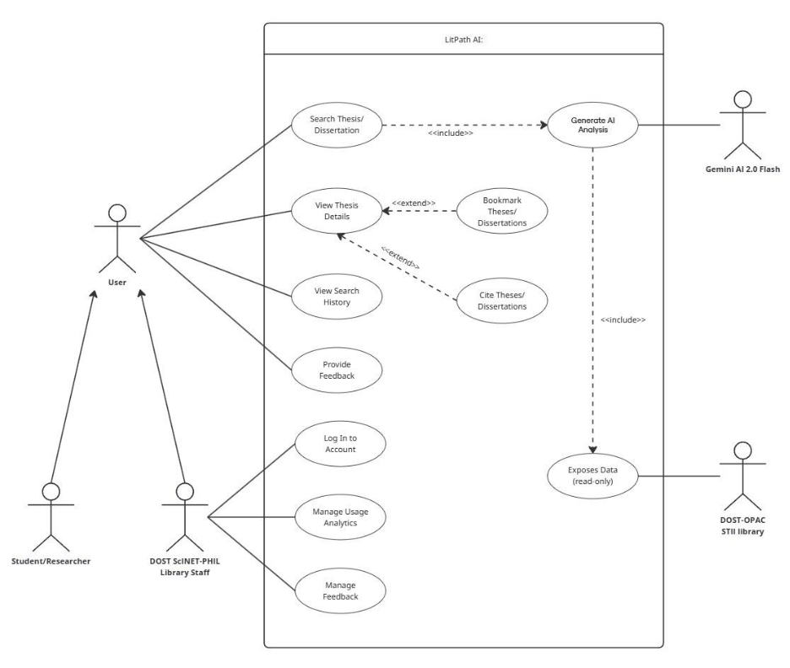

**Fully Dressed Use Cases**

*Table 2. Use Case Name: Search Thesis/Dissertation*

|  |  |
| --- | --- |
| Use Case ID | UC-01 |
| Author/s | Jenine Elaine Dulay, Charijoy Cempron |
| Purpose | To allow a user to enter a research question and receive a curated list of relevant theses and dissertations analyzed by an AI. |
| Requirement Traceability | BR-01, BR-02 |
| Priority | High |
| Preconditions | * The system is online and accessible. * User can access LitPath AI platform. |
| Postconditions | * On success, the user is presented with a ranked list of relevant documents and an AI-generated overview. * On failure, the user is notified of the issue (e.g., no results, system error). |
| Actors | Student/Researcher |
| Flow of Actions | **Basic Flow**   1. User accesses the “LitPath AI” search page. 2. User clicks search bar or "Start a new chat" and enters a research question into the search bar. 3. User clicks the search button to submit the query. 4. System retrieves relevant document data from the DOST-OPAC STII Library. 5. System sends the document data and the user's query to the Gemini AI for analysis. 6. System receives a ranked list of documents and a generated overview from the AI. 7. System displays the ranked search results and the AI-generated overview to the user.   **Alternative Flow**  **A1**: User Applies Filters  This can occur before or after step 3 of the Basic Flow.   1. User applies filters (ex. by discipline or publication date). 2. System constrains the data retrieval in step 4 based on the applied filters. 3. Use case continues from step 5 of the Basic Flow with the filtered dataset.   **A2**: AI Provides Clarifying Suggestions for Vague Query  This occurs if the system detects a vague or broad query at step 5 of the Basic Flow.   1. The AI engine identifies the query as ambiguous. 2. Instead of a ranked list, the system presents the user with clarifying questions or suggested, more specific research topics. 3. The user selects one of the suggestions or manually refines their original query. 4. The use case restarts from step 3 of the Basic Flow with the new, refined query.   **Exception Flows**  **E1**: No Results Found  This occurs if the system, after step 4 of the Basic Flow, finds no matching documents in the library.   1. System displays a message to the user indicating that no relevant documents were found. 2. System may provide tips on how to broaden the search query. 3. Use case ends.   **E2**: System Timeout or AI Service Error  This can occur at step 5 or 6 of the Basic Flow if the connection to the Gemini AI fails or times out.   1. System detects the error. 2. System displays an error message to the user, such as "We're sorry, the AI service is currently unavailable. Please try again later." 3. Use case ends. |

*Table 3. Use Case Name: View Thesis Details*

|  |  |
| --- | --- |
| Use Case ID | UC-02 |
| Author/s | Jenine Elaine Dulay |
| Purpose | To allow users to view comprehensive details of a selected thesis or dissertation. |
| Requirement Traceability | BR-03 |
| Priority | High |
| Preconditions | * User is on the search results page. * System is online |
| Postconditions | * On success, the user is shown detailed information for the selected document. * User's viewing activity is logged for analytics. |
| Actors | Student/Researcher |
| Flow of Actions | **Basic Flow**   1. From the search results list, the user clicks on the title of a thesis or dissertation they wish to view. 2. System retrieves the detailed record for the selected document. 3. System displays the document's details, including the title, author, publication year, abstract, disciplines, and library location. 4. System logs the viewing of this document to the usage statistics.   **Alternative Flows (Extensions)**  **A1:** User bookmarks the document   * Condition: At any point after step 3 of the Basic Flow, the user clicks the "Bookmark" button. * Action: The flow of the UC-03: Bookmark Theses/Dissertations use case is executed.   **A2:** User generates a citation   * Condition: At any point after step 3 of the Basic Flow, the user clicks the "Cite" button. * Action: The flow of the UC-04: Cite Theses/Dissertations use case is executed.   **Exception Flows**  **E1:** Document details are unavailable  This occurs if the system at step 2 of the Basic Flow cannot retrieve the selected record.   1. System displays an error message, such as "Sorry, the details for this document could not be retrieved at this time." 2. Use case ends. |

*Table 4. Use Case Name: Bookmark Theses/Dissertations*

|  |  |
| --- | --- |
| Use Case ID | UC-03 |
| Author/s | Jenine Elaine Dulay |
| Purpose | To allow users to save a specific thesis or dissertation for future reference. |
| Requirement Traceability | BR-04 |
| Priority | High |
| Preconditions | * User is viewing the detailed information of a specific document (UC-02: View Thesis Details is active). * System is online |
| Postconditions | * On success, the selected document is added to the user's bookmark list, and the user is notified. * The bookmarking action is logged for analytics. |
| Actors | Student/Researcher |
| Flow of Actions | **Basic Flow**   1. While viewing the details of a document, the user clicks the "Bookmark" icon. 2. System saves item to bookmarks and appears in "Saved Items" section. 3. System displays a confirmation message to the user, such as "Bookmark added." 4. System logs the bookmarking action for analytics.   **Alternative Flow**  **A1:** User removes an existing bookmark  **Condition:** The user clicks the "Bookmark" icon for a document that is already bookmarked.   1. System removes the document's reference from the user's bookmark list. 2. System displays a confirmation message, such as "Bookmark removed." 3. Use case ends.   **Exception Flows**  **E1:** System fails to save the bookmark  **Condition:** This occurs at step 2 of the Basic Flow if the system cannot write to the bookmarks data store.   1. System detects the save error. 2. System displays an error message to the user, such as "Sorry, the bookmark could not be saved at this time." 3. Use case ends. |

*Table 5. Use Case Name: Cite Theses/Dissertations*

|  |  |
| --- | --- |
| Use Case ID | UC-04 |
| Author/s | Jenine Elaine Dulay |
| Purpose | To allow users to generate a formatted citation for a specific document. |
| Requirement Traceability | BR-05 |
| Priority | High |
| Preconditions | * User is viewing the detailed information of a specific document (UC-02: View Thesis Details is active). * System is online |
| Postconditions | * On success, a formatted citation is displayed to the user. * Citation action is logged for analytics. |
| Actors | Student/Researcher |
| Flow of Actions | **Basic Flow**   1. While viewing the details of a document, the user clicks the "Cite" icon. 2. System displays a list of available citation formats (APA, MLA, Chicago, IEEE) 3. Choose citation format. 4. System generates and displays the citation in the default format. 5. System provides an option for the user to copy the citation to their clipboard. 6. System logs citation action for analytics.   **Alternative Flow**  **A1:** User changes citation format  **Condition:** At step 3 of the Basic Flow, the user selects a different citation format from the list.   1. System regenerates and displays the citation in the newly selected format. 2. Use case resumes at step 5 of the Basic Flow.   **Exception Flows**  **E1:** System fails to generate the citation  **Condition:** This occurs at step 3 of the Basic Flow if the document's metadata is incomplete or corrupted.   1. System detects the error. 2. System displays an error message to the user, such as "Sorry, a citation could not be generated for this document due to missing information." 3. Use case ends. |

*Table 6. Use Case Name: Provide Feedback*

|  |  |
| --- | --- |
| Use Case ID | UC-05 |
| Author/s | Tracie Tomon |
| Purpose | To allow users to rate the quality of the AI-generated results and provide optional text feedback. |
| Requirement Traceability | BR-06 |
| Priority | High |
| Preconditions | * User is viewing a set of search results generated by the AI (UC-01 has been completed). * System is online |
| Postconditions | * On success, the user's feedback is saved to the feedback log. * User receives a confirmation that their feedback was submitted. |
| Actors | Student/Researcher |
| Flow of Actions | **Basic Flow**   1. After viewing the AI-generated search results, the user decides to provide feedback. 2. Rating interface appears. 3. User clicks on a star rating (1-5). 4. User enters text comments into the feedback field. 5. User clicks the "Submit Feedback" button. 6. System displays a confirmation message to the user, such as "Thank you for your feedback!" 7. System saves the rating and text comments to the D4: Feedback Log data store for admin review.   **Alternative Flows**  **A1:** User provides a rating but no text feedback  **Condition:** At step 3 of the Basic Flow, the user gives a rating but leaves the text field empty.   1. User clicks the "Submit Feedback" button. 2. Use case continues from step 6 of the Basic Flow. 3. System saves just the rating to the D4: Feedback Log data store for admin review.   **Exception Flows**  **E1:** System fails to save feedback  **Condition:** This occurs at step 5 of the Basic Flow if the system cannot write to the feedback data store.   1. System detects the save error. 2. System displays an error message to the user, such as "Sorry, your feedback could not be submitted at this time." 3. Use case ends. |

*Table 7. Use Case Name: View Search History*

|  |  |
| --- | --- |
| Use Case ID | UC-06 |
| Author/s | Tracie Tomon |
| Purpose | To allow users to access and resume their previous search sessions. |
| Requirement Traceability | BR-07 |
| Priority | High |
| Preconditions | * User has previously conducted at least one search. * System is online |
| Postconditions | * On success, the user is shown the details of a selected previous search session. |
| Actors | Student/Researcher |
| Flow of Actions | **Basic Flow**   1. User clicks on the "Research History" link or button. 2. System retrieves and displays a list of the user's previous search sessions. 3. User selects a specific session from the list to view. 4. System retrieves the full context for the selected session, including the original query and the AI-generated results. 5. System displays the selected search session, allowing the user to continue the interaction.   **Alternative Flow**  **A1:** User deletes a single search history item  **Condition:** At step 2 of the Basic Flow, the user decides to delete one of their previous searches.   1. User clicks the "Delete" icon next to a specific search session. 2. System prompts the user to confirm the deletion. 3. User confirms. 4. System removes the selected session from the search history. 5. System refreshes the list of previous search sessions. 6. Use case resumes.   **A2:** User clears the entire search history  **Condition:** At step 2 of the Basic Flow, the user decides to delete all previous searches.   1. User clicks the "Clear History" button. 2. System prompts the user to confirm they want to delete all history. 3. User confirms. 4. System removes all sessions from the user's search history. 5. System displays a message indicating the history has been cleared. 6. Use case ends.   **Exception Flow**  **E1:** System fails to load the selected session  **Condition:** This occurs at step 4 of the Basic Flow if the system cannot retrieve the details of the selected search history.   1. System detects the error. 2. System displays an error message to the user, such as "Sorry, this session could not be loaded." 3. Use case ends. |

*Table 8. Use Case Name: Log In to Account*

|  |  |
| --- | --- |
| Use Case ID | UC-07 |
| Author/s | Jenine Elaine Dulay |
| Purpose | To allow authorized library staff to securely access the administrative dashboard using their existing DOST OPAC credentials. |
| Requirement Traceability | BR-09 |
| Priority | High |
| Preconditions | * User is a library staff with a valid, active DOST OPAC account. * System is online |
| Postconditions | * On success, the library staff is authenticated and granted access to the admin dashboard. * On failure, the library staff is denied access and shown an error message. |
| Actors | DOST SciNET-PHIL Library Staff |
| Flow of Actions | **Basic Flow**   1. Library staff navigates to the admin login page. 2. Staff enters their DOST OPAC username and password into the login form. 3. Staff clicks the "Log In" button. 4. System verifies the provided credentials. 5. Upon successful validation, the system grants access and displays the administrative dashboard.     **Exception Flow**  **E1:** Invalid Credentials  **Condition:** This occurs at step 4 of the Basic Flow if the username does not exist or the password does not match the stored record.   1. System rejects the authentication attempt. 2. System displays an error message, such as "Invalid username or password." 3. Use case ends, and the user remains on the login page.   **E2:** System Fails to Connect to Account Data Store  **Condition:** This occurs at step 4 of the Basic Flow if the system cannot access the account data.   1. System detects the connection error. 2. System displays a system error message, such as "Please try again later." 3. Use case ends. |

*Table 9. Use Case Name: Manage Usage Analytics*

|  |  |
| --- | --- |
| Use Case ID | UC-08 |
| Author/s | Charijoy Cempron |
| Purpose | To allow authorized library staff to view and analyze platform usage statistics. |
| Requirement Traceability | BR-10 |
| Priority | High |
| Preconditions | * Library staff is successfully logged into the admin dashboard (UC-07 is complete). * There is data in D3: Usage Statistics data store to be displayed. * System is online. |
| Postconditions | * On success, the library staff is presented with the usage analytics dashboard. |
| Actors | DOST SciNET-PHIL Library Staff |
| Flow of Actions | **Basic Flow**   1. From the admin dashboard, the library staff clicks on the "Usage Analytics" section. 2. System retrieves the usage logs and analyzes data patterns and trends. 3. System generates reports or export data if needed. 4. System displays the analytics dashboard, showing charts and metrics for most searched topics, user activity trends, and most frequently cited/bookmarked documents.   **Alternative Flow**  **A1:** Staff applies filters to the dashboard  **Condition:** At any point after step 4 of the Basic Flow, the staff member decides to filter the data.   1. Library staff selects a date range or other filter criteria (ex. by discipline). 2. System re-queries the usage statistics based on the applied filters. 3. System refreshes the dashboard to display the filtered charts and metrics. 4. Use case ends.   **Exception Flow**  **E1:** Analytics data is unavailable  **Condition:** This occurs at step 2 of the Basic Flow if the system cannot retrieve data from the usage statistics log.   1. System detects the error. 2. System displays an error message, such as "Usage analytics data could not be loaded at this time." 3. Use case ends. |

*Table 10. Use Case Name: Manage Feedback*

|  |  |
| --- | --- |
| Use Case ID | UC-09 |
| Author/s | Tracie Tomon |
| Purpose | To allow authorized library staff to view, analyze, and manage user-submitted feedback. |
| Requirement Traceability | BR-11 |
| Priority | High |
| Preconditions | * Library staff is successfully logged into the admin dashboard (UC-07 is complete). * There is data in the D4: Feedback Log to be displayed. * System is online |
| Postconditions | * On success, the library staff is presented with a list of user feedback. |
| Actors | DOST SciNET-PHIL Library Staff |
| Flow of Actions | **Basic Flow**   1. From the admin dashboard, the library staff clicks on the "Manage Feedback" section. 2. System retrieves all records from the feedback log. 3. System displays a list or dashboard of all user feedback, showing ratings and text comments.   **Alternative Flow**  **A1:** Library staff filters feedback  **Condition:** At any point after step 3 of the Basic Flow, the staff member decides to filter the feedback.   1. Library staff selects a filter criterion (ex. by date range, by star rating). 2. System re-queries the feedback log based on the applied filters. 3. System refreshes the feedback list to display only the filtered results. 4. Use case resumes.   **A2:** Library staff marks feedback as resolved  **Condition:** At any point after step 3 of the Basic Flow, the staff member decides to update the status of a feedback item.   1. Library staff selects a feedback item. 2. Library staff clicks a button to mark the item as "Resolved" or "Addressed." 3. System updates the status of the feedback item in the log. 4. System provides a confirmation of the status change on the screen. 5. Use case resumes.   **Exception Flow**  **E1:** Feedback data is unavailable  **Condition:** This occurs at step 2 of the Basic Flow if the system cannot retrieve data from the feedback log.   1. System detects the error. 2. System displays an error message, such as "User feedback data could not be loaded at this time." 3. Use case ends. |

*Table 11. Use Case Name: Generate AI Analysis*

|  |  |
| --- | --- |
| Use Case ID | UC-10 |
| Author/s | Charijoy Cempron |
| Purpose | To have the AI engine process a set of documents against a user's query, then rank them and generate a summary overview. |
| Requirement Traceability | BR-02 |
| Priority | High |
| Preconditions | * A primary use case (UC-01) has provided a user query and a set of relevant documents. * The connection to the Gemini AI service is active. * Data retrieved. |
| Postconditions | * On success, a ranked list of documents and a summary overview are returned to the calling use case. * On failure, an error is returned. |
| Actors | Gemini AI 2.0 Flash, LitPath AI System |
| Flow of Actions | **Basic Flow**   1. Use case is triggered by the system, receiving a user's research query and a collection of document data. 2. System sends the query and document data as a prompt to the Gemini AI engine. 3. AI engine analyzes the content of the documents in relation to the query. 4. AI engine scores and ranks the top 10 most relevant documents. 5. AI engine generates a concise summary overview based on the top 5 results. 6. System receives the ranked list and the summary overview from the AI engine. 7. Use case returns the formatted analysis to the primary use case (UC-01) for display to the user.   **Exception Flow**  **E1:** AI fails to process the data  **Condition:** This occurs at step 3 if the AI engine cannot parse the provided data or times out.   1. AI engine returns an error status. 2. Use case returns an error to the primary use case, which then displays a system error message to the user. 3. Use case ends.   **E2:** AI returns no meaningful analysis  **Condition:** This occurs at step 6 if the AI engine processes the data but returns an empty or invalid result.   1. System detects the empty result. 2. Use case returns an error to the primary use case, which then displays a "No results found" message to the user. 3. Use case ends. |

*Table 12. Use Case Name: Exposes Data (read-only)*

|  |  |
| --- | --- |
| Use Case ID | UC-11 |
| Author/s | Charijoy Cempron |
| Purpose | To retrieve thesis and dissertation records from the DOST-OPAC STII Library data store based on a specific query. |
| Requirement Traceability | BR-08 |
| Priority | High |
| Preconditions | * A primary use case (UC-01) has provided a query for specific documents. * DOST OPAC database accessible. * Read-only credentials configured. |
| Postconditions | * On success, a set of relevant document records is returned to the calling use case. * On failure, an error or an empty set is returned. |
| Actors | LitPath AI System, DOST-OPAC STII Library |
| Flow of Actions | **Basic Flow**   1. Use case is triggered by the system, receiving a validated and filtered query for document data. 2. System establishes a secure, read-only connection to the DOST-OPAC STII Library database. 3. System executes a search against the database using the provided query. 4. LitPath AI receives a set of matching thesis and dissertation records. 5. Use case returns the retrieved document data to the primary use case for processing.   **Exception Flow**  **E1:** Connection to database fails  **Condition:** This occurs at step 2 of the Basic Flow if the system cannot connect to the library database.   1. System detects the connection error. 2. Use case returns an error to the primary use case, which then displays a system error message to the user. 3. Use case ends.   **E2:** No records found  **Condition:** This occurs at step 4 of the Basic Flow if the query returns no matching records.   1. System receives an empty result set. 2. Use case returns a "no results" status to the primary use case. 3. Use case ends. |

## **Activity diagrams with Swim-lanes**

**1.0 Search Thesis/Dissertation**  
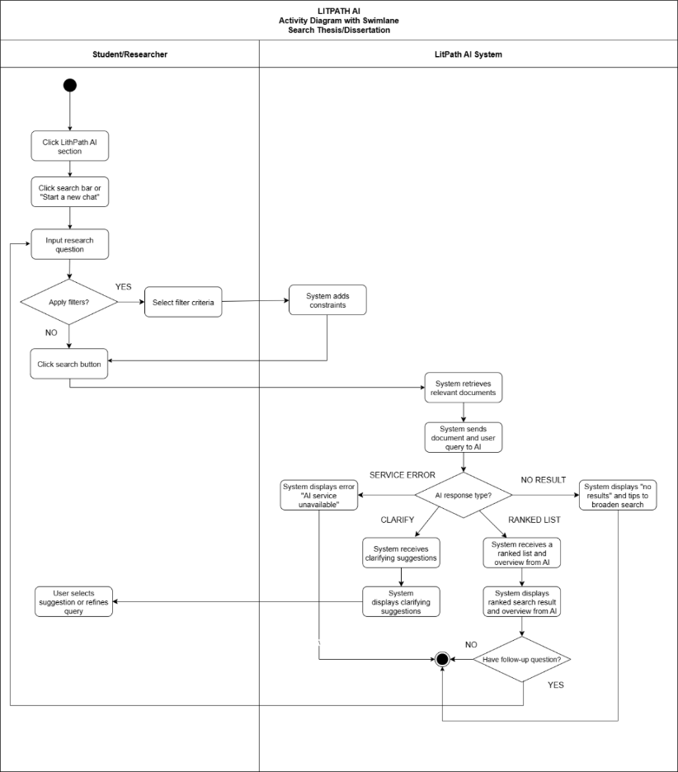

**2.0 View Thesis Details**  
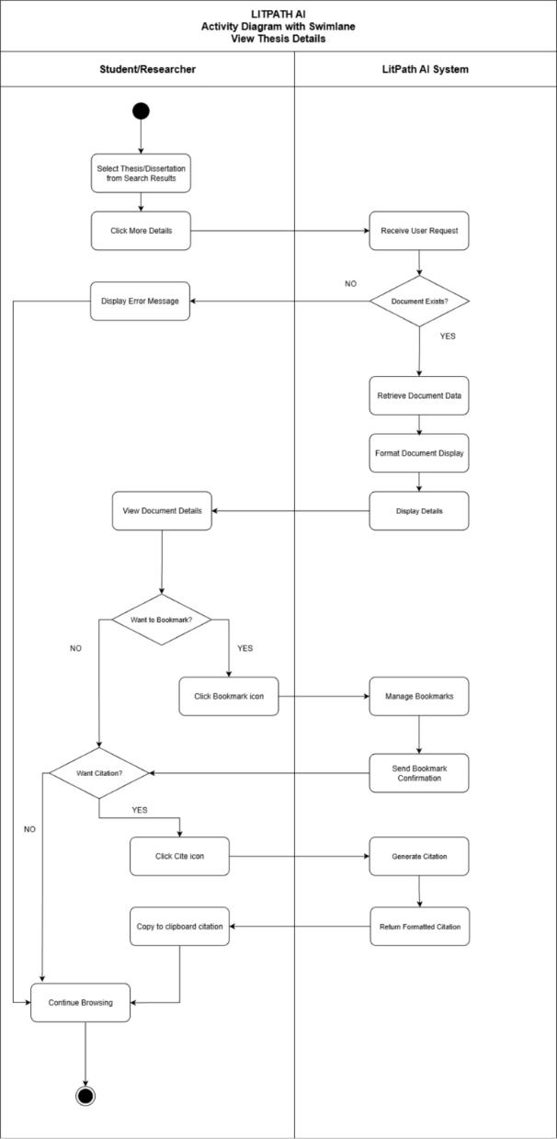

**3.0 Provide Feedback**  
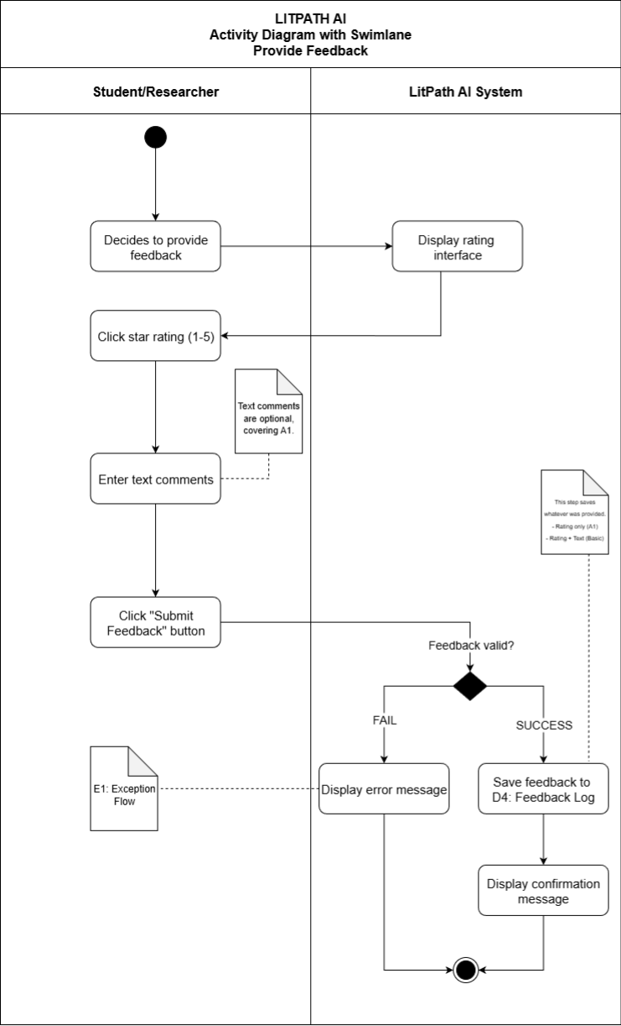

**4.0 View Search History**  
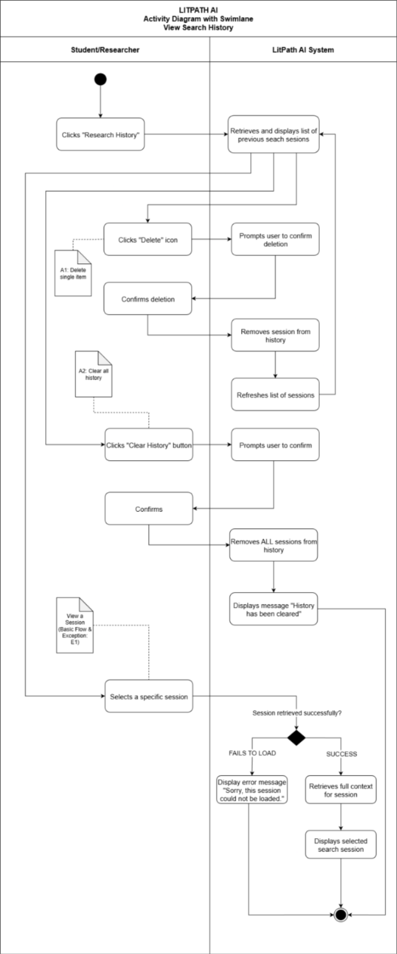

**5.0 Log In to Account**

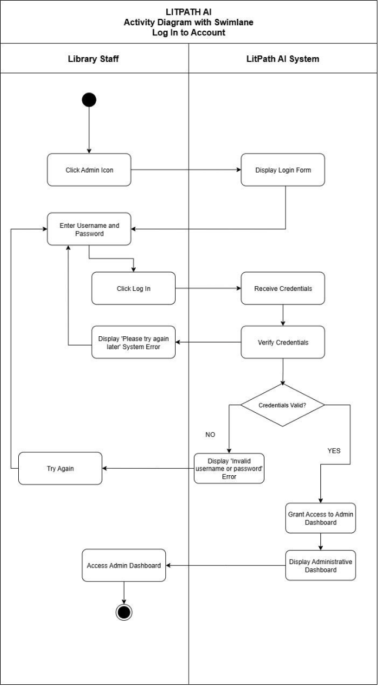

**6.0 Manage Usage Analytics**

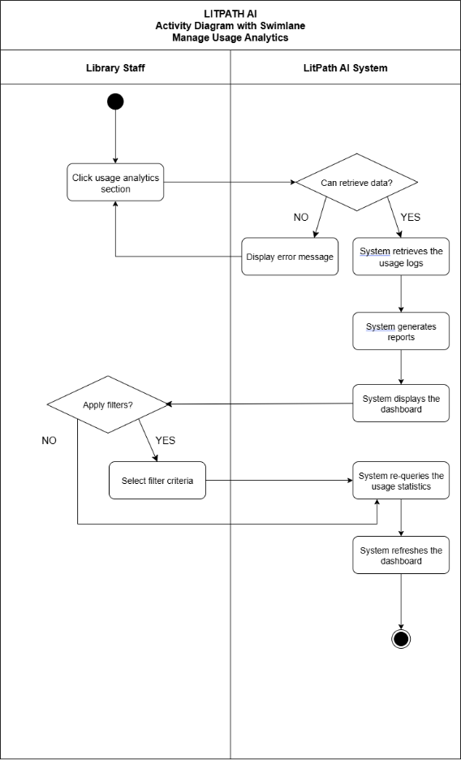

**7.0 Manage Feedback**  
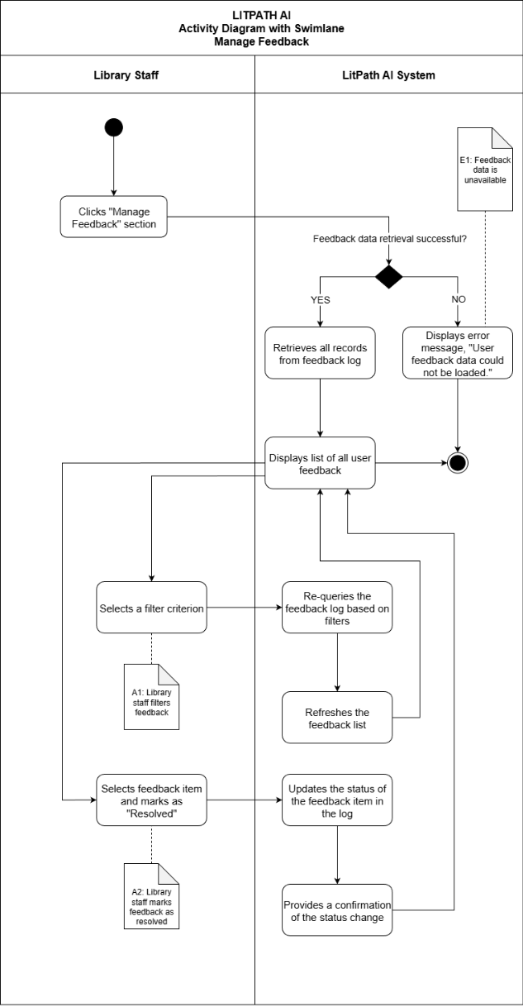

## **Test Cases**

**UC-01 TC01**  
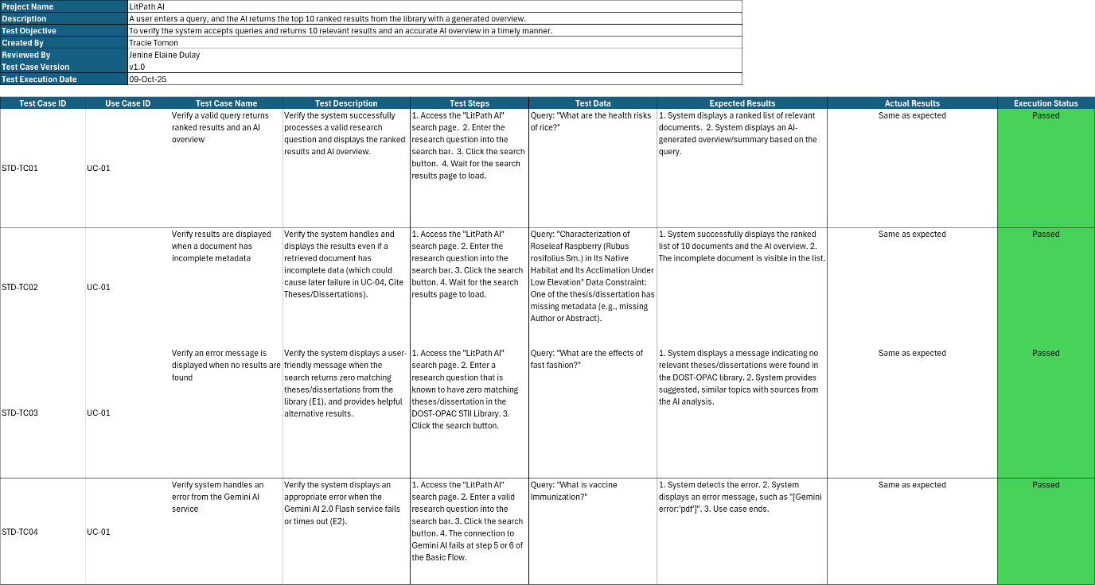

**UC-02 TC02**  
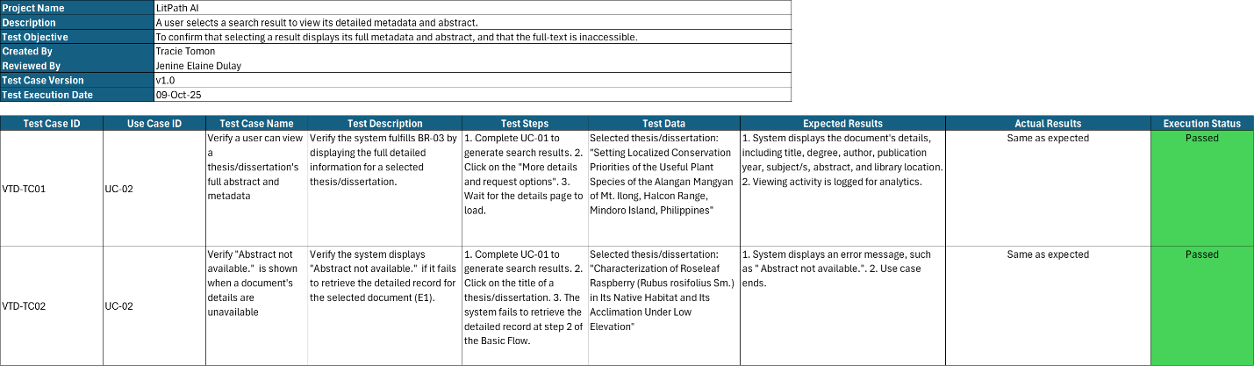

**UC-10 TC10**  
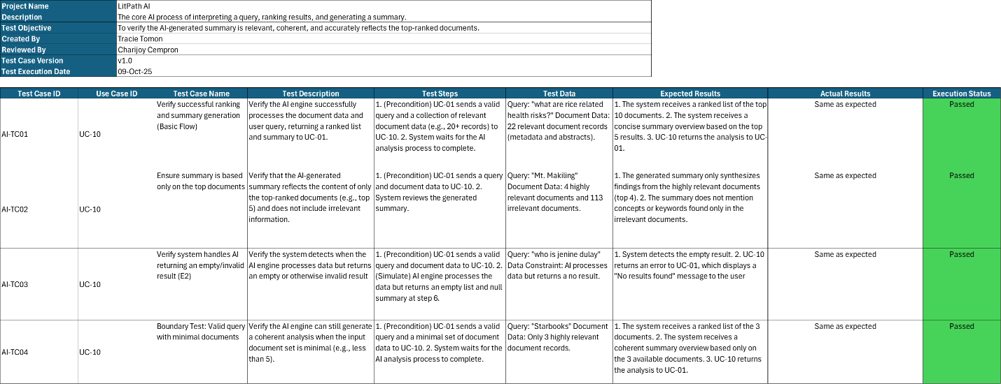

# **Entity Relationship Diagram**

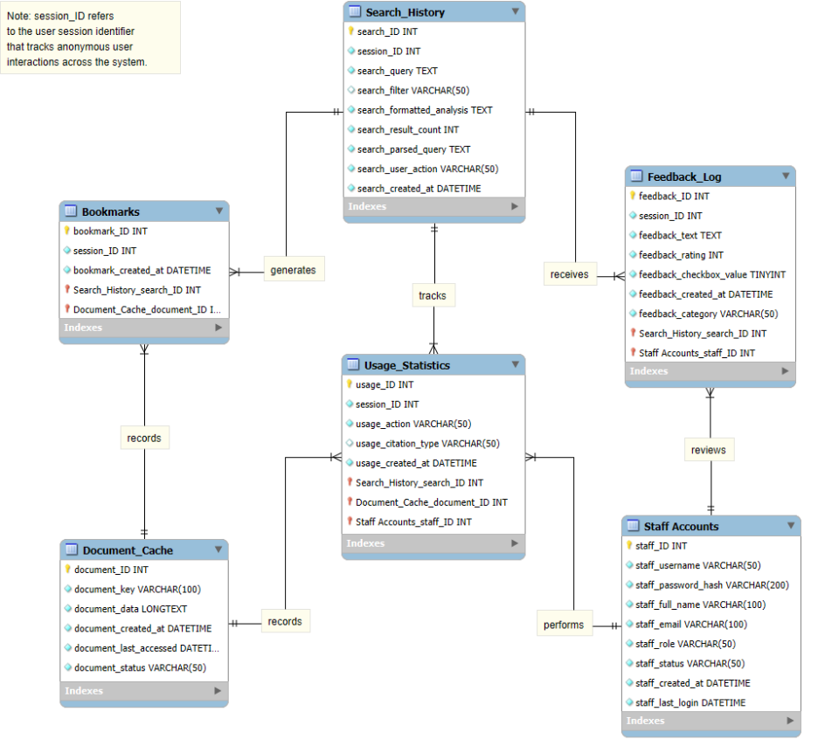

# **Technology Stack**

* **Frontend Framework**

React.js has already been implemented in the project to build a dynamic and responsive user interface. Its component-based structure allows for efficient development through reusable elements and consistent design. The use of React’s virtual DOM enhances performance by ensuring fast and smooth rendering of updates. With React already in place, the frontend is well-optimized for integration with backend services and real-time data handling.

* **Backend Framework**

Django will be implemented as the project’s backend framework to manage server-side logic, data processing, and database operations. Its built-in features such as authentication, admin interface, and ORM will allow for faster and more organized development. The framework’s strong emphasis on security will help protect the application from common vulnerabilities. Django’s scalability and reliability will ensure stable backend performance as the project grows.

* **Frontend/ Backend communication**

The project will employ a REST API to establish communication between the React frontend and the Django backend. Through HTTP requests, the API will manage data exchange, enabling efficient retrieval and submission of information. This approach will maintain a clear separation between the user interface and backend logic. It will also provide flexibility for future updates or system integrations without major architectural changes.

**GitHub APC-SoCIT Project Repository URL Link** |[Link](https://github.com/APC-SoCIT/APC_2025_2026_T1_MI231_G07-LitPath-AI)|

**OpenProject Team Site URL Link** |[Link](https://openproject2025.apc.edu.ph/projects/apc-2025-2026-t1-mi231-g07-hectech-litpath-ai/)|

**Cloud hosted site URL Link** |[Link](https://fictional-parakeet-jjjxq969xp6wfjg7p-5173.app.github.dev/)|

**Note**: We used an HTTP server to connect our frontend with our python backend, so we currently don’t have a backend framework. This is why we can’t use Vercel to cloud host it, hence, why we are currently using *Codespace* instead.